Ph.D. Thesis

Develop and Evaluate a Transferable Model Predictive Control Based Group Occupant-Centric Control Strategy

Committee Members:

Jin Wen, Ph.D. (Drexel University)

James Lo, Ph.D. (Drexel University)

Simi Hoque, Ph.D. (Drexel University)

Amanda Pertzborn, Ph.D. (National Institute of Standards and Technology)

Zhelun Chen, Ph.D. (Daikin Comfort)

Prepared By:

Yicheng Li

Department of Civil, Architectural and Environmental Engineering,

Drexel University

Philadelphia, PA 19104, USA

Date: May 2025

**Acknowledgments**

First and foremost, I wish to express my profound gratitude to my supervisor, Professor Jin Wen, for her invaluable guidance and unwavering support throughout my doctoral journey. Like raw timber finding its shape under a master carpenter's chisel, I owe my academic formation to her meticulous mentoring. Beyond her encyclopedic expertise, I sincerely appreciate her for the care and warmth she extended. Her kindness and support mean a great deal to me throughout this journey.

I am also immensely grateful to the members of my thesis committee: Dr. James Lo (Drexel University), Dr. Simi Hoque (Drexel University), Dr. Amanda Pertzborn (National Institute of Standards and Technology), and Dr. Zhelun Chen (Daikin Comfort). Over the years, their insightful feedback and valuable suggestions have significantly enhanced my work. I am truly honored to have had the opportunity to learn from their extensive knowledge and experience. Special recognition goes to Dr. Zhelun Chen, who has been like a fellow student and close companion throughout my PhD journey. His encouragement and assistance have profoundly impacted my PhD experience.

I would also like to express my sincere gratitude to all the members of the Building, Science & Engineering Group (BSEG) lab for their stimulating discussions, collaborative spirit, and the many enjoyable happy hours we shared throughout this journey. They are Richard Kimball, Gabriel Grajewski, Noreshvarman Manisagar, Naghmeh Ghalamsiah, Jose Moussa, and Dr. Ojas Pradhan. Their support, camaraderie, and good humor have made my time in the lab enriching and memorable.

To my family across the ocean, I extend my heartfelt thanks for their continuous encouragement and support throughout my studies. Their video calls have reminded me time and time again of my family's selfless love. To my close friends in Philadelphia, the cheesesteaks, hot pot dinners, and shared laughter have made the city feel like home. I am deeply grateful for the precious friendships and memories we’ve made along the way. To my girlfriend, Yiqing Wang, her patience, understanding, and constant support provided me with strength and comfort when I needed it most, and I could not have made it through without her.

Lastly, my deepest and most heartfelt gratitude goes to my parents. Words will never be enough to fully express how much I appreciate everything they have done for me. They gave me life, nurtured me with love and care, and have been the strongest support throughout my doctoral journey. It is their hard work, encouragement, and support that has made me who I am today. I will always remain deeply grateful.

**Table of Contents**

List of Figures 8

List of Tables 10

Abstract 11

Chapter 1 Introduction 13

1.1 Background 13

1.2 Literature Review 15

1.3 Overview of Study 29

1.4 Research Tasks 30

1.5 Outline of Contents 31

Chapter 2 Virtual Testbed Development 32

2.1 Introduction 32

2.2 Terminology 32

2.3 Virtual Testbed Framework 33

2.4 HVAC System Model 34

2.5 Zone Model 38

2.6 Occupant Comfort Model 40

2.7 Data Generation from the Virtual Testbeds 42

2.8 Chapter Conclusions 42

Chapter 3 Predictive Model Development 43

3.1 Introduction 43

3.2 Group Thermal Comfort Model 43

3.3 Zone Environment and System Power Model 51

3.4 Chapter Conclusions 57

Chapter 4 Transfer Learning Used in Group Thermal Comfort Model 58

4.1 Introduction 58

4.2 The Framework and Methodology of Transfer Learning Used in Group Thermal Comfort Model 58

4.3 Evaluation Cases Design of Transfer Learning 62

4.4 Evaluation Results 69

4.5 Chapter Conclusions 72

Chapter 5 Development of MPC-based Group Occupant Centric Control 73

5.1 Introduction 73

5.2 MPC Development 73

5.3 Evaluation Method 77

5.4 Evaluation Results and Analysis 81

5.5 Chapter Conclusions 94

Chapter 6 Summary and Future Works 95

6.1 Overall Achievement 95

6.2 Limitation and Future Work 96

6.3 List of Publications 98

References 101

Appendix A Preliminary Test of TL Used in Group Thermal Comfort Model 111

Appendix B Information Entropy Calculation of Target Domain Data in TL 114

# List of Figures

Figure 1‑1 The framework of OCC in thermal comfort [21] 15

Figure 1‑2 Schematic representation of the three approaches of transfer learning [89] 25

Figure 1‑3 The overall framework of the study 28

Figure 2‑1 The framework of virtual testbed 32

Figure 2‑2 The schematic of ASHP [110] 34

Figure 2‑3 The ducts of ASHP in NIST [120] 34

Figure 2‑4 ASHP MATLAB model validation results in a medium thermal load scenario 36

Figure 2‑5 Schematic diagram of the ASHP speed control in the cooling mode 37

Figure 2‑6 Prototype Building Models –Small Office [111] 38

Figure 2‑7 Example of EnergyPlus FMU settings 39

Figure 2‑8 PMV-PPD curves for Fanger, RP-884 HVAC and RP-884 NV building [116] 40

Figure 2‑9 ASH vote distribution by PMV for RP-884 HVAC buildings [116] 40

Figure 3‑1 Weighted average JSD calculation schematic diagram 47

Figure 3‑2 5-fold cross-validation schema 49

Figure 3‑3 Validation results of zone air temperature model with different prediction horizons 55

Figure 3‑4 Validation results of zone air relative humidity model with different prediction horizons 55

Figure 3‑5 Validation results of HVAC system power model with different prediction horizons 55

Figure 4‑1 Transfer learning framework proposed for the group occupant thermal comfort model 59

Figure 4‑2 Changes in p-value in the chi-square test as the number of sampling groups increases 62

Figure 4‑3 3D distribution of source domain data in evaluation cases 63

Figure 4‑4 Zone air temperature and cooling/heating setpoints for two HVAC system operating scenarios 65

Figure 4‑5 Information entropy varies with the time period of data collection 66

Figure 4‑6 A evaluation framework of transfer learning used in group thermal comfort model 67

Figure 4‑7 Results of the transfer learning evaluation 69

Figure 4‑8 The results of model performance (JSD) and transfer learning effects (ΔJSD) under different information entropy 70

Figure 5‑1 TMPC-GOCC MPC framework 73

Figure 5‑2 Flowchart of the development process of the three MPCs 77

Figure 5‑3 Prediction model performances for evaluation case 15occ-N-3SP-4D with temperature-based MPC 81

Figure 5‑4 Prediction model performances for evaluation case 15occ-N-3SP-4D with GOCC-based MPC 82

Figure 5‑5 Prediction model performances for evaluation case 15occ-N-3SP-4D with GOCC+TL MPC 83

Figure 5‑6 JSD boxplots of group thermal comfort models in GOCC-based MPC and GOCC+TL MPC for evaluation cases 84

Figure 5‑7 Average Occupant Discomfort Vote boxplots of three MPCs in evaluation cases 85

Figure 5‑8 HVAV energy usage of three MPCs in all evaluation cases 87

Figure 5‑9 15occ-N-3SP-4D GOCC-based MPC predictive performance 89

Figure 5‑10 15occ-N-3SP-4D GOCC+TL MPC predictive performance 89

Figure 5‑11 PMV-PDD curves for 5-, 15-, and 7-occupants group with neutral thermal preference 90

Figure 5‑12 Relationship between the JSD of a group thermal comfort model and the control effect of its MPC 92

# List of Tables

Table 2‑1 Two-Stage Air-Source Heat Pump Fitted Parameters 35

Table 2‑2 Summary of the validation error (RMSE) in ASHP system model 37

Table 3‑1 Candidate feature 44

Table 3‑2 The settings of machine learning algorithms in MATLAB for group thermal comfort model 45

Table 3‑3 Cross-validation results 49

Table 3‑4 The settings of machine learning algorithms in MATLAB for zone environment and HVAC system power model 53

Table 3‑5 Zone air temperature prediction error (RMSE) [°C] 54

Table 3‑6 Zone air relative humidity prediction error (RMSE) [%] 54

Table 3‑7 HVAC system power prediction error (RMSE) [W] 54

Table 4‑1 Summary of the design of source and target domains in transfer learning 66

Table 5‑1 Summary of the key characteristics of Temperature-based MPC and Proposed GOCC MPC strategies 75

Table 5‑2 The validation errors (JSD) of group thermal comfort model in the TMPC-GOCC evaluation cases 78

Table 5‑3 key performance indicators for TMPC-GOCC evaluation 79

Table 5‑4 Prediction error (RMSE) of zone temperature, zone relative humidity, and HVAC system power for all evaluation cases 83

Table 5‑5 The median and mean of prediction accuracy ($JSD$) of group occupant thermal comfort in evaluation cases 85

Table 5‑6 The median and mean of the average occupant discomfort vote in evaluation cases 85

Table 5‑7 The total energy usage [kWh] in all evaluation cases 87

# Abstract

Occupants’ well-being is significantly influenced by how buildings are designed and operated. In recent years, occupant-centric control (OCC) strategies have gained growing attention for their potential to enhance occupant comfort and energy efficiency. Among advanced control approaches, model predictive control (MPC) has been increasingly applied to OCC, as it leverages predictive models and optimization algorithms to reduce HVAC energy consumption while improving thermal comfort. Based on the literature review, there are many well-established methodologies for modeling building and heating, ventilation, and air conditioning (HVAC) systems, but the thermal comfort model to be used in MPC still requires further exploration. Specifically, (1) there is a lack of publicly available and comprehensive virtual testbed that integrates buildings, HVAC systems, and occupant models; (2) there is a lack of thermal comfort models that address individual variability and resolve comfort conflicts among a group of occupants; (3) there is a high cost to collect sufficient occupant data to train reliable models; and (4) evaluation of MPC performance in occupant-centric applications is not widely reported. To this end, the objective of this study is to develop a transferable MPC-based group OCC strategy that enhances occupant thermal comfort and saves energy without requiring large amounts of occupant comfort data.

This study aims to bridge these gaps through the following contributions:

* Virtual testbed development: A calibrated virtual testbed (representing a single zone with two-stage air source heat pump system in typical commercial building) was developed. Results indicate that the virtual testbed can accurately simulate the building thermal environment, HVAC system energy consumption, and occupant thermal comfort.
* Data-driven prediction model development: Data-driven prediction models needed in the proposed MPC framework were developed, specifically group thermal comfort model, HVAC system power model, and zone environment (air temperature and humidity) models. Among them, the primary focus is on the definition and development of group thermal comfort model. Results show that the random forest-based model provides accurate predictions for group thermal comfort, and the RMSE values for other models are less than 0.5 °C, 5%, and 90W, respectively.
* Transfer learning for group thermal comfort model: To address data scarcity, an instance-based transfer learning framework was introduced to improve the performance of group thermal comfort models. Evaluation results demonstrate that this method can enhance model predictive performance and is robust across varying occupant groups.
* Development of a Transferable MPC-Based Group Occupant-Centric Control (TMPC-GOCC) strategy: By integrating the developed prediction models, a TMPC-GOCC strategy was developed and evaluated using the virtual testbed. The results show that compared to a conventional MPC that uses zone temperature as the constraint, the proposed strategy achieves better control performance in occupant comfort, reducing occupants' discomfort votes by up to 50%.

Finally, this thesis presents the overall achievements, identifies key limitations, and proposes future works.

# Introduction

## Background

Occupants’ well-being is significantly affected by how buildings are designed and operated. The National Human Activity Pattern Survey reported that people spend an average of 87% of their time indoors[1]. With the combined impact of the COVID-19 pandemic, this percentage is expected to go higher [2]. Considerable studies have demonstrated that an appropriate building indoor environment can improve occupants’ well-being, including more comfortable physical conditions, better health, and higher productivity [3-5]. However, most traditional indoor environmental control systems (usually referring to as Heating, ventilation, and Air Conditioning (HVAC) systems and lighting systems), especially in commercial buildings, operate on a predefined schedule with fixed setpoints and do not consider the presence or absence of occupants and their comfort requirements. When occupants feel uncomfortable, they are naturally inclined to adjust the systems manually. However, in commercial buildings, indoor environmental control systems are usually not easily accessible to occupants [6]. In addition, even if manual control is available, the control may not meet the needs of the occupants well and result in energy waste. In fact, indoor environmental control systems have always been designed with an intention to enhance the comfort of occupants. However, existing control strategies often fail to align with occupant's comfort due to the lack of real-time access to information on the indoor environment and occupants.

In recent years, a control approach called occupant-centric control (OCC) has been proposed. As defined in IEA-EBC Annex 79 [7], OCC is a method of indoor climate control in which occupant personal information such as comfort, preference, skin temperature, etc., is directly measured or indirectly inferred through various sensors, wearable devices, and feedback systems. This information is then used to develop models to simulate or predict the indoor environment and occupant needs. In brief, OCC is to control the indoor environment based on the needs of occupants, thereby improving their satisfaction with the indoor environment. The indoor environment is a broad concept. The assessment of occupants’ satisfaction with the indoor environment generally consists of four main components: thermal comfort, visual comfort, acoustic comfort, and indoor air quality (IAQ) [8]. All these metrics can be considered in the OCC.

To ensure occupant comfort while optimizing energy efficiency, control strategies for building energy management must prioritize both objectives effectively. HVAC systems account for a significant proportion of a building's energy consumption. In commercial buildings, the HVAC system consumes more than 40% of the energy [9]. Optimizing their use could result in significant energy savings. Predictive control strategies, particularly Model Predictive Control (MPC), have demonstrated their effectiveness in managing indoor environments by forecasting heating and cooling needs, thereby reducing unnecessary energy use [10, 11]. MPC uses predictive models to predict the behavior of a system over a period of future time, and optimizes the control strategies so that the predicted results are close to the desired target, such as energy saving and occupant’s comfort improvement. In MPC, typical predictive models can be divided into physics-based models, data-driven models, and hybrid models combining physics-based and data-driven models. Among these, data-driven models are often preferred in MPC due to their low model development costs and efficient computational capabilities[12, 13]. In general, optimized control strategies aim to minimize energy consumption while reducing occupant discomfort. This is a typical multi-objective optimization problem. Typical approaches include 1) using multi-objective optimization methods, such as Pareto and scalarization methods [14], 2) using a penalty term in the objective function to account for occupant dissatisfaction, such as deviations from a predetermined set point [15], or 3) using boundary conditions to limit certain indoor environment variables, such as zone temperature.

To be effective, MPC relies on robust predictive models to accurately predict occupant comfort, indoor environment, and HVAC system performance, including energy consumption. While there is extensive literature and established methodologies for modeling building environments and air conditioning systems, the development of models related to thermal comfort is still in the process [16, 17]. Typical thermal comfort models are for general population , such as Predicted Mean Vote (PMV) model [18]. These models do not consider inter-individual differences, which could result in deviation from the actual thermal comfort of occupants when applied. Recently, individual thermal comfort models are increasingly discussed, but this leads to the problem of comfort conflict, i.e., it is difficult to ensure that everyone in the same space is comfortable due to individual differences [19]. For this reason, this paper proposes to develop group thermal comfort models for specific groups, which enables a balance among the needs of different occupants within the group. However, it will also introduce a new problem concurrently. The primary problem in creating a group comfort model lies in its lack of universality and the complexities associated with collecting thermal comfort data. Similar to the comfort preferences of individuals, different groups of occupants would have different comfort preferences which means that each group of occupants would need their own comfort model. However, in practice, it is usually challenging to collect enough data to develop such customized group comfort models. In response, this study also proposes a solution that uses transfer learning to solve the insufficient data problem. Transfer learning is a method in machine learning where knowledge gained while solving one problem is applied to a different but related problem.

Given the significance of OCC strategies and the lack of studies applied to solve comfort conflict and insufficient data problems, this project primarily aims to develop and validate a transferable MPC-based group occupant-centric control framework. The framework will be validated using a virtual testbed that represents a typical commercial building.

## Literature Review

This section provides a general review of the OCC strategies to identify their limitations and gaps. First, Section 1.2.1 provides an overview of the literature-reported OCC strategy framework. Prediction models, including the indoor environment and system energy prediction models, are discussed in Section 1.2.2. Section 1.2.3 reviews the literature on group decision-making, which provides the fundamental framework for group occupant centric control. Next, Section 1.2.4 reviews transfer learning and its applications for OCC, which provides a potential solution to address the scalability of developed occupant comfort models. Section 1.2.5 summarizes the literature review. Note that due to the large energy consumption of HVAC systems, this study focuses on the research about the OCC of occupant thermal comfort. Only cursory mention is provided for other aspects of comfort.

### General OCC Framework

OCC is a topic that has been extensively researched. Numerous publications offer comprehensive literature reviews, each examining OCC from various perspectives. For example, June et al. [20] reviewed the field implementation cases of OCC in actual buildings. The results showed that field implementation of OCC was relatively limited. Most OCC studies focus on HVAC systems or lighting systems, and most OCC studies were conducted in 10 zones over a period of less than 3 months. Xie et al. [21] reviewed occupant-centered thermal comfort studies. The study showed that cases implementing occupant-centered thermal comfort control strategies saved 22% of air conditioning energy and improved thermal comfort by 29.1%. Sophia et al. [22] provided a detailed review of the control aspects of OCC, including real-time response, occupant preferences, activity response, and future prediction. It was shown that more sophisticated control systems such as forecasting can achieve higher potential energy savings, but at the cost of higher computational requirements. Atiya et al. [23] provide a critical review of research on occupant-centered thermal and lighting control and find that OCC can maintain occupant comfort without compromising energy savings.

To introduce OCC in a more systematic and organized way, this review is structured around three main perspectives, i.e., sensing (data and information collection), predicting, and controlling. Figure 1‑1 demonstrates the general framework of the OCC using thermal comfort as an example[21]. This framework forms the basic structure of this section and will be further divided into sub-sections to provide more details.

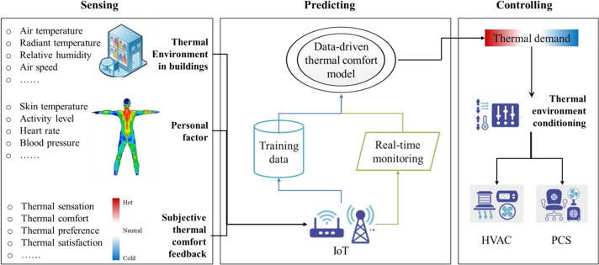

Figure ‑ The framework of OCC in thermal comfort [21]

#### Sensing - Data and Information Collection

The foundation of OCC lies in the comprehensive collection of data and information, which spans a broad spectrum of categories essential for subsequent prediction and control activities. This includes environmental physical information (both outdoor and indoor), occupants' physiological and psychological information, personal information, and building information. These categories encompass a range of data such as air temperature, occupant skin temperature, subjective feedback, and building occupancy, among others.

* Environmental Physical Information: Environmental physical parameters critical for occupant comfort vary across thermal, acoustic, visual comfort, and indoor air quality (IAQ). Fanger's thermal comfort model, for instance, employs air temperature, mean radiation temperature, air velocity, and humidity, with some studies also considering outdoor factors like air temperature for thermal comfort[24].
* Occupants’ Physiological Information: It’s crucial for assessing comfort levels, especially thermal comfort. The collection methods range from invasive to non-invasive sensors, focusing on indicators like skin temperature, heart rate, and even psychological state through parameters like galvanic skin response and Electroencephalography [21].
* Occupants’ Psychological Information: Gathered through subjective methods such as questionnaires and interviews, this information provides insight into the occupants' perceptions and expectations of their environment [25, 26].
* Occupants’ Personal Information: This information includes stable personal characteristics like gender, age, and can be collected via surveys or inferred from technology like Wi-Fi and Bluetooth to enable personalized comfort models [27].
* Building Information: It encompasses data about the building itself and the interactions between occupants and the building, aiding in the management of occupancy levels and environmental conditions [19, 28].

#### Prediction

The predictive phase utilizes the collected data to model and forecast future states or current but hard-to-measure conditions, focusing on occupancy, comfort, and behavior. This involves:

* Occupancy Prediction: Utilizes environmental sensors and machine learning algorithms to estimate the presence and movement of occupants within a space. Techniques range from support vector machines to deep learning, emphasizing the importance of accurate feature selection[29-33].
* Comfort Prediction: Develops models for thermal, acoustic, and visual comfort using inputs like environmental conditions and physiological responses. Machine learning algorithms, including random forests and neural networks, are employed to predict individual or average comfort levels based on environmental and physiological data [21, 34-36].
* Behavior Prediction: Aims to model how occupants interact with building systems, using approaches like Markov chains and agent-based models to simulate decisions and actions related to HVAC, lighting, and window use[37-40].

#### Control

Control strategies in OCC are divided into reactive and predictive approaches, both of which rely on the data gathered and insights gained from predictive modeling.

* Reactive Control: This control strategy involves an immediate response to real-time changes detected in the environment or through occupant feedback. It includes adjusting building operation settings based on occupancy or direct feedback and is effective for immediate comfort adjustments. This method is widely used in lighting systems, where real-time adjustments based on motion detection significantly enhance energy savings while maintaining occupant’s visual comfort [41].
* Predictive Control: Unlike reactive control, predictive control uses predictive models to anticipate future environmental conditions and occupant needs, allowing for preemptive adjustments to building systems. This approach typically employs Model Predictive Control (MPC) techniques, optimizing for both energy efficiency and occupant comfort. MPC operates by continuously predicting future states of the building environment based on historical data, weather forecasts, and real-time sensor inputs. It formulates an optimization problem, such as minimizing energy consumption while ensuring thermal comfort, to adjust HVAC operations proactively rather than reactively. The effectiveness of MPC depends on multiple factors, including the accuracy of predictive models, the reliability of input data, and the efficiency of the optimization algorithms used. Previous research has demonstrated the effectiveness of MPC in optimizing HVAC system energy [42-44] and occupant’s comfort [43, 44]. Several comprehensive review papers provide detailed insights into the application of MPC in HVAC systems, covering aspects such as modeling approaches, optimization techniques, and real-world implementation challenges [11, 45, 46].

As summarized above, OCC integrates data collection, predictive modeling, and control strategies to provide a holistic approach for optimizing building performance while improving occupant comfort. Since the HVAC system accounts for a significant portion of the energy consumed in a building, and its control is intended to satisfy the thermal comfort needs of the occupants, the focus of this paper is narrowed down to the OCC with respect to the thermal comfort of the occupants. Although there have been many studies demonstrating the feasibility and benefits of MPC-based OCC strategies , there are still some challenges that hinder its wide application in the building industry.

* Difficulties in obtaining training data on occupants: High-quality training data is required in both the prediction and control phases. This often requires a variety of data such as occupancy, occupant feedback, and environmental properties. However, cost-effective sensors to obtain such data are not yet available in most buildings, making it hard to provide insight into the occupants, environment, or system conditions [47]. In real building systems, even if the appropriate sensors are available, collecting data of the required quantity and quality is still a time-consuming task. Liu et al[48] investigated the effect of data quantity on prediction performance. The study indicated that the more data, the better the model performance. The authors also showed that a moderate level of performance can be obtained with 200 points of data. Daum et al [49] argued that more than 90 data points are required to build a convergent and complete profile of personalized thermal preferences. In addition to the quantity of data, data quality is another important issue in the data collection process and may also affect the amount of data required[50]. Liu et al[48] found that one participant's vote remained almost unchanged for three consecutive days. The laborious data collection process may distract participants and introduce substandard data. To ensure the robustness and reliability of models, it is necessary to provide a sufficient amount of data instances under different environmental conditions, which limits the development of OCC in practice.
* Scalability: The scalability of the predictive models is also a key impediment to the adoption of OCC. It is widely recognized that the failure of applying MPC-based OCC strategies at scale is due to the large amount of engineering hours needed in model development/calibration and control problem formulation [23]. Few engineers in the construction industry have the knowledge required to develop and commission such controllers. In addition, inconsistent measurements across buildings limit the scalability of OCC. For example, variables such as indoor temperature and humidity are usually easy to measure. In contrast, indoor air velocities are not routinely monitored parameters and are not considered in subsequent predictive model development. The non-uniformity of monitoring variables across buildings leads to the situation that models for different buildings often do not use the same features as inputs, thereby compromising the scalability of these models for applications in related buildings [51, 52].
* Comfort conflict: Due to individual differences, such as differences in metabolic rate and personal preferences, each person may have a different comfort response to the same environment. Therefore, it is difficult to ensure that every person in the same indoor environment is comfortable. In groups of people influenced by the same indoor environment, such differences can lead to a comfort conflict problem, which can pose a great challenge for the indoor environment control. How to perform OCC for a group of occupants remain to be challenging.
* Lack of comprehensive, validated and easily reusable testbed: The development of MPC involves training of predictive models and tuning of optimization algorithms, etc. These efforts need to be supported by a real or virtual testbed, requiring time and cost budgets to collect data and debug control strategies. For a specific OCC study, the testbed involved often is developed for specific purposes. In other words, the testbeds used vary from case to case.
  + On the one hand, there are studies that develop testbeds based on real environments involving real occupants, building systems, etc. June et al. performed a detailed review of case studies applying OCC in real buildings. The results show that the experimental design varies from study to study [20]. For example, Zu et al. constructed an Occupant-Centric Heating and Natural Ventilation Control (OCHNVC) strategy in a classroom at the University of Nottingham UK campus by using an AI camera to collect occupants' behavior [53]. Meng et al. performed real-time control of HVAC systems based on occupancy-aware technology to predict occupancy at Syracuse University's Total Indoor Environmental Quality (TIEQ) lab [54].
  + On the other hand, due to its simplicity and repeatability, more studies have used virtual testbeds to investigate OCC strategies, e.g., Mohamed et al. verified lighting and heating/cooling setpoint OCC strategies for individual offices by creating objects including occupant behavior in EnergyPlus [55]. Zeinab et al. implemented three OCCs in EnergyPlus and optimized the OCC configurations and design parameters for different occupancy scenarios using a Python package [56]. June et al. examined a reinforcement learning (RL)-based OCC strategy in EnergyPlus, which involves monitoring indoor air temperature, occupancy, and thermal voting that learns the occupant behaviors and indoor environments and computes adaptive thermostat setpoints [57].

To support this study, the desired testbed should include HVAC systems, buildings, and occupants. Although previous literature has reported the use of real-world or virtual testbeds for their research, there is a lack of a publicly available testbed suitable for the development of the transferable MPC-based group OCC strategy proposed in this study. This gap makes it necessary to develop a testbed specifically for this study.

### Indoor Environment and Building Energy Forecasting Models

Besides the prediction of occupancy, comfort, and behavior as presented above, OCC often also needs the prediction of indoor environment and/or energy consumption of the building system. Prediction models for indoor environment and energy consumption have been well reviewed. Since they are not the focus of this study, only a brief literature summary is performed.

Modeling techniques of indoor environment and HVAC system can be divided into black-box (data driven), white-box (physics based), and grey box models, each with its strengths and limitations. The following is a summary of the review papers[18, 50, 58-63] about the indoor environment and building system power predictions.

* Black-box models, leveraging historical data to predict future outcomes, are essential in contexts where input-output relationships are too intricate for physical laws or when detailed physical modeling is unfeasible. These models include Machine Learning (ML) Models—such as neural networks, support vector machines, and random forests—and Regression Models, like linear, polynomial, and logistic regression. ML Models excel in learning complex relationships between variables (e.g., outdoor temperature, occupancy) and outcomes (e.g., zone temperature, HVAC power consumption) from past data, with deep learning models (e.g., ANNs, CNNs, RNNs) capturing nonlinear dynamics effectively. In contrast, Regression Models are simpler and more interpretable, but it is hard to handle nonlinear complexities. For this purpose, the appropriate machine learning algorithm should be selected based on the complexity and characteristics of the target model.
* White-box, or Physics-based, Models employ physical equations and principles to simulate HVAC systems and thermal dynamics within buildings. Requiring extensive information about the system and its surroundings, these models offer deep insights into the fundamental processes and the effects of modifications in system design or operation. Building Energy Simulation Tools, such as EnergyPlus, TRNSYS, and DOE-2, utilize these detailed physical models to predict the energy consumption of buildings, accounting for heat transfer processes, thermodynamics of HVAC systems. However, due to its complexity and time-consuming, it is usually not used as a predictive module for OCC.
* Grey-box models integrate the methodologies of both black-box and white-box models by employing data-driven techniques to refine physics-based models. In Parameter Estimation Models, physical equations are augmented with parameters adjusted based on empirical data, enhancing the models' alignment with real system behavior. A typical example is the zone RC (resistance-capacitance) model. It captures the thermal behavior through electrical circuit analogies, where resistance represents the thermal resistance of the building's envelope, and capacitance represents the building's thermal mass.

In general, there are well established models to make predictions about indoor environments and building energy. Physical-based models have better reliability, interpretability and accuracy. Data-driven models are useful if there is enough historical data and little or no information on designed buildings. Hybrid models make a good balance between physical and data-driven models and it's a better choice when the information required for the other two models is not available. In the MPC studies of this field, most of the cases used data-driven models, in which ANNs take the lead in a large number of applications such as environmental, load, and energy forecasting[63]. Note that feature selection is a necessary strategy in data-driven modeling[64, 65].

### Group Thermal Comfort: Group-Decision-Making Problem

One of the challenges of OCC, mentioned in Section 1.2.1 above, is the comfort conflict. In other words, it is how to consider each occupant's feedback on comfort under the same indoor environment. This predicament can be classified as a group decision-making problem, defined as a scenario in which multiple individuals are required to collaboratively make decisions[66].

Determining the thermal comfort of a group is a process of group decision making in which the thermal comfort of the group is judged from the thermal comfort of multiple individuals. This paragraph is a summary of the literature [66, 67] on the general group decision making problem. Group decision making is the process of reaching a collective decision in a group of people in which each individual may have different interests, ideas, and perspectives. The outcome of collective decision-making should be accepted by other stakeholders and consensus should be reached among them. To promote human rights, ensure inclusiveness, and address inequalities, equality, equity, and justice need to be considered when making group decisions. Equality refers to the principle of treating all individuals in a group fairly and without bias [68]. Equity focuses on providing individuals with the resources and support they need to achieve fair outcomes, taking into account their unique circumstances and needs [69]. Justice entails making decisions that are morally right, fair, and impartial[70].

In the context of equality, equity, and justice, group decision making usually includes the following methods:

* Majority rule (voting)[71]: This is the most common and democratic method of group decision-making. Each member has one vote and the option with the most votes is selected. Rooted in democratic principles, the plurality method is usually easy to implement, but may not always produce the best results, especially if the majority is misinformed or biased.
* Nominal Group Technique (NGT)[72]: NGT is a structured method for group brainstorming that encourages everyone to contribute and facilitates rapid agreement on the relative importance of the issue, problem, or solution. Participants are encouraged to contribute ideas independently, reducing the influence of groupthink.
* Delphi method[73, 74]: This is a framework, originally developed for forecasting, that relies on a panel of experts who respond anonymously to a questionnaire, then receive feedback in the form of a statistical representation of the "group response", and then repeat the process until consensus or stabilization of opinion is reached. This method reduces the impact of group politics and power dynamics.
* Multi-Criteria Decision Analysis (MCDA)[75]: MCDA is a decision-making tool that helps to assess multiple conflicting criteria in a decision. Both quantitative and qualitative aspects of a decision can be incorporated into the model.

From the thermal comfort perspective, the group thermal comfort is judged by the thermal comfort of the individuals, so it is necessary to consider the above principles and methods as much as possible. However, it is difficult to realize some of the approaches mentioned above in a real building environment for automated system control, such as the Nominal Group Technique which involves group brainstorming or expert group discussion activities. Therefore, by analyzing the actual situation, the thermal comfort of the group can be evaluated based on the following two aspects: inclusive or exclusive, homogeneous, or heterogeneous. Understanding the group thermal comfort issue through the lenses of inclusiveness vs. exclusiveness and homogeneity vs. heterogeneity offers a nuanced approach to addressing the complexities of group decision-making in environmental control. This perspective allows for a more refined analysis of how different group dynamics can impact the process and outcomes of achieving thermal comfort for all.

* Inclusiveness in the context of thermal comfort means ensuring that every individual within a group has their preferences and needs considered in the decision-making process. This approach acknowledges the diversity within a group and aims to find solutions that accommodate as many people as possible. In practice, this could involve using adaptive comfort models that consider a wider range of thermal preferences, or implementing flexible environmental controls that allow for individual adjustments within a collective setting. The challenge here is to design systems and processes that are responsive to individual feedback while maintaining overall group harmony[76, 77].
* Exclusiveness, on the other hand, might occur when decisions about thermal comfort prioritize the preferences of a specific subset of the group, potentially neglecting the needs of others[78]. This could be due to various reasons, such as hierarchical decision-making structures, where only a few have the authority to make changes, or scenarios where the majority’s preferences override minority needs.
* Homogeneity, in group thermal comfort, emphasizes the principle that everyone in the group has equal importance. This means that everyone's comfort needs are given equal importance in the decision-making process, regardless of their status, roles, or personal characteristics[79].
* Heterogeneous approach emphasizes the consideration of vulnerable or disadvantaged individuals. In this context, heterogeneity means giving extra weight to the thermal comfort needs of these groups in the decision-making process. This is a conscious effort to adjust for differences in the impact of environmental conditions on different groups of people, recognizing that some individuals may need more attention to ensure their comfort due to their health status, ages, or other factors[80, 81].

In conclusion, analyzing group thermal comfort from these perspectives highlights the importance of a comprehensive and inclusive approach to decision-making. By considering the nuances of inclusiveness vs. exclusiveness and homogeneity vs. heterogeneity, it becomes possible to develop more effective strategies for managing the complex issue of thermal comfort in group settings, ultimately leading to environments that are more comfortable, equitable, and satisfying for all.

### Transfer Learning

As mentioned in Section 1.2.1, the collection of sufficient data for the development of reliable thermal comfort models for individuals or groups in OCC is a difficult task. And previously existing models cannot be used directly for a new building or group of occupants. In machine learning practice, this problem is very common. There is often a lack of data to build a ML model when approaching a new specific goal, which is referred to as a cold start [82]. When a model uses sparse data, it often lacks reliability. With the advancement of ML, a technique called transfer learning has been developed to address this problem. Transfer learning is a ML technique where a model developed for one task is reused on a new task, leveraging previously learned knowledge to improve learning efficiency and performance on the new task[83]. Commonly, transfer learning tends to address three main problems of traditional ML: (1) insufficient labeled data, (2) incompatible computation power, and (3) distribution mismatch [84, 85]. The following content first illustrates the basic concepts in transfer learning. Subsequently, the problems associated with transfer learning and the solutions that have been proposed are explored. Finally, several recent studies about transfer learning for thermal comfort modeling are reviewed.

#### Basic Concepts in Transfer Learning

This subsection a summary of references [83-85]. Source and Target are two fundamental objects in transfer learning, where the source refers to the domain and task from which knowledge is transferred, and the target refers to the domain and task to which knowledge is applied. The goal in transfer learning is to improve the learning of the predictive function for the target task by leveraging information from the source task.

In transfer learning, a domain, D = (𝑋, P(𝑋)), consists of a feature space (𝑋) and a marginal probability distribution (P(𝑋)) over this feature space. Essentially, the domain defines the space in which the data exists and how data points are distributed within this space. If two domains are different, then they either have different feature spaces (𝑋t ≠ 𝑋s) or different marginal distributions (P(𝑋t)≠ P(𝑋s)).

* The feature space is the set of attributes or characteristics by which the data is represented.
* The marginal probability distribution describes how frequently different instances (data points) occur or are likely to occur within the input feature space of that domain.

A task, T= (𝑌, f(𝑥)), in transfer learning, is defined by a label space (𝑌) and an objective predictive function (f(𝑥)). It represents the specific problem or activity to be learned or performed. In general, if two tasks are different, then they may have different label spaces(𝑌t ≠ 𝑌s) or different objective predictive function (ft(𝑥) ≠ fs(𝑥)).

* The label space refers to the set of all possible labels that can be assigned to instances in the task. The label space can vary significantly between tasks, even within the same domain.
* Predictive Function is the function that the model learns, mapping input data points from the feature space to predictions in the label space. In transfer learning, the predictive function learned for one task may be adapted or reused to improve learning in a related task.

#### Categories of Transfer Learning Problems and Methods

This subsection is a summary of several transfer learning review papers [83, 84, 86-88]. Transfer learning aims to leverage knowledge from one or more source tasks to improve learning in a related target task. Traditionally, transfer learning problems were categorized into three main groups based on the similarity between domains and also the availability of labeled and unlabeled data: Inductive transfer learning, transductive transfer learning, and unsupervised transfer learning.

* Inductive transfer learning focuses on improving the performance of the target task in the target domain, leveraging knowledge from the source domain and task. In inductive transfer learning, the target task is different from the source task, no matter whether the source and target domains are the same or not. The source domain may provide a rich dataset that helps to pre-train a model, which is then fine-tuned on a smaller labeled dataset from the target domain to perform the target task effectively.
* Transductive transfer learning is used when the task remains the same across domains, but the source and target domains have different data distributions. Generally, the transductive transfer learning problem is also recognized as a domain adaptation problem. It involves adapting a model to the target domain without the need for retraining from scratch, typically without requiring additional labeled data in the target domain. The focus is on the domain adaptation where the main objective is to mitigate the distributional differences between the source and target domains for the same task. The challenge lies in transferring knowledge when the marginal probability distributions of the source and target domains differ significantly.
* Unsupervised transfer learning is applied when the target task has unlabeled data, and the goal is to leverage knowledge from the source domain and task to understand or make predictions about the target domain. In the unsupervised transfer learning setting, similar to inductive transfer learning setting, the target task is different from but related to the source task. However, the unsupervised transfer learning focus on solving unsupervised learning tasks in the target domain. In this case, there is no labeled data available.

The methods of transfer learning can be broadly categorized into three types based on “what to transfer”: Instance-based Transfer Learning, Feature-based Transfer Learning, and Model-based Transfer Learning (Figure 1‑2).

* Instance-based transfer learning methods try to reweight the samples in the source domain with an attempt to correct for marginal distribution differences. These reweighted instances are then directly used in the target domain for training. Using the reweighted source samples helps the target learner to use only the relevant information from the source domain. These methods work best when the conditional distributions are the same in both domains. Instance-based transfer learning is often used in transductive learning problems.
* Feature-based Transfer Learning is used to find a “good” feature representation that reduces difference between the source and the target domains. This method minimizes the distribution mismatch between the source domain and target domain by transferring features to another space (usually to lower-dimension space). Feature-based transfer learning can be used in the three types of transfer learning problems mentioned above.
* Model-based Transfer Learning approach involves transferring parts of models (e.g., parameters or layers in neural networks) that capture knowledge from the source task to the target task, and adjusting the model as necessary for the target task. The idea behind this method is that a well-trained model on the source domain has learned a well-defined structure, and if two tasks are related, this structure can be transferred to the target model. It is widely used in deep learning, where pre-trained models on large datasets are fine-tuned for specific tasks.

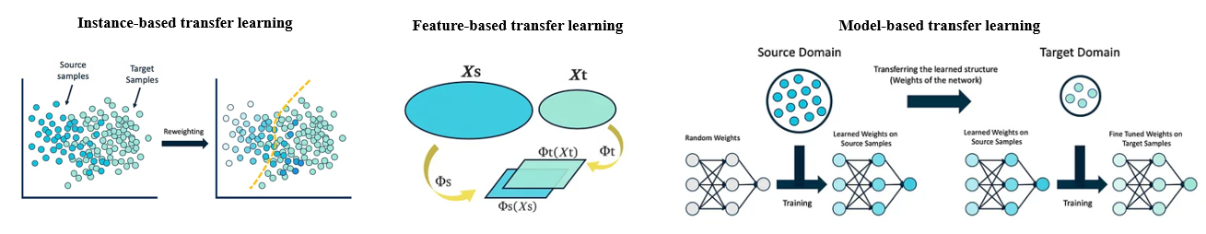

Figure ‑ Schematic representation of the three approaches of transfer learning [89]

#### The State-of-the-art in Transfer Learning

As mentioned above, transfer learning can be used to quickly and efficiently transfer existing knowledge to new tasks. In this section, the applications of state-of-the-art transfer learning techniques will be presented through some examples in general industrial fields. Currently, transfer learning has been successfully applied to applications in various domains, which demonstrates the versatility and effectiveness of transfer learning applications, especially for text-related problems and image-related problems. For example, Gupta et al. [90] summarized 16 applications of transfer learning in text detection and text recognition. In this application, the most representative method is maximally stable extremal regions (MSER) [91] and stroke width transform (SWT) [92]. Applying transfer learning to image-related problems is typically done by freezing the front and middle layers of the relevant pre-trained model and fine-tuning the lateral layers for new tasks/datasets [93]. Another example is Yosinski et al.[94] in image related modeling, where the first few layers of the CNN extract the edges, corners and tiny patches of a given image. Further layers combine these details to detect objects or faces. Additionally, transfer learning has made its mark in specific domains such as medicine, transportation, and recommended systems. In medicine, transfer learning can make use of pre-trained neural networks on large datasets (e.g., ImageNet) and fine-tune them for specific medical tasks (e.g., Alzheimer's disease detection, osteoarthritis assessment of the knee joints) to improve the accuracy of model classification [95-97]. In transportation, transfer learning can be used to understand images of traffic scenes under different conditions, model driver behavior, and recognize driver poses [98-100]. In recommender systems, general approaches usually require a large amount of training data to make accurate recommendations; however, the necessary training data (e.g., historical interaction data) are often scarce in the real world. Transfer learning solves the data scarcity problem by transferring knowledge from other systems through instance-based and feature-based approaches [101, 102].

The combination of transfer learning and MPC is an emerging research direction in control systems. When there is a lack of sufficient target domain data, transfer learning enables the predictive model in MPC to be trained with source domain data, which improves control accuracy and system adaptability, and reduces the time and cost of field experiments. This study finds two literature references closely related to the topic of applying transfer learning to MPC. Ming et al. developed a transfer learning framework using recurrent neural networks (RNNs) for modeling and predictive control of nonlinear systems. The chemical process example of A continuous stirred tank reactor (CSTR) is utilized to demonstrate the effectiveness of the framework [103]. Bao et al. proposed a transfer learning framework to improve the MPC control performance by refining the model through online transfer learning using closed-loop data. The proposed method is verified by testing on an experimentally validated high-fidelity reactivity controlled compression ignition (RCCI) engine model [104].

Returning to the thermal comfort modeling problem mentioned in this paper, there is also a limited amount of literature that discusses applying transfer learning in this field. Somu et al. [105] developed a transfer learning based convolutional neural network model to transfer knowledge from the source domain (same climate zone) to the target domain (different climate zone) where modeling data is scarce, thus solving the problem of insufficient data. The model was able to achieve accuracy greater than 55% with limited data on the target building. Park et al. [106] developed a robust individual thermal comfort model based on ensemble transfer learning. Even if the physiological and environmental data of the target object are insufficient, the model can predict individual thermal comfort by transfer learning and ensemble strategy. Li et al. [107] proposed an instance-based transfer learning model, which uses an automatic weighting mechanism to adjust the weights of the training data through similarity assessment and data selection in the source domain, and finally improves the model's thermal comfort prediction performance. Gao et al. [108] utilized sensor data from multiple cities in the same climate zone to learn thermal comfort patterns by introducing a transfer learning based multilayer perceptron model for accurately predicting thermal comfort in the same climate zone. Zhang et al. [109] proposed an inter-building migration learning framework for developing deep learning models applicable to indoor building environments with limited data. Thus, it solves the problem of insufficient data and improves the predictive performance of the model. The accuracy and F1 scores of this method outperform other existing methods in three selected datasets.

In summary, transfer learning is currently being used in multiple industrial scenarios. A few studies have also explored the use of transfer learning in MPC. There have been some studies demonstrating the feasibility of transfer learning for thermal comfort modeling. Due to the over-idealization of the data collection, e.g., using the RP884 dataset, or a dataset under a specially designed experiment, most of these studies use the data with high collection cost, such as the occupants' skin temperatures, heart rates, or indoor air speed, etc. However, these measurements are often not available for a general building. Therefore, there is a lack of using transfer learning for thermal comfort modeling of groups of occupants and no studies have further explored its impact of transfer learning on MPC-based OCC.

### Summary of Literature Review

The sections above review the relevant literature to identify existing research gaps and research directions for MPC-based OCC methods. First, the literature on overall OCC framework and strategies is reviewed. Following this, a review about the prediction models to be used in OCC is performed. And a review of group decision problem is presented regarding how to determine group thermal comfort. Finally, there is a review of the literature regarding the use of transfer learning to solve the insufficient data problem often encountered in OCC applications. Based on the above literature review, the following research gaps are identified:

* A publicly available testbed for OCC strategy development is lacking. Only a few studies have reported the application of OCC strategies in real buildings. On one hand, this is because the implementation of OCC in existing buildings is complex, which contains a series of processes such as data collection, model development, and control tuning. On the other hand, it is due to the lack of a comprehensive and representative real-world testbed to support the development and validation of OCC.
* Research about addressing comfort conflict is lacking. With the development of personal comfort models, the issue of conflicting comfort levels between different people in the same area has received increasing attention. Due to individual differences, it is difficult to ensure that everyone in the same space is comfortable. Comfort level conflicts can lead to confusion for the controllers with no way to make the most favorable control. This issue is especially critical in MPC and can directly affect control performance.
* There is a lack of research addressing the poor scalability of occupant comfort models. The complex and time-consuming collection of occupant data resulted in insufficient data to train the relevant occupant comfort model, which leads consequently to poor scalability of the models. The use of transfer learning to solve the poor scalability problem has been validated in several domains. However, there are no studies applying transfer learning to group thermal comfort modeling. Furthermore, the different scenarios that will be encountered by applying transfer learning to group thermal comfort models are even less explored.
* MPC-based OCC strategies addressing group comfort conflicts are lacking. Combining the research gaps mentioned above, MPC-based OCC strategies to reduce the group comfort conflict have not been investigated. In addition, the impact of transfer learning on this MPC-based OCC has not been studied.

## Overview of Study

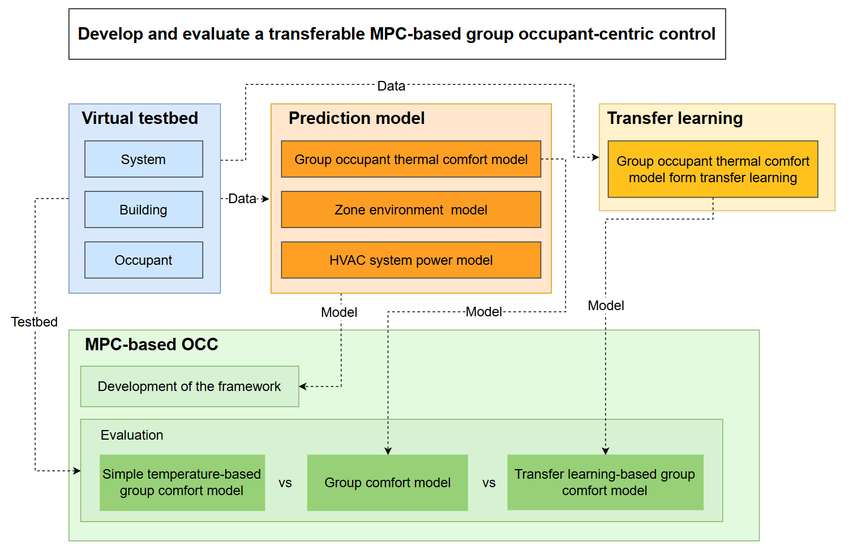

Figure ‑ The overall framework of the study

To address the above research gaps, the overall objective of this study is therefore aimed at developing and evaluating Transferable MPC-based Group Occupant-Centric Control, abbreviated as TMPC-GOCC. Figure 1‑3 shows the overall framework of this study. In order to achieve the overall objective, the following sub-objectives are proposed:

* Develop a virtual testbed including HVAC system, building zone, and occupants that reflect real world conditions. Given that the objective of this study is to develop and evaluate the TMPC-GOCC strategy, the virtual testbed was intentionally designed to avoid unnecessary complexity in HVAC systems, building zones, and occupants. Based on the literature review, the following components were selected in the proposed virtual testbed:
  + An Air-Source Heat Pump (ASHP) system, modeled using a second-order polynomial regression approach [110], was chosen to represent the HVAC system due to its broad applicability and simplicity.
  + A single thermal zone from the small office in the U.S. Department of Energy (DoE) Prototype Building Models [111] was selected to serve as the building model, ensuring relevance to common commercial applications.
  + An agent-based occupant model was incorporated to simulate realistic occupant thermal comfort dynamics [40].
* Train prediction models which will be used in subsequent MPC strategies. The prediction models include a group thermal comfort model, an indoor environment model, and an HVAC system power consumption model.
* Develop a transfer learning framework applicable to the group thermal comfort model to address the insufficient data issue in comfort model training.
* Develop an MPC-based OCC framework. The control performance of three different MPCs (i.e., the MPC with a simple temperature-based group comfort model, the MPC with a group comfort model, and the MPC with a transfer learning-based group comfort model) will be evaluated in the developed virtual testbed.

## Research Tasks

The research objective discussed in the last section can be broken down into three major tasks:

1. Develop a virtual testbed that includes ASHP system, a single zone in small office, and occupants.

Subtask 1.1. Develop simulation models for the proposed HVAC systems, i.e., an ASHP system.

Subtask 1.2. Adapt existing DOE prototype building model in EnergyPlus for the proposed building zones simulation, i.e. a single zone in small office.

Subtask 1.3. Adapt an existing occupant thermal comfort simulation model for proposed occupants’ thermal comfort simulation, i.e., an agent-based occupant model developed in the literature [40].

Subtask 1.4. Integrate component models to form the virtual testbed. Use the virtual testbed to generate the data required in the following section.

Task 2. Develop prediction models needed in the proposed TMPC-GOCC.

Subtask 2.1. Develop and evaluate the group occupant thermal comfort prediction model.

Subtask 2.2. Develop and evaluate prediction models for zone environment and HVAC system power.

Task 3. Develop transfer learning method used for group occupant thermal comfort model.

Subtask 3.1. Develop the framework of transfer learning used for the group occupant thermal comfort model.

Subtask 3.2. Design scenarios for evaluating developed transfer learning used for the group occupant thermal comfort model.

Subtask 3.3. Evaluate the effectiveness of the transfer learning framework in different scenarios.

Task 4. Develop and evaluate the proposed TMPC-GOCC.

Subtask 4.1. Develop the proposed three MPCs, i.e., the MPC with a simple temperature-based group comfort model, the MPC with a general group comfort model, and the MPC with a transfer learning-based group comfort model.

Subtask 4.2. Design cases that can be used to evaluate the performance of the proposed TMPC-GOCC strategy.

Subtask 4.3. Compare the proposed TMPC-GOCC strategy to the other two MPC-based OCC strategies using the virtual testbed. Evaluate their performances under different scenarios.

## Outline of Contents

This report is organized as follows: Chapter 2 discusses virtual testbed development. In Chapter 3, the development of the prediction models needed for the TMPC-GOCC is discussed. Chapter 4 presents the transfer learning used in the group occupant thermal comfort model. Chapter 5 evaluates the developed TMPC-GOCC strategy and compares its performance to the other two MPC-based OCC strategies. Finally, Chapter 6 summarizes the overall achievement of the dissertation.

# Virtual Testbed Development

## Introduction

Based on the literature review in the previous chapter, there is no publicly available testbed that can be used to develop and evaluate the proposed TMPC-GOCC. For this reason, the focus of this chapter is on the development of a virtual testbed, which represents a large open office with external exposures served by an air source heat pump, for this research. The virtual testbed serves as a data generation platform and a debugging environment for developing the proposed TMPC-GOCC strategy in subsequent chapters. The remainder of this chapter first introduces the overall framework of the testbed (Section 2.3) and then sequentially describes the three components of the test bed: the HVAC system model (Section 2.4), the zone model (Section 2.5), and the occupant thermal comfort model (Section 2.6). Lastly, there is a discussion about how to generate data from the testbed (Section 2.7) for predictive model development, transfer learning of group thermal comfort model, and MPC evaluation.

## Terminology

Before a detailed discussion of the proposed virtual testbed, predictive model training, transfer learning method, and other work, the following terms are defined firstly.

In this document:

* Calibration refers to using real-world measurement data to adjust the parameters of a model to achieve consistency between the output of real-world equipment and the model. It is primarily used when developing the HVAC simulation model in the virtual testbed.
* Training refers to using data and machine learning algorithms to develop predictive models so that they can be used to predict the future state of a target. It is mainly used in Chapters 3 (predictive model development) and 4 (transfer learning used in group thermal comfort model) for predictive model development .
* Validation refers to evaluating a calibrated model or trained model when using it to predict situations that are different from those in the calibrating or training data, assessing the generalization ability of the model. The validation process can help in model selection and hyperparameter tuning.
* Testing refers to using an independent dataset to evaluate the model’s performance. This test dataset should be completely unused during the training phase to ensure a fair assessment of the model's ability to handle new data. It is used to evaluate the control performance or to further validate the predictive model error after all the development work is done. Although both validation and testing are used to evaluate the predictive performance of a model, the stages being used are different. A simple way to understand the difference between test and validation datasets is that the validation dataset is used when the model has just been trained, while the test dataset is used after the model development and testing of the proposed control strategy.

## Virtual Testbed Framework

This section describes the framework of the virtual testbed used for this study. The framework is designed to integrate multiple component models to simulate real-world building operations, including HVAC systems, zone loads, and occupant comfort and behavior. Integration of the framework is achieved through co-simulation between various software environments, including MATLAB & Simulink [112] and EnergyPlus [113]. The component models are co-simulated in the Simulink environment. Data storage and exchange are implemented through MongoDB [114]. Figure 2‑1 provides an overview of the framework. The HVAC system component model needs to be calibrated from real system data, which will be discussed in details in Section 2.4. The zone and occupant comfort models are adapted from existing validated models, which will be discussed in Sections 2.5 and 2.6, respectively. The supervisory control block in Figure 2‑1 mainly refers to the control strategy used in the proposed TMPC-GOCC and is discussed in Chapter 5. This virtual testbed is designed to simulate real-world building operations and provide data and platform support for subsequent work such as developing the needed predictive models and evaluating the proposed control strategies.

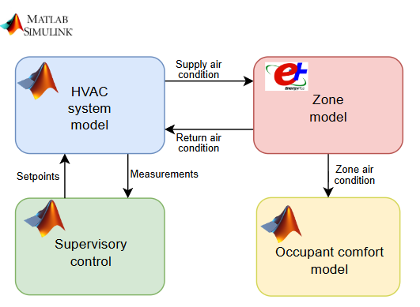

Figure ‑ The framework of virtual testbed

The HVAC system model simulates the operation of a real HVAC system based on boundary conditions (e.g., room return air temperatures) and control signals (e.g., room temperature setpoints) and, importantly, simulates its power and the air supply conditions to the rooms. The simulated HVAC system is an air source heat pump (ASHP) system reflecting the one at the National Institute of Standards and Technology (NIST) [110]. MATLAB is used to model the ASHP, which will be described in details in Section 2.4.

Zone models simulate the heating/cooling loads and zone environments of the building zone. The typical small office model from the Prototype Building Models developed by the Pacific Northwest National Laboratory (PNNL) [111] in EnergyPlus environment is used in this study. For co-simulation in MATLAB & Simulink environment, the EnergyPlus model is exported as a functional simulation unit (FMU) using the EnergyPlusToFMU software package developed by Lawrence Berkeley National Laboratory [115]. This FMU can be used to simulate the zone environment by inputting the zone air supply conditions. Relevant environmental variables (e.g. zone temperature and humidity, etc.) can thus be exported from the FMU. The details of the zone model will be described in detail in Section 2.5.

The thermal comfort of the occupants is the focus of this study. An agent-based occupant comfort and behavior model developed by Langevin et al [116] has been adapted for this framework. The model was validated through a one-year longitudinal survey conducted in a medium-size office building [40]. Given that the primary focus of this study is on occupant thermal comfort, the simulation of occupant behavior in the original occupant comfort and behavior model was excluded. Therefore, the updated model is just called the occupant comfort model. Based on the zone environment simulated from the zone model, the occupant comfort model simulates each occupant's thermal comfort. The details of the occupant comfort model will be described in detail in Section 2.6.

Supervisory control is designed to simulate how a supervisory control strategy generates setpoints to optimize building operations. During the generation of training and validation data, the supervisory control operates based on a predefined schedule to generate the setpoints, which is primarily discussed in Chapters 3 and 4. In contrast, during the evaluation of the proposed TMPC-GOCC strategy, the supervisory control generates the setpoints through MPC optimization, which is discussed in Chapter 5.

## HVAC System Model

Data collected from an ASHP system located at NIST from a previous study [117-119] were used to develop the HVAC model to represent a real system. This ASHP is a two-stage heat pump system. The ASHP and the zone that it serves are connected in a closed air loop. In the proposed virtual testbed, the ASHP is modeled using second-order polynomial regression method since its power and capacity are closely related to its environment. The model is implemented in MATLAB.

### ASHP System Description

The following is a general description of the ASHP system based on the literature [118, 120, 121]. The ASHP testing facility is equipped with two environmental chambers that emulate indoor and outdoor air conditions. The ASHP equipment comprises the indoor fan-coil section, outdoor section with a two-speed scroll compressor, thermostatic expansion valves, and connecting ducts. Figure 2‑2 shows the schematic of the ASHP, and Figure 2‑3 shows the picture of the ASHP duct in the indoor chamber.

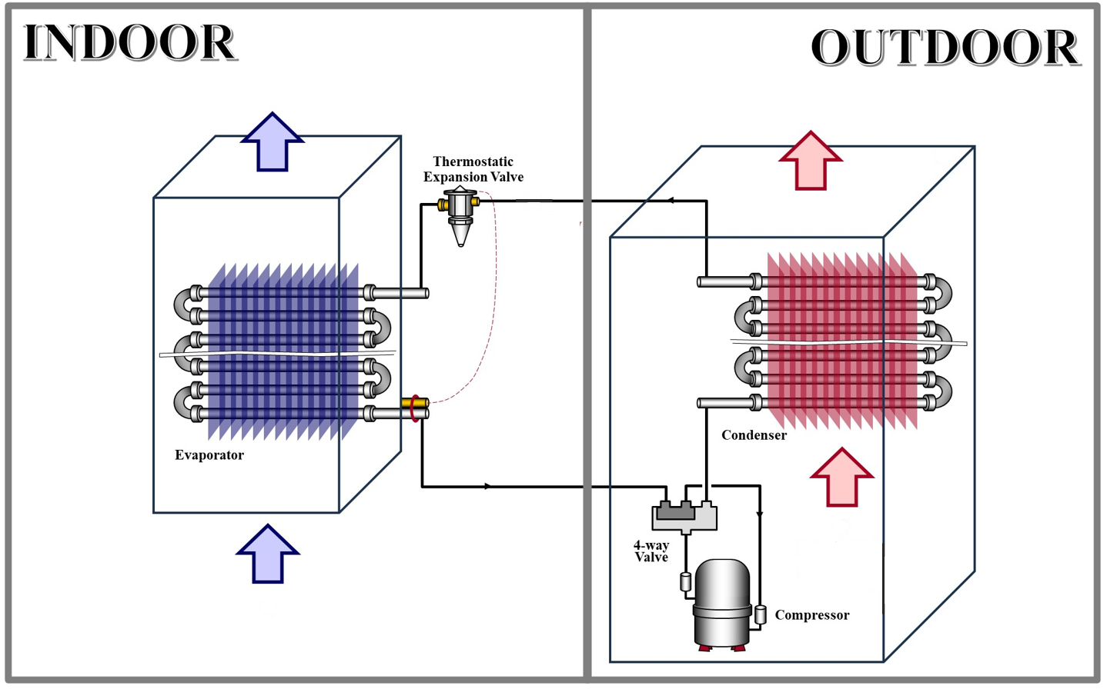

Figure ‑ The schematic of ASHP [110]

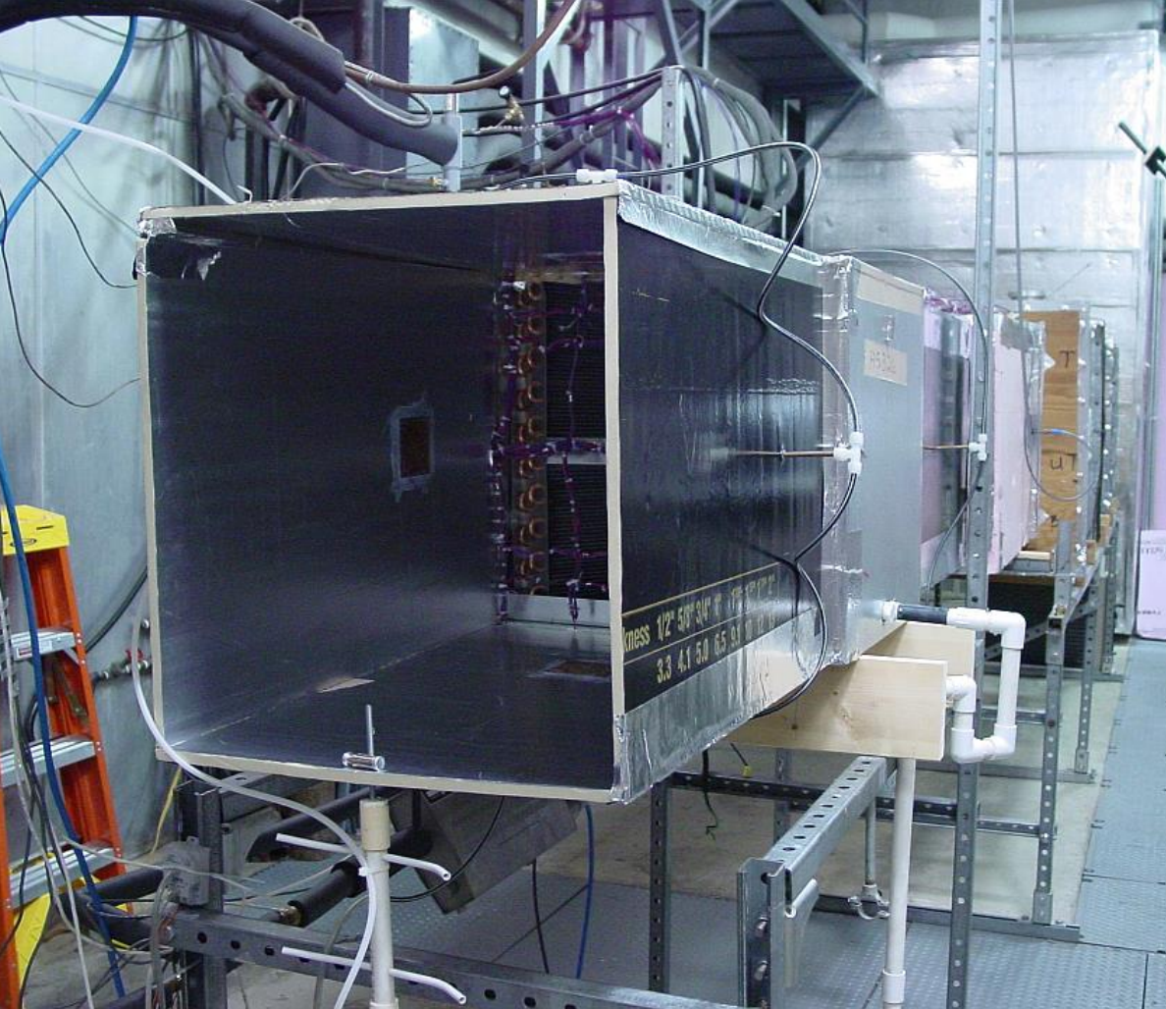

Figure ‑ The ducts of ASHP in NIST [120]

The ASHP has been widely utilized in various experimental studies related to heat pump technologies, including investigations about building demand flexibility [119, 122], fault detection diagnostics [110, 123], and the development of net-zero energy buildings [124]. Its broad application demonstrates its practicality and relevance for evaluating system performance, energy efficiency, and control strategies in real-world and simulated environments. Notably, research [122] recorded detailed performance data of the ASHP under a range of operating conditions in controlled experimental settings. These data will serve as calibration data described in Section 2.4.2. Additionally, research [119] used a hardware-in-the-loop (HIL) method to generate a comprehensive dataset to evaluate the load flexibility performance of the ASHP. This dataset includes performance data under various grid scenarios, climate conditions, and control strategies, capturing system response and energy consumption patterns. This dataset will be used as validation data in Section 2.4.3.

### Calibration Methodology

In this study, the ASHP was modeled using a second-order polynomial regression approach following the methods mentioned in the previous study [122]. The performance curves of the proposed virtual ASHP model can be described using Equation (1), where $x_{1}$, $x_{2}$, and $x_{3}$ represent zone air temperature $T_{z}$, zone air dewpoint temperature $T_{z,dp}$, and outdoor air temperature $T_{o}$ with unit F, respectively. The value of $y$ representing sensible heat capacity $Q_{s}$ with unit Btu/hr, total heat capacity $Q_{tot}$ with unit Btu/hr, and electric power $P$ with unit W, is calculated using the parameters $a_{0}$ to $a_{9}$. These parameters in Equation (1) was calibrated using empirical data from a series of controlled experiments at the NIST [110]. After using second-order polynomial regression approach, the calibrated parameters $a_{0}$ to $a_{9}$ are shown in Table 2‑1. Note that the performance curve only applies to the cooling mode of the ASHP.

$y=a_{0}+a_{1}x_{1}+a_{2}x_{2}+a_{3}x_{3}+a_{4}x_{1}x_{2}+a_{5}x_{1}x_{3}+a_{6}x_{2}x_{3}+a_{7}x_{1}^{2}+a_{8}x_{2}^{2}+a_{9}x_{3}^{2}$ (1)

Table ‑ Two-Stage Air-Source Heat Pump Fitted Parameters

|  |  |  |  |  |  |  |  |  |  |  |
| --- | --- | --- | --- | --- | --- | --- | --- | --- | --- | --- |
| $$y$$ | $$a_{0}$$ | $$a_{1}$$ | $$a_{2}$$ | $$a_{3}$$ | $$a_{4}$$ | $$a_{5}$$ | $$a_{6}$$ | $$a_{7}$$ | $$a_{8}$$ | $$a_{9}$$ |
| Low-Speed: | | | | | | | | | | |
| $$Q_{s}$$ | 1069.55 | 1234.58 | -1193.61 | -7.66 | -34.78 | 6.78 | -10.60 | 3.40 | 39.70 | 0.15 |
| $$Q_{tot}$$ | 44509.68 | 791.19 | -2542.84 | 285.47 | -45.54 | 7.95 | -10.42 | 7.57 | 64.31 | -2.35 |
| $$P$$ | 1234.02 | 32.71 | -45.62 | -6.45 | -5.43 | 0.62 | -1.04 | 1.47 | 4.75 | 0.24 |
| High-Speed: | | | | | | | | | | |
| $$Q_{s}$$ | -35523.54 | 931.84 | 1144.06 | -232.62 | 74.31 | -6.13 | 11.10 | -26.35 | -72.88 | -0.19 |
| $$Q_{tot}$$ | -48801.79 | -287.40 | 3184.57 | -100.17 | 48.24 | -4.47 | 4.13 | -12.05 | -61.72 | 0.19 |
| $$P$$ | 3794.47 | -173.31 | 210.13 | -40.11 | -2.09 | 0.22 | -0.33 | 1.85 | -0.28 | 0.39 |

At each timestep, given zone air temperature $T_{z}$, zone air humidity ratio $ω_{z}$, outdoor air temperature $T_{o}$, and operating mode (off/low-speed/high-speed), this model first calculates the sensible heat capacity $Q_{s}$, total heat capacity $Q_{tot}$, and the electric power $P$ of the heat pump by using the calibrated curves, then calculates supply air temperature $T_{s}$ and humidity ratio $ω_{s}$ for the next timestep by solving Equations (2) and (3) simultaneously. In these equations, $c_{pa}=$ 1.006 kJ/kg°C (0.24 Btu/lb°F) is the specific heat of the air, $c_{pw}=$ 1.86 kJ/kg°C (0.44 Btu/lb°F) is the specific heat of water vapor, $h_{we}=$ 2501 kJ/kg (1075 Btu/lb) is the heat of evaporation, $T_{z}$ and $ω_{z}$ are the zone return air temperature and humidity ratio provided by the zone model, and $m_{s}$ is the supply air mass flow rate, which is equal to 0.39 kg/s (52.41 lb/min) at low-speed and 0.62 kg/s (82.01 lb/min) at high-speed.

$Q_{tot}=m_{s}\left[c_{pc}\left(T_{z}-T_{s}\right)+c_{pw}\left(T_{z}ω_{z}-T_{s}ω_{s}\right)+h_{we}\left(ω_{z}-ω_{s}\right)\right]$ (2)

$Q_{s}=m_{s}\left[c_{pc}\left(T_{z}-T_{s}\right)+c_{pw}ω_{s}\left(T_{z}-T_{s}\right)\right]$ (3)

### Validation Results

The calibrated ASHP MATLAB model was validated under different thermal load cases. Three datasets representing low, medium, and high thermal load cases were selected from the flexibility load study [119] to validate the model. By inputting boundary conditions (including zone air temperature, humidity, and outdoor air temperature) and control signals (off, low-speed, or high-speed mode), the ASHP MATLAB model simulates the corresponding supply air conditions, including supply air flow rate, temperature, and humidity, as well as the ASHP's power. Comparing the actual measured values with the simulated results completes the examination. As an example, the Figure 2‑4 shows the results of the validation under the medium thermal load case. Table 2‑2 summarizes the RMSE values under all validation cases. Based on the common error criteria [125, 126], which is 50 CFM (0.03kg/s), 1 °F (0.56 °C), and 0.45×10-3 kgwater/kgair as the RMSE criteria for zonal supply air and 5% of the equipment average power as the RMSE criterion for the equipment power, all the validation results satisfy the requirements.

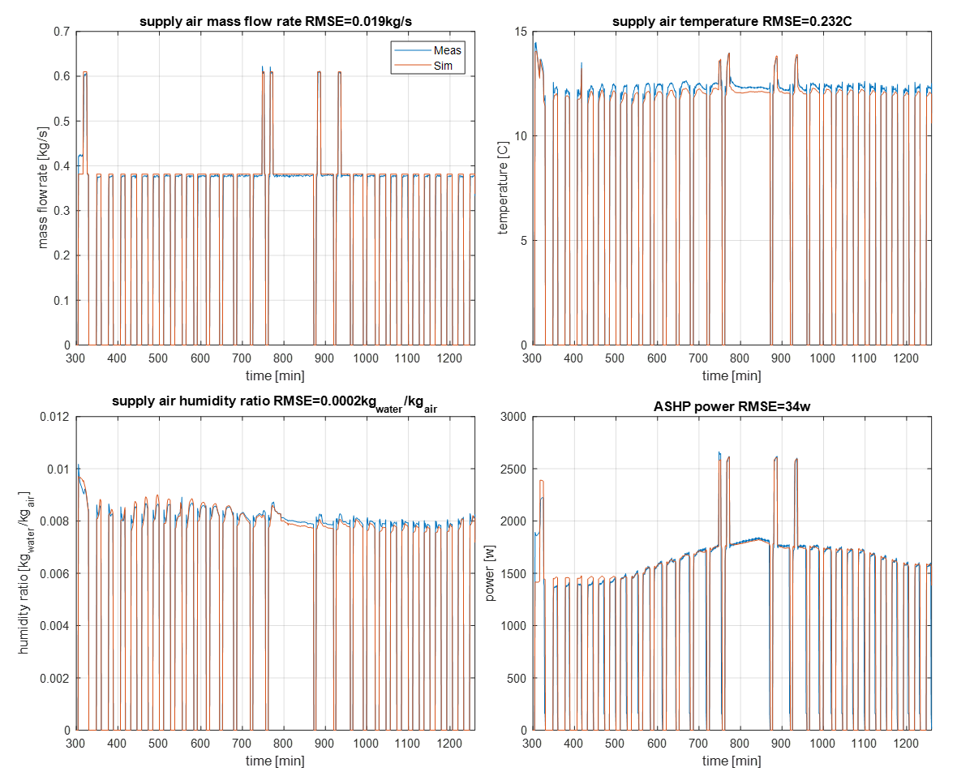

Figure ‑ ASHP MATLAB model validation results in a medium thermal load scenario

Table ‑ Summary of the validation error (RMSE) in ASHP system model

|  |  |  |  |  |
| --- | --- | --- | --- | --- |
| Validation case | Variables | | | |
| m_sup [kg/s] | T_sup [°C] | w_sup [kgwater/kgdry-air] | Power [W] |
| Low thermal load | 0.018 | 0.30 | 3.5×10-4 | 36 |
| Medium thermal load | 0.019 | 0.23 | 2.3×10-4 | 34 |
| High thermal load | 0.024 | 0.29 | 3.3×10-4 | 41 |

### ASHP Speed Controller Development

The modeled ASHP is a two-stage heat pump system. The stage mode is controlled based on the zone return air temperature and the zone cooling setpoint. The control logic of stage mode is described in the references [127]. Specially, when the return air temperature is 0.28 °C (0.5 °F) higher than the cooling setpoint, the heat pump operates in low-speed mode until the temperature drops below the cooling setpoint. And when the return air temperature exceeds the cooling setpoint by 0.56 °C (1 °F), the heat pump operates in high-speed mode until the temperature is less than 0.28 °C (0.5 °F) above the cooling setpoint and then it switches back to low-speed mode. Figure 2‑5 shows a schematic of the zone temperature (Tz) and cooling setpoint (TC) control of the ASHP speed in the cooling mode. The ASHP speed controller is integrated in the ASHP system model also in the format of MATLAB code.

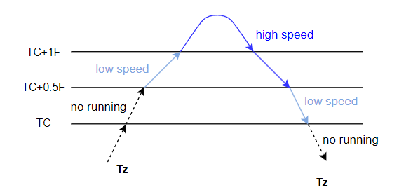

Figure ‑ Schematic diagram of the ASHP speed control in the cooling mode

In conclusion, Section 2.4 demonstrates the development process of the ASHP MATLAB model as well as the validation results. For the ASHP MATLAB model, the inputs are the zone air temperature measurement and the cooling temperature setpoint; the outputs are the zone supply air condition and the system power. The results show that the model can accurately simulate the dynamic behavior of a real ASHP system under different operating conditions.

## Zone Model

For zone load and indoor environment simulation, a typical small office EnergyPlus model from the Commercial Prototype Building Model [111] is used in this study. In the small office, Perimeter_Zn_1 (113.5 m2), a south-facing area, is selected as the simulated zone shown in Figure 2‑6. The other zones are served by an ideal load air system but are not utilized in this study. Based on our previous analysis, the temperature capacity multiplier in the prototype EnergyPlus model was modified to 8, in order to accurately reflect the air temperature dynamics with typical thermal mass under a thermostat setpoint reset strategy [128, 129].

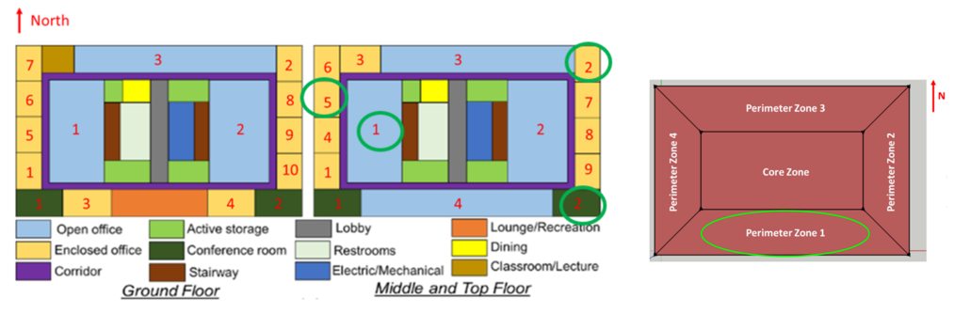

Figure ‑ Prototype Building Models –Small Office [111]

As mentioned above, the EnergyPlus model was exported as a functional simulation unit (FMU) to satisfy the co-simulation needs, using the EnergyPlusToFMU software package [115]. Specifically, important simulation outputs, such as zone air temperature, humidity, and mean radiant temperature, are exported from EnergyPlus using the *External Interface: Functional Mockup Unit Export: From: Variable* object, which is shown in the subfigure a) in Figure 2‑7. For inputs, *External Interface: Functional Mockup Unit Export: To: Schedule* object is used to input control signals (i.e., schedule) for thermostat schedules of the non-simulated zones within EnergyPlus, which is shown in the subfigure b) in Figure 2‑7. For an HVAC system that is modeled outside of the EnergyPlus environment, which is the case in this study, the *Ideal Loads Air System* and the *External Interface: Functional Mockup Unit Export: To: Actuator* objects (referred to as Actuator Object hereafter) of EnergyPlus is employed. Specifically, the Actuator Object enables overriding the discharge air conditions, such as air mass flow rate, air temperature, and air humidity ratio of the ideal loads air system, which is shown in the subfigure c) in Figure 2‑7. In general, the zone model simulates the zone air conditions based on the supply air conditions output from the ASHP model in MATLAB. The zone air conditions are passed to the ASHP model and the occupant comfort model for further co-simulation.

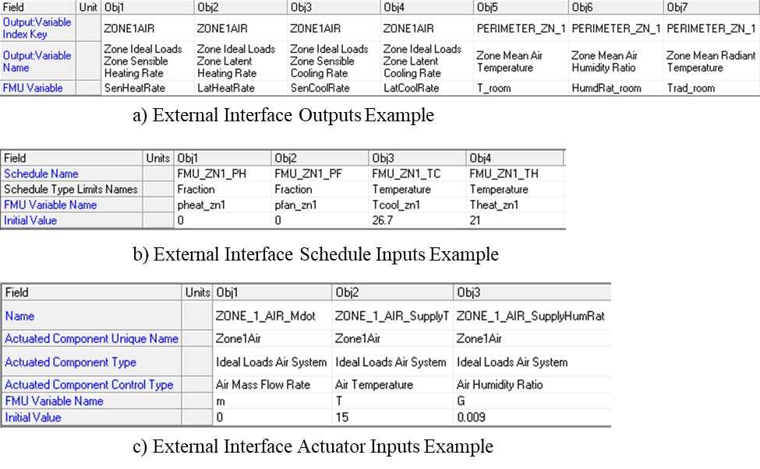

Figure ‑ Example of EnergyPlus FMU settings

Details about other parameter settings in the EnergyPlus zone model, such as location, weather, simulation time, etc., are provided in the relevant section of Chapters 4.

## Occupant Comfort Model

Occupant comfort model is used to simulate the thermal comfort and behavior of occupants in the simulated zone. The occupant comfort model used in this study is an adaptation of the original occupant comfort and behavior model developed by Langevin et al [40]. The original occupant comfort and behavior model has been verified using data collected from a year-long field study conducted in a medium-sized office building [116]. Specifically, the adaptation made to the original model involves retaining only the function related to the simulation of occupant thermal comfort. The function responsible for simulating occupant behavior has been excluded, given that occupant behavior is not the focus of this research. This simplification enables a more interpretable and efficient analysis of group thermal comfort within the context of HVAC control and optimization. The remainder of this section is an introduction to occupant comfort model based on the literature by Langevin J [40].

The zone model mentioned above was occupied by several simulated occupants whose characteristics were generated randomly prior to test and remained consistent during the simulation. For this study, the key characteristic is the occupant's thermal acceptability range, which is a range between -3 (cold) and 3 (hot). The occupant’s thermal acceptability range is sampled from the RP-884 HVAC building PMV-PPD curves shown in Figure 2‑8. The PMV-PPD curves reflect the proportion of occupants feeling dissatisfied with different thermal sensations. The specific thermal acceptability range of the virtual occupant in occupant comfort model will be based on the different evaluation cases in Chapter 4.

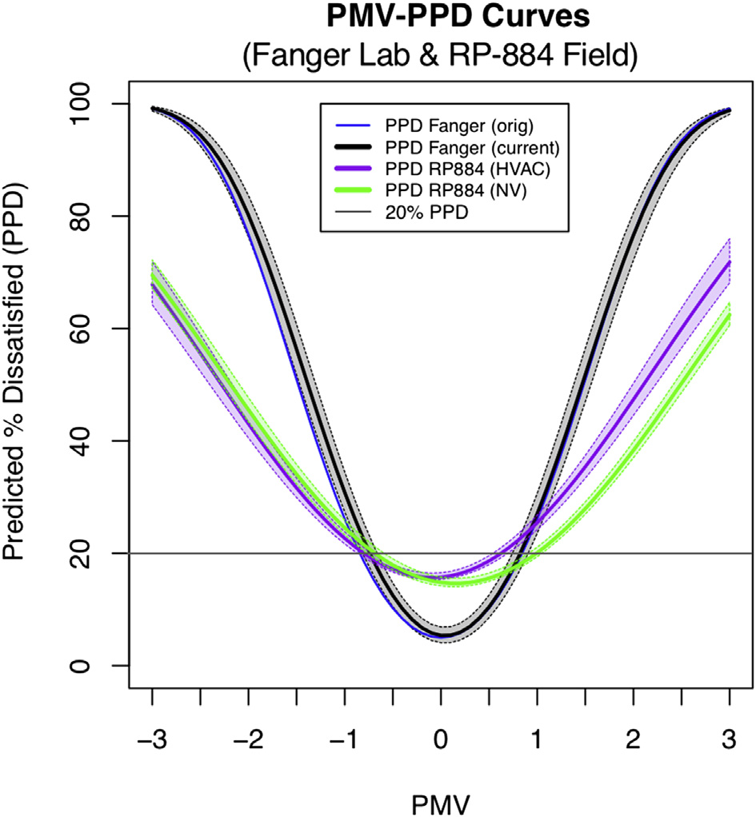

Figure ‑ PMV-PPD curves for Fanger, RP-884 HVAC and RP-884 NV building [116]

During a simulation, the occupant comfort model firstly uses the Predicted Mean Vote (PMV) equation to calculate the thermal sensations experienced by an occupant. The computed PMV value ranges also from -3 (cold) to 3 (hot), which corresponds to the seven ASHRAE sensations (ASH) [130]. Following this, the occupant comfort model assesses occupant comfort by comparing the occupant's thermal sensation with his or her thermal acceptability range. The probability that an occupant feels uncomfortable is equal to the likelihood that his or her ASH vote is outside of his or her thermally acceptable range. Figure 2‑9 shows the distribution of thermal sensation votes by PMV, which represents the probability of different voting at a given PMV value.

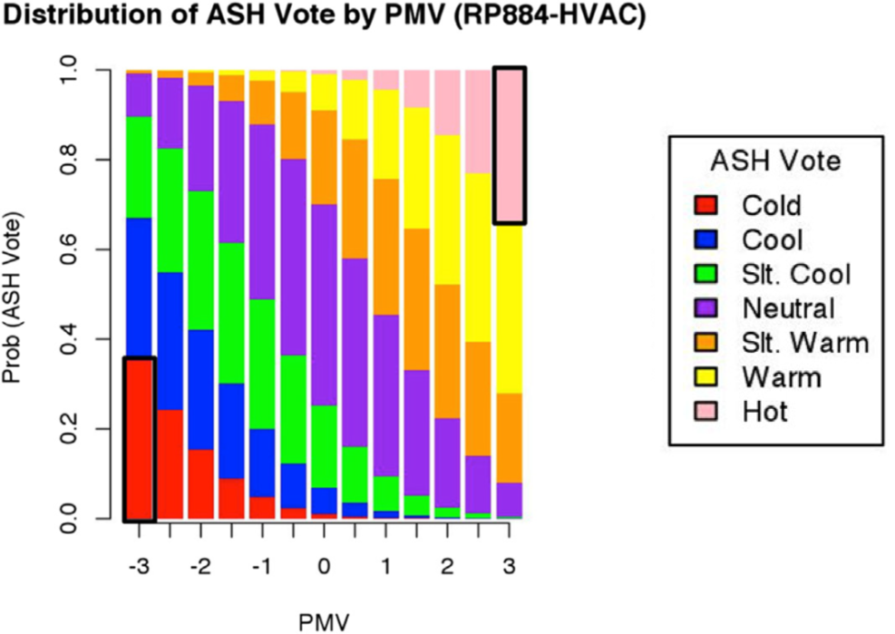

Figure ‑ ASH vote distribution by PMV for RP-884 HVAC buildings [116]

In summary, the occupant comfort model first calculates the PMV based on the given thermal environmental condition. It then uses Figure 2‑8 to determine the probability of each ASH vote corresponding to the calculated PMV. The probability that occupants being thermally comfortable or uncomfortable is then obtained based on their own thermal acceptability range. Finally, the occupant’s thermal comfort feedback is generated through a stochastic simulation process.

## Data Generation from the Virtual Testbeds

The developed virtual testbed is used to generate three categories of datasets.

* The first category consists of datasets designed for the development of predictive models for zone environment and HVAC system power consumption, which further includes three subcategories, namely,
  + Zone temperature predictive model development dataset
  + Zone relative humidity predictive model development dataset
  + HVAC system power predictive model development dataset
* The second category comprises the datasets used for transfer learning related to the group thermal comfort model, which further includes two subcategories, namely,
  + Source domain dataset in transfer learning
  + The different target domain datasets in transfer learning
* The third category is the dataset that is used to evaluate the performance of the proposed TMPC-GOOC after completing the above tasks.

For each dataset, the data contained therein and the corresponding virtual testbed simulation settings will be described in detail in the relevant subsequent chapters. Similarly, the training data, validation data, or test data included in each dataset will be discussed in the corresponding sections.

## Chapter Conclusions

This chapter presents the virtual testbed employed in this study, which simulates a single zone in small office with virtual occupants served by ASHP. The development process of each component in the virtual testbed and the interactions between the components are detailed in this chapter. This chapter also overviews the datasets generated using the proposed virtual testbed, which support the development of predictive models discussed in Chapter 3 and the transfer learning introduced in Chapter 4. Furthermore, the testbed provides a practical platform for implementing and evaluating the TMPC-GOCC approach explored in Chapter 5.

The work in this chapter corresponds to Task 1 mentioned in Section 1.4, i.e., the development of virtual testbeds containing the HVAC system, building, and the occupants components.

# Predictive Model Development

## Introduction

The objective of this study is to develop an MPC-based OCC strategy where the necessary are the predictive models in MPC. This chapter describes the development of three predictive models used in the proposed MPC: the group occupant thermal comfort model, the zone environment model, and the HVAC system power model. The model structure and development methodology for group thermal comfort prediction models are discussed in Section 3.2. Section 3.3 and 3.4 provide a detailed description of training and validation of the zone environment predictive model and the HVAC system power predictive model, respectively.

## Group Thermal Comfort Model

Occupant comfort holds a significant role within occupant-centered MPC. Individual occupant thermal comfort model, based on input variables such as temperature, humidity, airflow, and individual preferences, to forecast occupant comfort has been well studied in the literature. As identified in the literature review in Chapter 1, comfort conflicts, when a group of occupants exist, currently pose challenges in the control of zone environments. To address this issue, a concept termed "group thermal comfort" is introduced in this section. The following sections will focus on the definition and modeling of group thermal comfort.

### Definition of Group Thermal Comfort

As mentioned in Section 1.2.3, the group decision-making problem of group thermal comfort can be analyzed from two perspectives: inclusive or exclusive, and homogeneous or heterogeneous. To ensure fair consideration of each individual’s comfort in a group, this paper proposes an index to evaluate the group thermal comfort by using the inclusive and homogeneous method.

A inclusive and homogeneous method means that stakeholders with different perspectives are involved in the decision-making process and each member in the group is equally important. This method aims to ensure that the voices of all interested parties are heard. The equal-weight method is often used to assess the thermal comfort of the group so that individuals' opinions can be reflected in group decisions. Under this definition, the group thermal comfort refers to the number of the occupants within the group who feel comfortable, as shown in Equation (4).

$GroupComf=\#{Occ}_{comfortable}$ (4)

Depending on the needs of specific occupants and their groups, the calculation of the group thermal comfort indicator can be adaptable. For example, when considering the needs of vulnerable groups , their influence within the group can be weighed higher. In addition, it is noted that the definition above is not normalized. In other words, the group thermal comfort indices calculated using this definition from groups with different number of occupants are not comparable.

### Methodology of Group Thermal Comfort Model Development

This section introduces the methodology of developing the group thermal comfort prediction model, aiming to verify its feasibility. As an example, the section will use a publicly available dataset on occupants and indoor environments to illustrate the methods and processes for training and validating a group thermal comfort model. The methodology presented here also serves as a foundation for applying transfer learning to group thermal comfort models, as discussed in Chapter 4.

#### Model Training Data

Raw Data Preparation

The raw dataset is obtained from a hardware-in-the-loop load flexibility study [119], in which the occupants and built environment were simulated but HVAC system measurements were from real-world equipment. The occupant thermal comfort was simulated using the occupant comfort model as introduced in Section 2.6. The study measures the holistic load flexibility performance of a suite of commonly used commercial building HVAC under a variety of testing conditions. The data includes simulated occupant thermal comfort votes under typical operating conditions and related building environment and real-world HVAC measurements, with a resolution of 1 minute. The occupied data for 20 summer days (assumed to be 4 weeks of weekdays) is selected from the raw dataset as the training data. Since this dataset is derived from a hardware-in-the-loop test, its measurements’ sampling rate is faster than most of those used in real buildings. To align the data with practical applications, the selected dataset is resampled at 15-minute intervals to generate the final training data.

Feature Selection

In the selected data, the raw features contain very detailed measurements such as system supply air mass flow rate and temperature, zone air temperature, humidity, wall temperature, radiant temperature, thermal comfort from the occupants, behavior, and so on, as summarized in Table 3‑1. The output of the occupant thermal comfort prediction model, i.e., the group thermal comfort, is calculated based on the definition and Equation (4) above. Commonly available measurements in a typical building as suggested in the literature are firstly manually selected in this study as the input features in the group thermal comfort model, i.e., outdoor temperature, zone temperature, and zone humidity. Also, according to the literature review, occupants' thermal comfort is not related to historical data. Therefore, the group thermal comfort prediction model will use the current measurements in predicting the current group thermal comfort.

Table ‑ Candidate feature

|  |  |
| --- | --- |
| Source | Candidate feature |
| HVAC system | Zone supply air temperature, zone supply air mass flow rate, zone supply air humidity ratio,  System power |
| Zone environment | Outdoor air temperature, outdoor air relative humidity, outdoor air dewpoint temperature, wall inside surface temperature, zone air temperature, zone air relative humidity, zone radiant temperature, zone air dewpoint temperature |
| Occupants | Occupant count, occupant thermal sensation, occupant thermal comfort, occupant behavior, occupant clothing level, occupant metabolic rate |

#### Model Candidate Structure and Evaluation Method

The goal of this section is to determine the most suitable model by comparing the performance of all the candidate models. This section is formed by candidate learning algorithms, performance index of evaluation, and cross-validation.

Candidate Learning Algorithms

When determining the model structure, the first consideration is the type of prediction model—classification or regression. Since the number of occupants must be an integer, it is inherently a discrete, non-continuous variable. Therefore, based on the definition of group thermal comfort shown on Equation (4), the prediction target is also a discrete variable. Given these characteristics, a classification model is chosen for training the group thermal comfort prediction model.

There are several learning algorithms reported that are applicable for occupant’s thermal comfort prediction in the above literature review. The four frequently used learning algorithms (i.e., Artificial Neural Networks, Support Vector Machines, Random Forest, and k-Nearest Neighbor) as the candidate learning algorithms in this study are introduced and their predicting performance are discussed in this section. The following introduction to the different algorithms is summarized from the study by Han M, et al [131].

* Artificial Neural Networks (ANN) is the most frequent among thermal comfort predictive models and is popular in many other fields as well. There are many different architectures available for ANN models, depending on the research situation. With various architectures, ANN can model any complex nonlinear problem. The idea behind ANN is that they are designed to mimic the human brain. They consist of multiple layers of neurons that use weights and biases to learn the representation of data. And there are 3 categories of layers in ANN: input, hidden, and output layers. The input and output layers are used to input and output the data. The hidden layer is the intermediate layer between the input and output and contains the neurons, often referred to as hidden units, and some activation functions.
* Support Vector Machines (SVM) is a common classifier based on converting the input space into a high-dimensional feature space by using a nonlinear transformation and finding decision boundaries. The hyperplane is defined by using a support vector, which is a line in the data space that the SVM uses to classify the data. The support vector is composed of a subset of the training data close to the hyperplane boundary. Then, the SVM uses the kernel method to map the input data to the above-mentioned high-dimensional space. In the high-dimensional space, the data are mapped into a matrix, which is then solved to form an estimator for predicting the target value.
* A Random Forest (RF) is composed of many decision trees, and different decision trees are not associated with each other. When classifying, new input samples enter and let each decision tree in the forest judge and classify them separately. Each decision tree will get a classification result of its own. The random forest takes the most accurate classification result of decision trees as the final classification result. Random forest is an extension of the bagging algorithm and can be used for almost any kind of prediction problem (including nonlinear problems).
* k-Nearest Neighbor (kNN) is one of the simplest machine learning algorithms that can be used for classification and regression, which is a supervised learning algorithm. The idea behind this is that if the majority of the K most similar (i.e., most neighboring) samples in the feature space belong to a certain class, then the sample also belongs to that class. In other words, the method decides the category based on the category of the nearest sample. In the feature space, the straight-line distance (also called the Euclidean distance) is often used to represent the distance between the samples.

The development of these four types of algorithms is beyond the scope of this study. The algorithm code used in this study is based on the MATLAB Deep Learning Toolbox and guidance documentation [132]. The settings for the model parameters, as shown in Table 3‑2, are consistent with the examples used in the MATLAB guidance.

Table ‑ The settings of machine learning algorithms in MATLAB for group thermal comfort model

|  |  |  |  |
| --- | --- | --- | --- |
| **Algorithms** | **MATLAB function** | **Key parameters** | **Reference** |
| ANN | trainNetwork | 20 hidden layers, 'logsig' and 'purelin' transfer functions, 'traingdx' BackPropagation training fucntion | [133] |
| SVM | fitcsvm | 'rbf' kernel function, 'BoxConstraint'=1 | [134] |
| RF | TreeBagger | NumTrees=50, on 'OOBPredictorImportance' | [135] |
| kNN | fitcknn | 5-nearest neighbor | [136] |

Performance Index of Evaluation

The performance of a classifier is typically evaluated using instance-based accuracy metrics derived from the confusion matrix, such as precision, recall, and overall accuracy [137]. These metrics assess the model’s ability to correctly classify individual instances (or samples). However, as described in the occupant comfort model in Section 2.6, occupant thermal comfort is determined through stochastic simulation based on the probabilistic distribution to capture the stochastic nature of thermal comfort. This implies that even under identical environmental conditions, occupants may have different thermal comfort votes. Therefore, when evaluating the proposed group thermal comfort prediction model, the primary focus should not be on instance-based accuracy but rather on ensuring that the predicted probability distribution closely aligns with the true distribution.

This study proposes a method to assess the similarity between two probability distributions for evaluating the accuracy of the group thermal comfort model. There are roughly two methods for comparing probability distributions, i.e., statistical test and similarity measures. Common methods of statistical test include T-test, Chi-Square test, etc., all of which can be used to determine whether there is a significant difference between two groups of data [138]. Considering that transfer learning will be used subsequently to improve the prediction performance of the model, this study focuses more on quantitatively analyzing the differences between the two sets of distributions, so it is necessary to use similarity measures. Among them, the commonly used metrics are Kullback-Leibler divergence (KLD) and Jensen-Shannon divergence (JSD) [139]. These two metrics have been used under several domains, such as biology[140-142], machine learning [143, 144], and even occupant behavioral modeling[145]. KLD is usually used to measure how one distribution diverges from the other, defined as the expectation of the logarithmic difference between the probabilities of the two distributions. The formula for KLD is shown in Equation (5), where $P$ and $Q$ are two probability distributions in the sample space $X$, and $p\left(x\right)$ and $q\left(x\right)$ are the probabilities of the element $x$ in the sample space $X$ in $P$ and $Q$. One of the deficiencies of KLD is asymmetric, which means that the divergence of $P$ from $Q$ is not the same as the divergence of $Q$ from $P$. Therefore, JSD has been proposed, which is derived from KLD, and adopted in this study. The formula of JSD calculation is shown in Equations (6)-(8), where $M$ is a new probability distribution based on the probability distributions $P$ and $Q$. JSD is a value ranging from 0 to log2, where the smaller the JSD is, the closer the two distributions are. In general, if JSD < 0.1, it can be considered that the two distributions are close to each other [143, 146].

$KLD（P||Q）=\sum_{x∈X}{p(x)log\frac{p\left(x\right)}{q\left(x\right)}}$ (5)

$M=\frac{1}{2}(P+Q)$ (6)

$JSD(P||Q)=\frac{1}{2}KLD(P||M)+\frac{1}{2}KLD(Q|\left|M\right)$ (7)

$JSD(P||Q)=\frac{1}{2}\sum_{x∈X}{p(x)log\frac{p\left(x\right)}{p\left(x\right)+q\left(x\right)}}+\sum_{x∈X}{q(x)log\frac{q\left(x\right)}{p\left(x\right)+q\left(x\right)}}+log2$ (8)

Again, according to the occupant comfort model mentioned in Section 2.6, the probability distributions of occupant comfort vary across different environmental conditions. Accordingly, when using the proposed group thermal comfort model, the output probability distributions also differ across various regions of the feature space. Therefore, when evaluating the similarity between two probability distributions across the entire feature space, it is necessary to assess their similarity comprehensively across different regions of the feature space. This requires using an index to collectively represent the similarity between the two probability distributions. To achieve this, this study proposes using the weighted average JSD ($\overline{JSD}$) to comprehensively evaluate the similarity between probability distributions. The specific steps are as follows:

1. Gird the entire feature space into multiple subspaces.
2. Compute the JSD for each subspace individually.
3. Compute the final weighted average JSD ($\overline{JSD}$), where the weights are determined by the number of instances in each subspace.

The calculation formula are shown on Equations (9) and (10), and a 2-D schematic diagram is shown on Figure 3‑1, where $JSD_{i}$ is the JSD in feature subspace $i$; $n$ is the number of feature subspaces; $w_{i}$ is the weight of the feature subspace $i$; $m_{i}$ is the number of instances in the feature subspace $i$; $m_{total}$ is the total number of instances.

$\overline{JSD}=\sum_{i=1}^{n}{w_{i}JSD_{i}}$ (9)

$w_{i}=\frac{m_{i}}{m_{total}}$ (10)

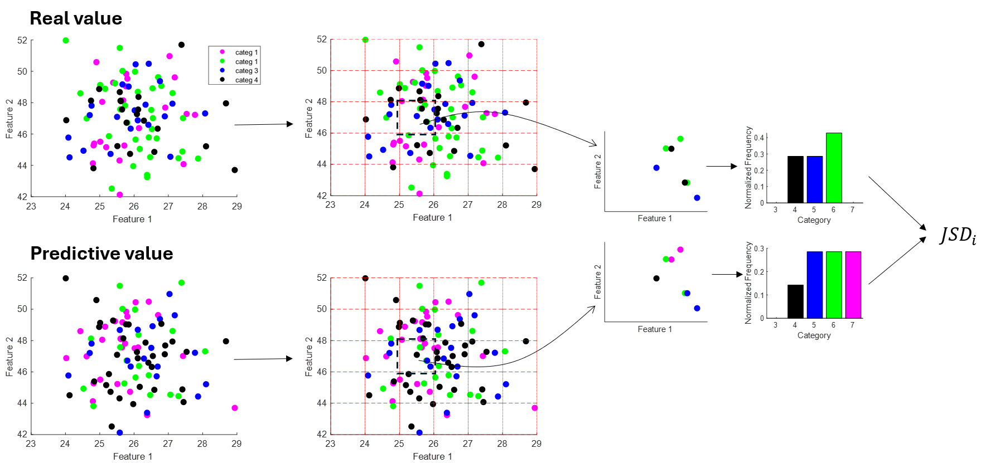

Figure ‑ Weighted average JSD calculation schematic diagram

This raises the question of how to grid the feature space, i.e., how to determine the size of each subspace. If the subspace is too small, the evaluation becomes analogous to assessing instance-based prediction accuracy rather than the similarity of probability distributions. Conversely, if the subspace is too large, it may overlook important variations across different regions of the feature space. To address this, this study determines the subspace size based on the smallest environmental change perceptible to humans. Within this range, individuals cannot detect variations in the environment, implying that the probability distribution of their thermal perception should remain unchanged. For the air temperature, there is literature indicating that the smallest perceptible temperature difference for humans is 0.92°C [147]. Therefore, when griding the feature space, a grid size of 0.5°C is used for both outdoor and indoor temperature dimensions in the subspace of the group thermal comfort model. This choice ensures computational convenience while maintaining a resolution that aligns with human thermal perception. Unlike temperature, there is no literature on the smallest perceptible difference in humidity, which is another crucial factor in the group thermal comfort model. To address this gap, a sensitivity analysis was conducted to examine the impact of varying relative humidity on the Percentage of People Dissatisfied (PPD) in a typical indoor environment. The analysis was based on the ISO 7730 code [148], and the results indicate that PPD increases by approximately 1% for every 5% rise in relative humidity. Hence, a 5% interval is selected as the grid size for the relative humidity dimension when griding the feature space.

Cross-validation

The above sections propose four candidate machine learning algorithms for training the group thermal comfort model and introduce the weighted average JSD as the performance index for model evaluation. To compare the model performance trained from the four algorithms, k-fold cross-validation is a typical statistical method used to estimate the performance of machine learning models. The idea of k-fold validation is that the existing datasets are divided into K sub-datasets. One sub-dataset is kept as the data for validating the model, and the other K-1 sub-datasets are used for training. The cross-validation is repeated K times, once for each sub-dataset. The average of K times errors is the final validation result [149]. In this study, 5-fold cross-validation is used to evaluate the algorithm performance, which is assessed by error. The equation and schema used are shown on Equation (11) and Figure 3‑2, respectively.

$Error=\frac{1}{5} \sum_{i=1}^{5}{{Error}_{i}}$ (11)

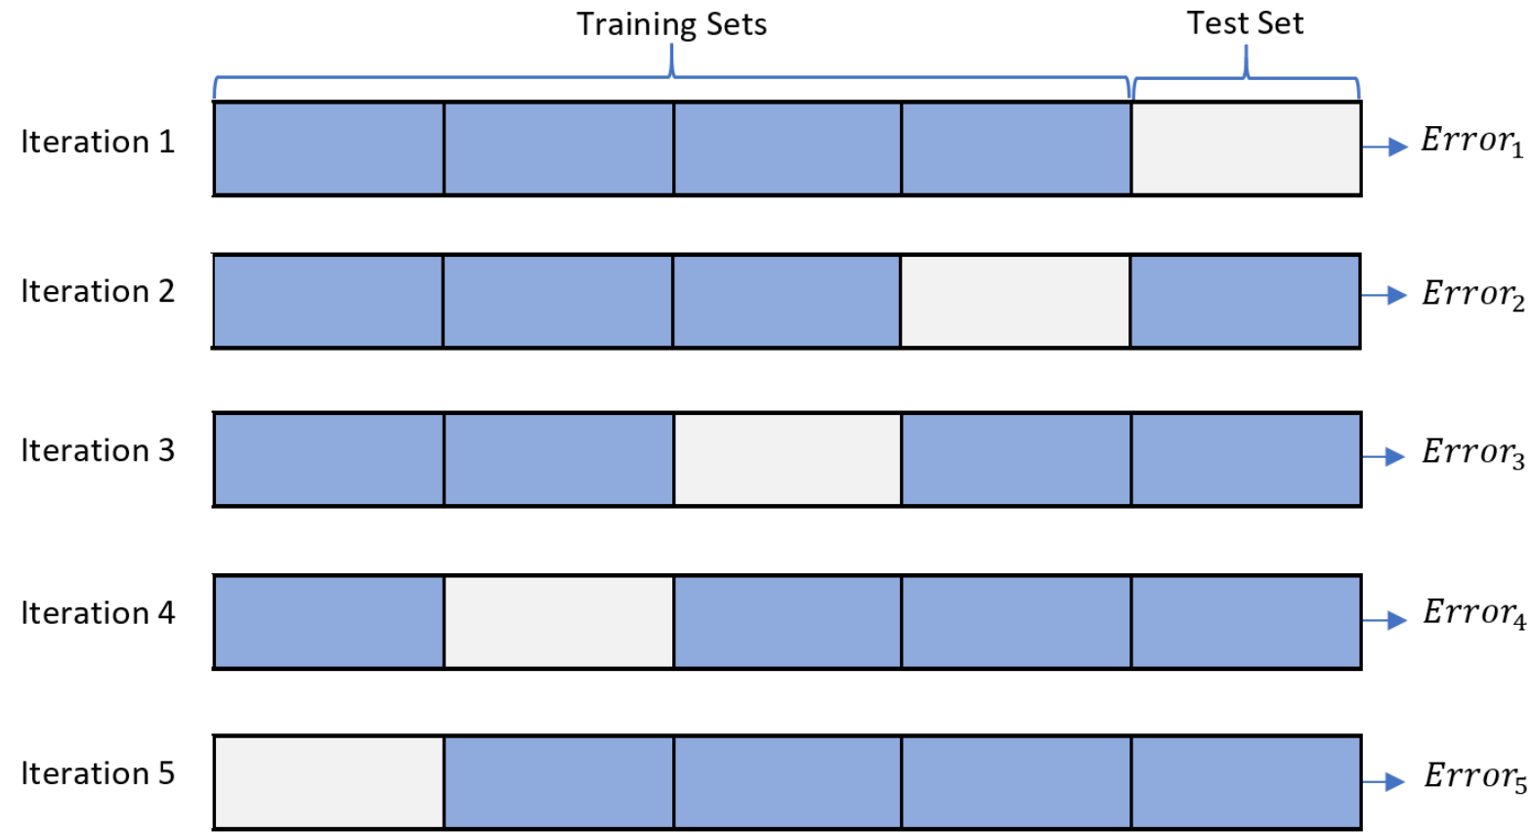

Figure ‑ 5-fold cross-validation schema

#### Model Structure Selection Results

After 5-fold cross-validation, the validation results for the ANN, SVM, RF, and kNN models are presented in the Table 3‑3. Among these, the RF model exhibits the lowest error, making it the preferred choice for training the proposed group thermal comfort model. Based on the results, the RF model will be consistently used as the training algorithm in Chapter 4, which explores the application of transfer learning in group thermal comfort models.

Table ‑ Cross-validation results

|  |  |
| --- | --- |
| **Candidate learning algorithms** | **Cross-validation error ($\overline{JSD}$)** |
| ANN | 0.314 |
| SVM | 0.247 |
| RF | 0.114 |
| kNN | 0.190 |

It is worth noting that some literature suggests that a JSD value below 0.1 can generally be used as a criterion for considering two probability distributions to be similar [143, 146]. However, this threshold may not be appropriate for evaluating the proposed group thermal comfort prediction model in this study. The predictive model will be integrated into subsequent MPC strategies to achieve the goal of reducing occupant discomfort or saving energy. The effectiveness of the predictive model will ultimately be judged by the resulting control performance. If the JSD of the group thermal comfort prediction model is relatively high but still leads to satisfying control performance, it indicates that a higher JSD is also acceptable, and the threshold should be relaxed accordingly. Conversely, if a lower JSD is necessary to achieve effective control, the criterion should be more stringent. The specific JSD threshold for the group thermal comfort prediction model will be further investigated in Chapter 5, which focuses on the development of MPC-based Group Occupant-Centric Control.

## Zone Environment and System Power Model

The HVAC system power model and the zone environment model are fundamental in the proposed MPC strategy. The inputs for both prediction models are measurements and control signals from the environment and the system. Combined with the group thermal comfort model mentioned in Section 3.2, a closed-loop prediction between the system, zone environment, and occupants can be accomplished, which will be used in the subsequent MPC development. More specifically, the zone environment model can be divided into an indoor air temperature prediction model and an indoor air relative humidity prediction model. Extensive research exists in the literature for HVAC system power modeling and zone environment modeling, which are hence not the focus of this study. Based on the literature review of Indoor Environment and Building Energy Forecasting Models mentioned in Section 1.2.2, this section describes the data preparation, model selection and model validation of the above three prediction models (i.e., indoor air temperature prediction model, indoor air relative humidity prediction model, and HVAC system power prediction model). The developed prediction models will be used in the development of MPC-based Group Occupant Centric Control in Chapter 5.

### Data preparation

Data Generation

As mentioned in Section 2.7, the developed virtual testbed will generate a series of datasets for training and validation of the HVAC system power and zone environment forecasting models. The simulation of the virtual testbed also required decisions regarding the HVAC system’s zone air temperature setpoint, the location and simulation period for the EnergyPlus zone model, and the characteristics of virtual occupants in the occupant comfort model. To generate the training data for the HVAC system power model and the zone environment model, the following is a detailed description of the virtual testbed settings, including zone model and HVAC system setpoints (occupant comfort model settings are omitted because occupants are not involved in zone environment or HVAC power modeling).

a) This study selected summer conditions in Atlanta as a representative case to demonstrate the effectiveness of the developed TMPC-GOCC strategy. Accordingly, the corresponding settings were made in the EnergyPlus zone model to reflect this scenario.

b) Although this study uses a virtual testbed, in order to mimic the real situation as much as possible, active learning technique is adopted to determine the zone air temperature setpoint for the HVAC system every hour [150]. This approach ensures efficient data collection to support the model development. A summer weekend (2 days) is selected to collect model training data using active learning to determine the zone air temperature setpoint.

The following is a brief introduction of active learning based on the literature by Zhang, L [150]. It is well known that the performance of machine learning models is highly dependent on the quality of the training data. Although the data required in this section is generated from a virtual testbed, to accurately mimic real-world conditions, it is essential to collect the data with minimal disruption to the building’s normal operations. Usually, regular operational data is concentrated in a few typical operating states, which leads to data bias. In that way, the prediction model developed based on this data is usually biased, which may lead to large prediction errors. To address that, an active learning strategy was proposed to effectively generate rich training data within a specified time. Basically, active learning improves the training efficiency of the model and reduces the labeling cost by actively selecting the most valuable data points for labeling.

The previous paragraphs described using active learning strategies to collect training data for model development. In addition to training data, validation data is also essential to evaluate the accuracy and applicability of the model, which is helpful for model structure selection. For this purpose, based on the potential HVAC operational condition in the proposed TMPC-GOCC, this study randomly generated setpoints every hour from 22.22°C (72°F) to 29.44°C (85°F) to generate the validation data. The virtual testbed settings for the occupant comfort model and the EnergyPlus zone model are maintained as described earlier. Under these settings, the virtual testbed simulates one day to generate the validation data for model evaluation.

It is worth noting that this study also involves the development and evaluation of the TMPC-GOCC strategy for varying numbers of occupants within the zone, which will be discussed in detail in Chapter 4. For scenarios with different occupancy sizes, the EnergyPlus zone model will be adjusted to account for indoor occupant internal load variations. Therefore, there will be corresponding indoor air temperature prediction models and relative humidity prediction models for scenarios with different numbers of occupants. This section will use a 5-occupants case as an example to present the model development process and the corresponding results.

Feature Selection

Since this study does not focus on model development for zone environment and HVAC system power, feature selection was conducted based on practical experience to select the relevant and applicable features. Although the virtual testbed used in this study is able to record very detailed measurements, only variables that are easily measurable in real-world settings were selected as model features to ensure practical applicability. The variables unavailable in typical buildings, such as average indoor radiant temperature and indoor air velocity, were excluded from the model feature. Based on the literature review on Section 1.2.2, commonly measured variables, i.e., indoor air temperature, indoor air humidity, outdoor air temperature, and HVAC system power, were manually selected as model features. Additionally, as described in Section 2.4.3, the HVAC system in the virtual testbed is a two-stage heat pump. The HVAC system's operating status (i.e., off, low-speed, and high-speed) influences both HVAC system power consumption and indoor environmental conditions in the future. Therefore, the HVAC system's operating status is also considered as a model feature. The prediction targets of the three models are the zone air temperature and relative humidity and the HVAC system power at future times. Based on the literature review in Section 1.2.2, the prediction timestep is set to 15 minutes.

In general, the input variables for all three prediction models are consistent and include the following: indoor air temperature, indoor air humidity, and HVAC system power at the current time (t), as well as the outdoor air temperature, outdoor air relative humidity, and HVAC system's operating status after 15 min (t+15). Among these variables, the outdoor air condition at t+15 min is derived from an ideal weather forecast, and the system status at t+15 min serves as the optimization target when the MPC is applied. The output variables for these models are the indoor air temperature, indoor air humidity, and HVAC system power after 15 min (t+15). The predicted results will be used as input variables for the next prediction horizon.

### Model Structure Selection

Candidate Learning Algorithms

Based on the literature review in Section 1.2.2, black box models (i.e., a data-driven model) will be used to train the above three models. Four common machine learning algorithms, Artificial Neural Network, Recurrent Neural Network, Multiple Linear Regression, and Multivariate Adaptive Regression Splines are selected as candidate algorithmic models.

* Artificial Neural Network (ANN): ANN is a computational model inspired by biological neural networks. It consists of a large number of interconnected neurons, where each neuron is linked to others through weighted connections. These weights are adjusted during the learning process. ANNs are commonly used for tasks such as pattern recognition, data classification, and forecasting.
* Recurrent Neural Network (RNN): RNNs are a class of artificial neural networks where connections between nodes form a directed graph along a temporal sequence. This allows them to exhibit temporal dynamic behavior and use their internal state (memory) to process sequences of inputs. They are particularly useful for tasks involving sequential data, like speech recognition or time series analysis.
* Multiple Linear Regression (MLR): MLR is a statistical technique that models the relationship between a dependent variable and one or more independent variables by fitting a linear equation to observed data. It is used to predict the value of the dependent variable based on the values of the independent variables, assuming a linear relationship between them.
* Multivariate Adaptive Regression Splines (MARS): MARS is a non-parametric regression technique that models complex nonlinear relationships between dependent and independent variables. It builds models by automatically selecting and fitting piecewise linear regressions, making it flexible and capable of capturing nonlinearities and interactions between variables.

Similar to the development of the group thermal comfort model described in Section 3.2, the algorithm code used in this study is also based on the MATLAB Deep Learning Toolbox and guidance documentation [132]. The settings for the model parameters, as shown in Table 3‑4, are consistent with the examples used in the guidance.

Table ‑ The settings of machine learning algorithms in MATLAB for zone environment and HVAC system power model

|  |  |  |  |
| --- | --- | --- | --- |
| **Algorithms** | **MATLAB function** | **Key parameters** | **Reference** |
| ANN | trainNetwork | MaxEpochs=150, InitialLearnRate=0.01, Shuffle='every-epoch', GradientThreshold=1 | [133] |
| RNN | train | numInputs=5, adaptFcn='adaptwb', trainFcn='trainlm' | [151] |
| MLR | fitlm | Modelspec='linear' | [152] |
| MARS | aresbuild | maxFuncs=40, threshold=1e-04, verbose='false' | [153] |

Model Evaluation Method and Index

The purpose of model evaluation is to select the most appropriate model structure for the three prediction models that will be employed in the subsequent TMPC-GOCC strategy. The data for this evaluation is from the validation dataset generated by the virtual testbed described earlier. In this study, the Root Mean Square Error (RMSE) [154] is used as the index to assess the predictive performance of the models and quantify their prediction errors, as defined in Equation (12). In this equation, $y_{i}$ represents the actual observed value, $ŷ_{i}$ ​ denotes the model’s predicted value, and $N$ is the total number of samples. Furthermore, since the development of the control strategies involves selecting an appropriate prediction horizon, the evaluation also considers prediction errors across different prediction horizons (PH). When PH > 1, the prediction result of the current prediction timestep will be used as the model input for the next prediction timestep, allowing the model to iteratively predict future states. In this study, PH=1, 2, 4, and 8 (i.e., 15 minutes, 30 minutes, 1 hour, and 2 hours) were selected as candidate prediction horizons.

$RMSE= \sqrt{\frac{\sum_{i=1}^{N}{{(y_{i}-ŷ_{i})}^{2}}}{N}}$ (12)

### Model Validation Results

After training the three prediction models using the four candidate machine learning algorithms and the corresponding training datasets, the prediction errors at different prediction horizons were evaluated using the validation dataset, with RMSE as the performance index. The model validation results are presented in Table 3‑5 to Table 3‑7. Based on these results, the RNN, MARS, and ANN were selected as the model structures for the zone air temperature, zone air relative humidity, and HVAC system power models, respectively. Figure 3‑3 to Figure 3‑5 illustrate the predictions of these models at different prediction horizons compared to the real validation data.

Table ‑ Zone air temperature prediction error (RMSE) [°C]

|  |  |  |  |  |
| --- | --- | --- | --- | --- |
| **Candidate learning algorithms** | **Candidate Prediction Horizons** | | | |
| **ph=1** | **ph=2** | **ph=4** | **ph=8** |
| ANN | 0.35 | 0.48 | 0.72 | 1.12 |
| **RNN** | 0.08 | 0.13 | 0.21 | 0.28 |
| MLR | 1.31 | 1.54 | 2.06 | 3.12 |
| MARS | 0.12 | 0.85 | 1.97 | 2.64 |

Table ‑ Zone air relative humidity prediction error (RMSE) [%]

|  |  |  |  |  |
| --- | --- | --- | --- | --- |
| **Candidate learning algorithms** | **Candidate Prediction Horizons** | | | |
| **ph=1** | **ph=2** | **ph=4** | **ph=8** |
| ANN | 1.48 | 3.26 | 5.73 | 8.59 |
| RNN | 3.47 | 5.82 | 8.36 | 11.09 |
| MLR | 5.63 | 9.27 | 13.58 | 18.94 |
| **MARS** | 1.51 | 2.74 | 4.74 | 8.12 |

Table ‑ HVAC system power prediction error (RMSE) [W]

|  |  |  |  |  |
| --- | --- | --- | --- | --- |
| **Candidate learning algorithms** | **Candidate Prediction Horizons** | | | |
| **ph=1** | **ph=2** | **ph=4** | **ph=8** |
| **ANN** | 62 | 65 | 71 | 79 |
| RNN | 62 | 74 | 86 | 98 |
| MLR | 81 | 95 | 122 | 148 |
| MARS | 64 | 69 | 75 | 88 |

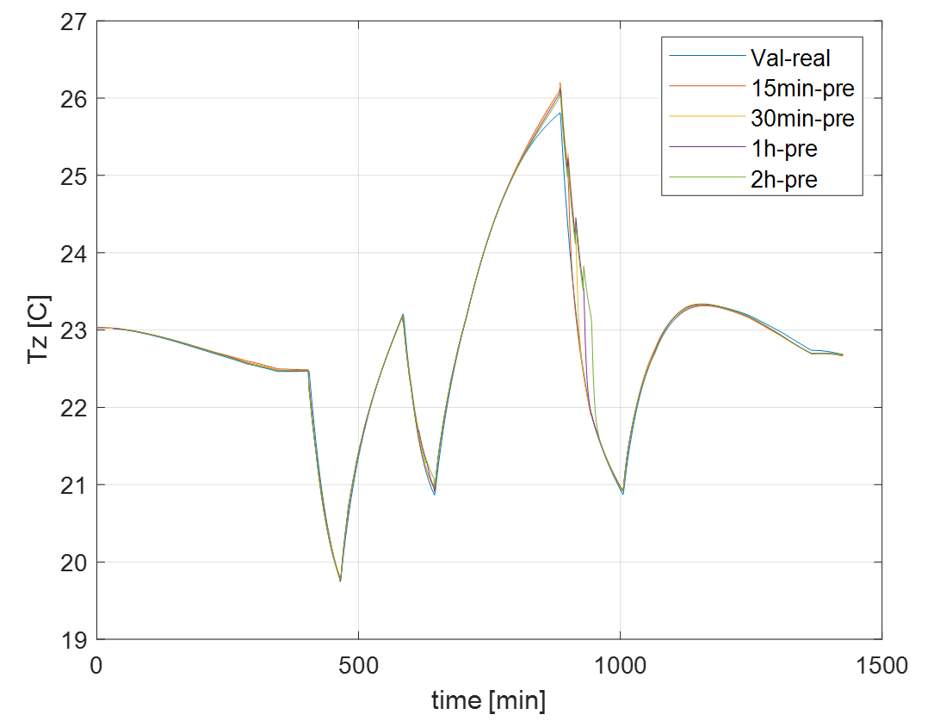

Figure ‑ Validation results of zone air temperature model with different prediction horizons

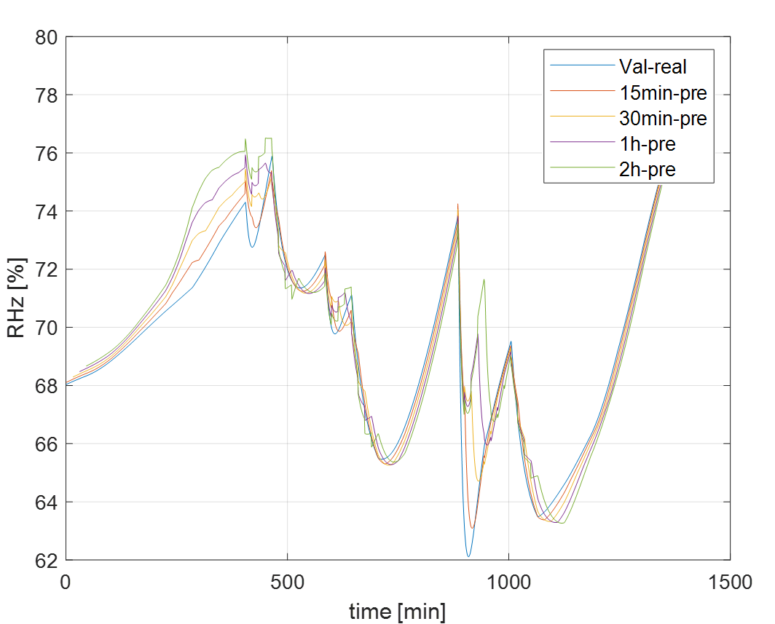

Figure ‑ Validation results of zone air relative humidity model with different prediction horizons

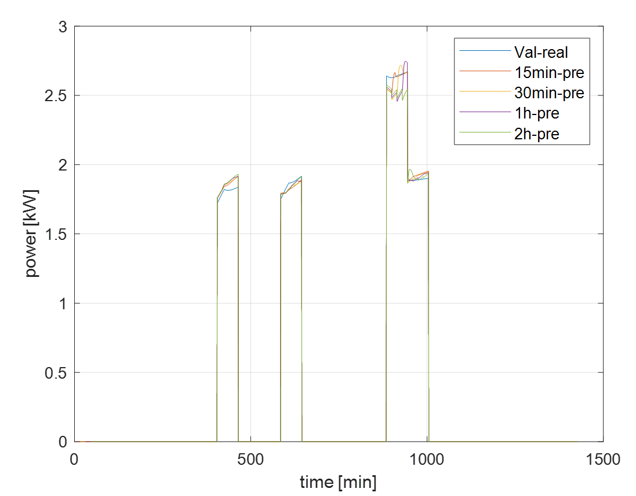

Figure ‑ Validation results of HVAC system power model with different prediction horizons

According to the guidelines from the American Society of Heating, Refrigerating, and Air-Conditioning Engineers (ASHRAE) Guideline 14 [125, 126] and the Federal Energy Management Program (FEMP) criteria [155], the validation criteria for RMSE are set at 0.5°C for temperature, 5% for relative humidity, and 90 W (equivalent to 5% of the HVAC system's average power consumption) for HVAC system power. When the prediction horizon is set to 4 (i.e., 1 hour), the errors for the selected models are 0.21°C, 4.74%, and 71 W, all of which meet the selected validation criteria. Therefore, a prediction horizon of 4 is selected and will be used in the subsequent development of the TMPC-GOCC strategy in Chapter 5.

## Chapter Conclusions

This chapter describes the development of the prediction models utilized in the TMPC-GOCC strategy. Specifically, it proposes a definition of group thermal comfort and presents a detailed methodology for training and validating a group thermal comfort model using publicly available datasets. Group thermal comfort will be developed using the RF model with weighted average JSD as the model evaluation index. Additionally, this chapter details the development of the zone air temperature model, the zone air relative humidity model, and the HVAC system power model. Various data-driven modeling approaches were evaluated. The final modeling structures selected for the three models were RNN, MARS, and ANN structure, respectively. Their prediction errors comply with ASHRAE guidelines 14: 0.5 °C for temperature, 5% for relative humidity, and 90W for HVAC power. These models will serve as the foundation for the TMPC-GOCC strategy discussed in Chapter 5.

In this chapter, Section 3.2 corresponds to Subtask 2.1 outlined in Section 1.4, although it does not directly output the group thermal comfort model, it discusses the methodology for its model training and validation, which will be used in Chapter 4. Section 3.3 corresponds to Subtask 2.2, which involves developing the zone environmental prediction model and the HVAC system power prediction model.

# Transfer Learning Used in Group Thermal Comfort Model

## Introduction

As discussed in Chapter 1, occupant thermal comfort models often face challenges related to scalability. In particular, the development of new models is frequently hindered by insufficient data, making it difficult to create reliable personalized occupant thermal comfort models. This issue is even more pronounced in the context of group thermal comfort models, as mentioned in Chapter 3. For this reason, one of the objectives of this study is to use transfer learning techniques to address the problem of insufficient data in the development of group thermal comfort models. Section 4.2 introduces the methodology and framework for implementing transfer learning in group thermal comfort modeling. Following this, a series of case studies are designed to evaluate the effectiveness of the proposed transfer learning approach, as detailed in Sections 4.3 and 4.4.

## The Framework and Methodology of Transfer Learning Used in Group Thermal Comfort Model

### The Framework of Instance-based TL

In real life, building HVAC systems generally run in a typical condition, resulting in a relatively stable indoor environment for occupants. Additionally, as discussed in Section 1.2.1, obtaining occupant data is always difficult and time-consuming. For this reason, when developing the group thermal comfort model proposed in Chapter 3 for occupants in a real building, there is often a lack of sufficient data to support the model development. Fortunately, the virtual test bed introduced in Chapter 2 can generate virtually unlimited simulated data on various occupants, building, and HVAC system variations. Therefore, this study proposes using transfer learning techniques to leverage knowledge gained from simulated occupant data to support model development for real occupant groups. The proposed transfer learning approach involves three main steps:

1. Source domain simulated data generation: In Chapter 2, a virtual testbed was developed, enabling the generation of simulated occupant data. This virtual testbed allows for the adjustment of HVAC system settings to produce sufficient data for modeling purposes. Recalling the literature review on transfer learning in Section 1.2.4, transfer learning involves the source domain and the target domain. In the framework of transfer learning proposed in this paper, these simulated data will be served as source domain data for transferring knowledge.
2. Target domain real data collection: Again, considering that only limited occupant data is available to develop group thermal comfort model in a real building, the dataset collected from the real building will be the target domain in transfer learning. In this study, the virtual testbed is configured to reflect the limitation of real world occupant data, and is used to generate the target domain data.
3. Knowledge Transfer: Transfer learning techniques are applied to transfer knowledge from the source domain (simulated data) to the target domain (real data). Model developed from the combination of the original target domain data and the transferred knowledge is expected to have better performance.

The first two steps outlined above focus on generating or collecting data for the source and target domains, serving as data preparation for the pre-stage of transfer learning. Section 4.3 will introduce the evaluation case design of the transfer learning framework, where the source and target domain data used in this study will be described in detail. The following section presents the methodology of transfer learning applied in the group thermal comfort model.

According to the classification of transfer learning problems in the literature in Chapter 1, the application of transfer learning in the group thermal comfort model studied in this paper belongs to transductive transfer learning. The transductive transfer learning problem is used to solve the same task when the data distributions of the source and target domains are different. The primary objective of transductive transfer learning is to transfer knowledge from the source domain to the target domain by minimizing the distributional differences between them, thereby improving the model’s applicability to the target domain. The transfer learning approach adopted in this study is instance-based transfer learning. This method re-weights or samples instances from the source domain to better align with the marginal distribution of the target domain, thereby helping the development of predictive models for the target domain. Other common transfer learning methods, feature-based transfer learning and model-based transfer learning, were not used for the following reasons, respectively:

1) Feature-Based Transfer Learning: The proposed group thermal comfort model uses typical measurements as model features, i.e., outdoor temperature, indoor temperature, and indoor relative humidity, which are standard features across different buildings. Therefore, feature-based transfer learning is not necessary.

2) Model-Based Transfer Learning: As outlined in Chapter 2, model-based transfer learning transfers knowledge by reusing and fine-tuning model parameters or architectures learned from a source task to enhance performance on a related target task. As discussed in Chapter 3, the proposed group thermal comfort model uses Random Forest as model structure for its overall performance. Unlike deep learning models, such as various types of neural networks, random forest models are inherently non-fine-tunable due to their non-differentiable nature [87, 156]. Consequently, model-based transfer learning is not a suitable approach in this study.

Back to instance-based transfer learning, the key idea of instance-based transfer learning is to select samples from the source domain that are close to the marginal distribution of the target domain to enrich the target domain data, thereby improving the scalability of the target task. Figure 4‑1 shows the framework of instance-based transfer learning applied to the group thermal comfort model.

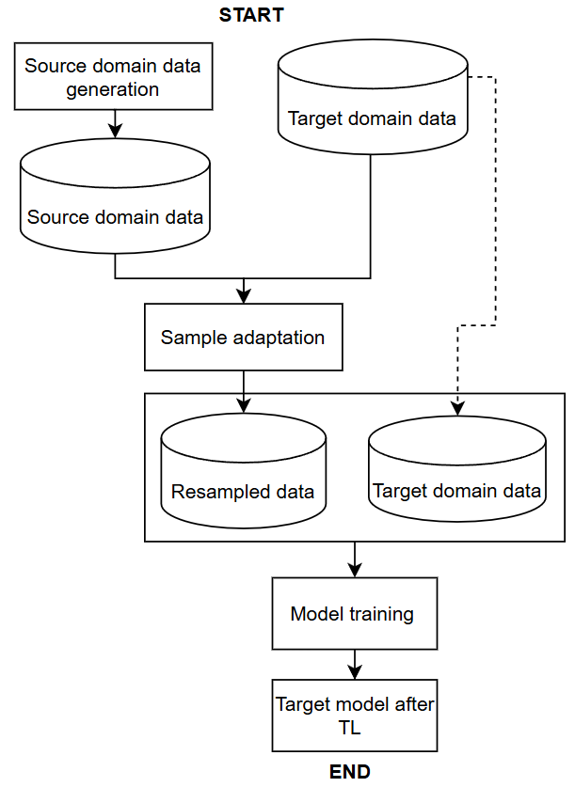

Figure ‑ Transfer learning framework proposed for the group occupant thermal comfort model

The following is a detailed introduction to this framework:

* The input to this framework is the target domain data, i.e. data on occupant thermal comfort votes, indoor temperature and humidity, and outdoor temperature that are typically obtained from real buildings. The source domain data, in contrast, consists of rich datasets that can be generated using a virtual testbed such as that described in Chapter 2. Note that the virtual testbed was used to generate both the source and target domain data; however, the target domain data was produced with constraints that simulate the limitations of real-world buildings.
* Normalization is firstly applied to the data in the source and target domains. Subsequently, normalized data from the source domain is sampled using a technique called sample adaptation to enrich the data in the target domain. More details about sample adaptation are provided in Section 4.2.2.
* After sample adaptation, the data sampled from the source domain, referred to as resampled data, is combined with the target domain data to form the final training dataset. Using the Random Forest model training method described in Chapter 3, a group thermal comfort model is then developed for the target building.

### The Methodology of Instances-based TL

In transfer learning, Instance-based Transfer Learning is a method that reuses some samples in the source domain to help learn the target task. The core idea is that although there are differences between the source domain and the target domain, there are still some samples in the source domain that are helpful for the target task and can be selected for transfer. Sample adaptation is a key part of instance-based transfer learning, and its goal is to solve the problem of distributional differences between the source and target domains.

To sample the data in the source domain to the target domain, it is required that the marginal distribution of resampled data and target domain data should be converged. To obtain samples with a marginal distribution similar to the target domain from the source domain, the technique employed is called sample adaptation. Sample adaptation is a key technique in transfer learning, which mainly solves the problem of inconsistent marginal distributions between the source and target domains [157]. The basic idea of sample adaptation is to sample the data in the source domain to make it closer to the marginal distribution of the target domain, so that the data resampled in the source domain can be used in the target domain. In this process, Maximum Mean Discrepancy (MMD) can be used as a metric to measure the difference between the two distributions of the resampled data and the target domain data [158]. MMD equals the inner product of points mapped on higher-order functions (like the Gaussian kernel function) of two distributions. Its value is generally between 0 and 1, the closer to 0 the better. The calculation formula of MMD is shown in Equation (13-14), where $x_{i}$ and $y_{i}$ is the data in two distributions $X$ or $Y$; $m$ and $n$ is the number of data points in $X$ or $Y$; $K$ is Gaussian kernel function; $σ$ is the parameter in Gaussian kernel function, typically equal to 1. By using MMD to measure the difference, the sample adaptation process becomes an optimization problem, which attempts to find out which data in the source domain has a marginal distribution that is closer to the target domain. Specifically, the object of optimization is the indicator of the instance samples in the source domain, indicating those samples to be selected from the source domain. The optimization objective is to minimize the MMD between the marginal distributions of the resampled data and the target domain, as shown in Equation (15). In this context, $x$ is a binary indicator vector of size 1×k, where k represents the total number of instances in the source domain. Each element in $x$ takes a value of 0 (indicating that the instance was not selected) or 1 (indicating that the instance was selected). $Ds$ and $Dt$ are the instances in the source and target domain respectively. The objective equation can be optimized using global optimization algorithms such as Simulated Annealing method, Genetic Algorithm etc. In this research, a genetic algorithm, specifically the MATLAB function "ga" [159], was be used to optimize Equation (15) to sample the source domain data.

$MMD^{2}(X,Y)=\frac{1}{m^{2}}\sum_{i=1}^{m}{\sum_{j=1}^{m}{K(x_{i},x_{j})}}-\frac{1}{mn}\sum_{i=1}^{m}{\sum_{j=1}^{n}{K(x_{i},y_{j})}}+\frac{1}{n^{2}}\sum_{i=1}^{n}{\sum_{j=1}^{n}{K(y_{i},y_{j})}}$ (13)

$K(x,y)=e^{-\frac{{∥x-y∥}^{2}}{2σ^{2}}}$ (14)

$J(x)=MMD(Ds_{(x)},Dt)$ (15)

## Evaluation Cases Design of Transfer Learning

This section aims to evaluate whether the proposed transfer learning framework enhances the performance of the group thermal comfort model. To achieve this, various evaluation cases are designed to examine the effectiveness of the framework under different scenarios. Again, the proposed transfer learning involves both source and target domains. It is envisioned that in a practical application, the source domain is a sufficiently rich dataset generated from simulations, while the target domain comprises real-world data collected from actual buildings. However, in the current development and evaluation phase, both domains are derived from the virtual testbed developed in Chapter 2. Specifically, the source domain data is generated through virtual testbed simulations, and the virtual testbed is reconfigured to represent a real building to provide the target domain data.

Since the goal of transfer learning is to enrich the limited group occupant comfort data in target domain by using the simulated source domain data, the evaluation focuses on assessing the effectiveness of the transfer learning framework across different occupant groups. To ensure consistency, the building zone, weather, and HVAC system remain the same when generating both source and target domain data. Atlanta summer was selected as the representative location and season for the zone model in the virtual testbed for both source and target domains. The weather file USA_GA_Atlanta-Hartsfield.Jackson.Intl.AP. 722190_TMY3.epw was used to simulate climatic conditions in the virtual testbed. The primary variations across the designed evaluation cases come from differences in occupant group compositions and data collection strategies in the target domain. In other words, the transfer learning in this study is used to transfer knowledge across different groups of occupants. For the case using transfer learning across different seasons or buildings, it has been described in the proposal report and is detailed in Appendix A. The following sections will provide a detailed explanation of simulation of the source domain data in the case design, collection of target domain data from the “real” building for different evaluation cases, and evaluation methods for the transfer learning used in the group thermal comfort model.

### Source Domain Data Generation for Transfer Learning

As discussed earlier, in order to provide samples that have a similar marginal distribution with the target domain, the source domain must be diverse and comprehensive, covering various occupant group characteristics and HVAC system operating conditions. Therefore, the design of source domain data generated by virtual testbed simulations is characterized from the following three perspectives:

* Number of occupants: The simulated zone in the virtual testbed has an area of 113 m². Based on industry references, the minimum office space per occupant should not be less than 7.4 m² [160, 161], which implies a maximum occupancy of 15 people in the simulated space. To incorporate the cases with different numbers of occupants in the group, three representative occupant numbers, 5, 10, and 15, were selected in the source domain.
* Thermal acceptability range of occupants: As outlined in Section 2.6, the thermal acceptability range of occupants is derived from the RP-884 curve through sampling. To ensure that the source domain data reflects a variety of thermal preferences, multiple samples were drawn from the RP-884 curve for each occupant group size. Too few samples may result in the distribution of the sample differing from the RP-884 curve. Also, excessive samples are not reasonable for simulation cost reasons. Therefore, this study uses a preliminary study to determine how many samples are needed to make the sampled samples representative of the RP-88 curve. In this study, the chi-square test [162] is used to determine the goodness-of-fit of two distributions. In general, when p-value in the chi-square test is larger than 0.95, it is concluded that the two distributions can be considered similar. Figure 4‑2 shows the change of p-value in the chi-square test as the number of sampling groups increases for 5-, 10-, and 15-occupant groups. From the Figure 4‑2, for 5, 10, and 15 occupants, the p-value stabilizes when the number of sampled groups reaches 24. Therefore, 24 samples were generated for each occupant group size, ensuring an adequate representation of diverse thermal acceptability ranges in the source domain.

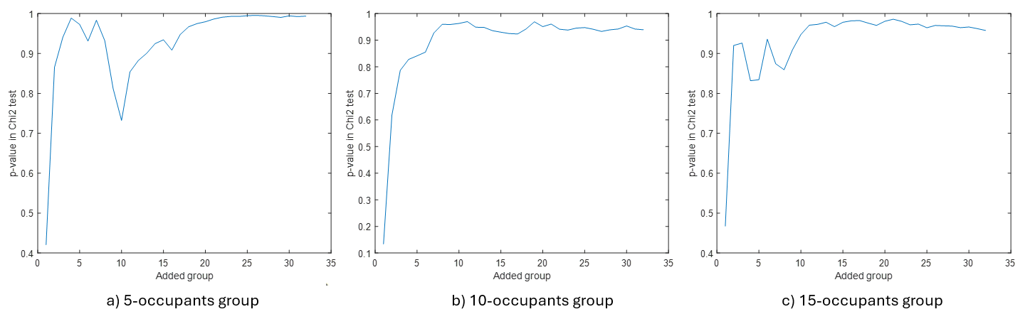

Figure ‑ Changes in p-value in the chi-square test as the number of sampling groups increases

* HVAC System Operating Conditions: To encompass a broad range of HVAC system behaviors, the virtual testbed’s HVAC system was controlled hourly using randomly generated cooling setpoints ranging from 65°F (18.33℃) to 85°F (29.44℃). In addition to zone air temperature, the inputs of the proposed group thermal comfort model also include zone air relative humidity and outdoor air temperature. To capture richer input data of the model, the virtual test bed is simulated for one month (July 1-31). This variability ensures that the source domain data reflects diverse HVAC operational conditions.

Simulations were conducted for each occupant group size, considering different thermal acceptability ranges and randomized cooling setpoints to generate a sufficiently large and diverse source domain dataset for subsequent sample adaptation in transfer learning. During the simulations, key variables related to the group thermal comfort model were recorded, including indoor air temperature, indoor air relative humidity, outdoor air temperature, and occupant thermal comfort votes. At the end of the simulations, occupancy periods of 20 weekdays (equivalent to 4 weeks) were sampled at 15-minute intervals. Figure 4‑3 shows the 3D distribution of source domain data in the evaluation case, where zone air temperature ranges from 20.1℃ to 30.5℃, zone air relative humidity from 51.7% to 100%, and outdoor air temperature from 21.3℃ to 36.7℃. In summary, the one-month simulation dataset for the three occupant group sizes (each with different thermal acceptability ranges and randomized cooling setpoints) constitutes the source domain data for transfer learning in this study.

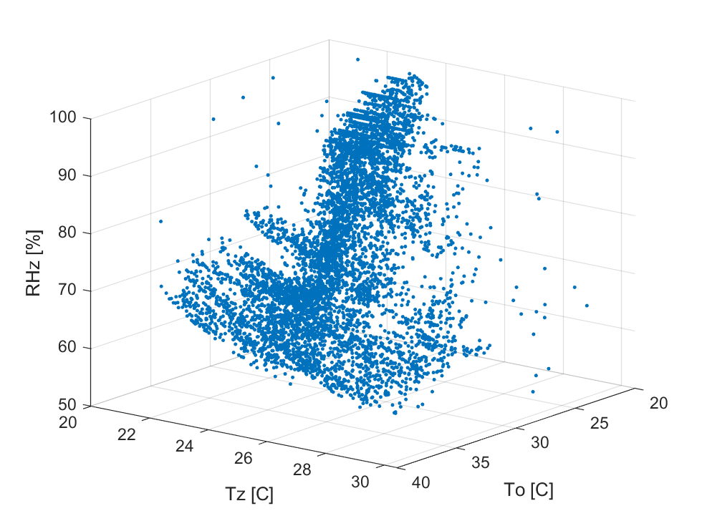

Figure ‑ 3D distribution of source domain data in evaluation cases

### Target Domain Data Generation for Transfer Learning Evaluation

As discussed earlier, this study uses the virtual testbed to represent a real building and generate target domain data for transfer learning. When designing the simulation scenarios for target domain dataset generation, two principles are considered. The first principle is to ensure that the simulated target domain data closely resembles real-world conditions. The second principle is to ensure that the target domain data are able to evaluate the effectiveness of transfer learning across various scenarios, specifically, to determine whether it improves the performance of the group thermal comfort model. Similar to the source domain design in Section 4.3.1, the following four factors are considered when defining target domain scenarios, following the above two principles:

* Number of occupants: The source domain includes occupant group sizes of 5, 10, and 15. When evaluating the performance of transfer learning in different scenarios. It is important to consider both cases: when the number of occupants in the target domain is included in the source domain and when it is not. Therefore, the following three scenarios were selected as the target domain occupant group sizes.
  + 5 (minimum occupant size in source domain)
  + 15 (maximum occupant size in source domain)
  + 7 (a different size not included in the source domain)
* Thermal acceptability range of the occupant group: The source domain thermal acceptability range is derived from the RP-884 curve through sampling. To evaluate the scalability of transfer learning, two main types of scenarios with different thermal acceptability ranges need to be considered. One scenario is that the group occupant thermal acceptability ranges in the target domain are also sampled from the RP-884 curves (assumed neutral preference). The other scenario is the manually generated thermal acceptability ranges for different thermal preference. Accordingly, three categories of thermal acceptability ranges were selected for the target domain:
  + Neutral thermal preference (RP-884 sampled)
  + Cold preference (Manually generated)
  + Hot preference (Manually generated)
* HVAC system operating conditions: HVAC systems in real buildings typically are operated at a stable cooling setpoint in occupancy period, which can be considered as one scenario. In addition, grid-interactive efficient buildings (GEB) are currently gaining attention for their energy efficiency and demand flexibility [163]. A typical GEB strategy is load shifting, where precooling is performed before peak demand periods and cooling set point is relaxed during peak periods to minimize energy costs while maintaining occupant comfort. This strategy involves three cooling setpoints in occupancy period, namely, normal operation setpoint, precooling setpoint, and peak setpoint. More details about the development of load shifting control strategies can be found in the literature [119]. Based on this, two HVAC operating scenarios were selected when generating target domain dataset:
  + One stable cooling setpoint control: 78°F, here after referred to as one setpoint scenario.
  + Three cooling setpoints (load shifting) control: 76°F (precooling), 78°F (normal), and 80°F (peak), here after referred to as three setpoint scenario.

Figure 4‑4 shows the change in zone air temperature and cooling/heating setpoints over time for two HVAC system operating scenarios. The orange line represents the zone air temperature, and the blue and yellow lines represent the cooling and heating setpoints, respectively.

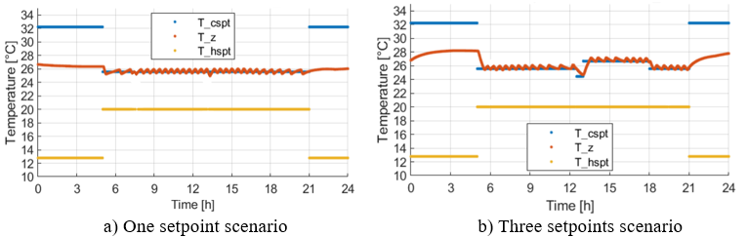

Figure ‑ Zone air temperature and cooling/heating setpoints for two HVAC system operating scenarios

* Duration of data collection: As mentioned in Chapter 1, data availability in real buildings depends on practical constraints, and the period of data collection is limited. The literature shows that for transfer learning, the richness of the target domain data will affect the transfer learning performance [86, 87, 164]. Therefore, different amounts of target domain data (implying different data collection periods and richness) also need to be evaluated. Common data richness metrics include information entropy [165, 166], convex hull [167], and coverage [168]. In this study, information entropy is used to evaluate data richness. A preliminary test was conducted using the virtual testbed (Atlanta, summer, 5, 7, and 15 occupants with neutral preference) using the control in one setpoint scenario and three setpoints scenario, respectively. More details about this preliminary study are shown in Appendix B. The information entropy is calculated by the feature and objective of the group thermal comfort model. During the simulation, the information entropy was monitored as the number of simulation days increased. The results, shown in Figure 4‑5, indicate that information entropy stabilizes after five days of data collection. Combining realistic situations, based on the assumption of maximum disturbance of the occupants' working hours, this study selects 1 to 5 days with data starting on July 6 (the beginning of a typical summer week) as the data collection period scenario when generating target domain dataset.

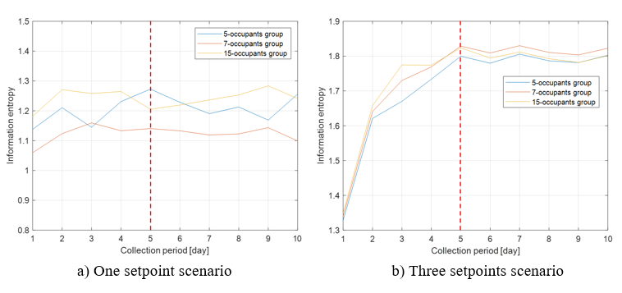

Figure ‑ Information entropy varies with the time period of data collection

By combining these four factors, 90 evaluation cases were generated to develop target domain datasets. In these target domain datasets, the zone air temperature ranges from 23.5°C to 28.1°C, the zone air relative humidity ranges from 55.9% to 84.0%, and the outdoor air temperature ranges from 23.5°C to 31.1°C. Each evaluation case is labeled according to its key parameters (e.g., 5Occ-N-1SP-1D means the case with the group occupant size of 5, neutral thermal preference, the HVAC system running in one setpoint scenario, and the data collection period of 1 day). Similar to how the source domain dataset is generated, during the occupancy period, sampling is performed at every 15 minutes to produce the target domain data.

In this transfer learning evaluation case design, Table 4‑1 summarizes the above source and target domain settings for comparison.

Table ‑ Summary of the design of source and target domains in transfer learning

|  |  |  |  |  |  |  |  |  |  |
| --- | --- | --- | --- | --- | --- | --- | --- | --- | --- |
|  | Source domain  (simulated building) | Target domain  (“real” building) | | | | | | | |
| Occupants | 24 groups of 5 occupants  24 groups of 10 occupants  24 groups of 15 occupants | 5 occupants | | 7 occupants | | | | 15 occupants | |
| neutral preference | | cold preference | | | | hot preference | |
| HVAC operation | Random cooling setpoints | one cooling setpoint | | | | three cooling setpoints | | | |
| Data collection period | 1 month | 1 day | 2 days | | 3 days | | 4 days | | 5 days |

### Evaluation Method

To assess the effectiveness of transfer learning in improving the performance of the group thermal comfort model, a comparative analysis is conducted. Specifically, the performance of the model trained without transfer learning (i.e., using only target domain data) is compared against the performance of the model trained with transfer learning (i.e., incorporating knowledge from the source domain). Figure 4‑6 illustrates the evaluation framework for applying transfer learning to the group thermal comfort model.

In addition to the target and source domain data, the evaluation framework also uses another dataset, i.e., model validation dataset to assess the developed group thermal comfort model’s forecasting performance. The model validation data is generated from the virtual testbed with configurations that are consistent with the corresponding settings of target domain cases (i.e., the same zone model, group size, and group thermal preference). The difference between target domain data and model validation data is the cooling setpoint settings. To ensure that the validation data sufficiently covers the potential thermal environment where occupants may feel uncomfortable, the model validation dataset should be within the range of ASHRAE recommendations for indoor thermal environments [169]. Therefore, randomly generated cooling setpoints from 72°F to 80°F every hour was applied to the virtual testbed for generating the validation data. The virtual testbed simulation was conducted for five weekdays, starting from July 13, which follows the target domain data collection period. At the end of the simulation, data was sampled every 15 minutes during occupancy periods to obtain the final model validation dataset.

To evaluate whether transfer learning improves predictive performance, the methodology outlined in Section 3.2.2.2 was employed, where the Jensen-Shannon Divergence (JSD) is used as a performance metric for the group thermal comfort model. The JSD was calculated separately for the models trained with and without transfer learning, using the validation dataset, to assess the impact of transfer learning on model performance.

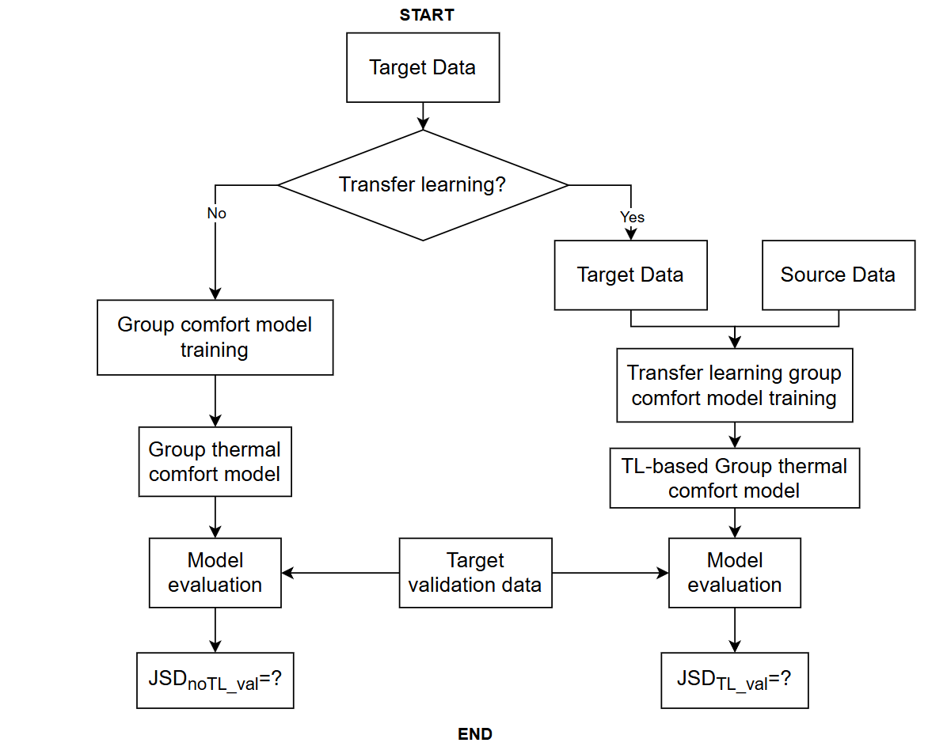

Figure ‑ A evaluation framework of transfer learning used in group thermal comfort model

Since the prediction model's performance directly impacts the effectiveness of the following TMPC-GOCC control strategy discussed in Chapter 5, understanding the relationship between the characteristics of the target domain data and the corresponding model performance can provide practical guidance to the user for ensuring that the control strategy can be effectively implemented. As discussed earlier, the richness of the target domain data influences not only the performance of models trained without transfer learning but also the effectiveness of the transfer learning process itself. Therefore, this study will also explore the relationship between the information entropy of the target domain on the performance of the group thermal comfort model before and after using transfer learning. By doing this, the impact of data quality and diversity on the group thermal comfort model's performance can be understood. The study can also provide users with advice on what data is needed to make the control strategy successful in practice.

## Evaluation Results

The computer configuration used in this study is an Intel(R) Xeon(R) CPU E5-2699 v4 @ 2.20 GHz. Each evaluation case required approximately 30 minutes to complete the sample adaptation optimization using a genetic algorithm as discussed in Section 4.2.2, followed by model development and evaluation, as illustrated in Figure 4‑6. All optimization processes executed in this study were terminated successfully when the average change in objective function was less than the function tolerance.

As described in Section 4.3.2, a total of 90 evaluation cases were conducted. After applying the transfer learning evaluation framework outlined in Section 4.3.3, a series of results were obtained by comparing the Jensen-Shannon Divergence (JSD) of the group thermal comfort model before and after transfer learning. These results are presented in the Figure 4‑7, which visualizes the evaluation results across different target domain scenarios. The subfigures on top, medium, and bottom represent results for 5, 10, and 15-occupant scenarios, respectively. The subfigures on the left correspond to the one-cooling-setpoint scenario, and the subfigures on the right correspond to the three-cooling-setpoints scenario. Within each subfigure, results are further categorized by three different occupant groups with different thermal preferences, represented by different shapes (circles, squares, and diamonds denote neutral, hot, and cold thermal preference groups, respectively). The horizontal axis represents the number of days of data collection in the target domain. The vertical axis represents the JSD of the model, indicating model performance. To enhance readability and avoid overlapping markers, occupant groups with the same number of data collection days have been assigned slightly different horizontal positions. The blue markers and orange markers in the figure indicate the cases with are without transfer learning, respectively. The translucent blue and orange trend bars illustrate the overall trend between model performance and the number of days of data collection.

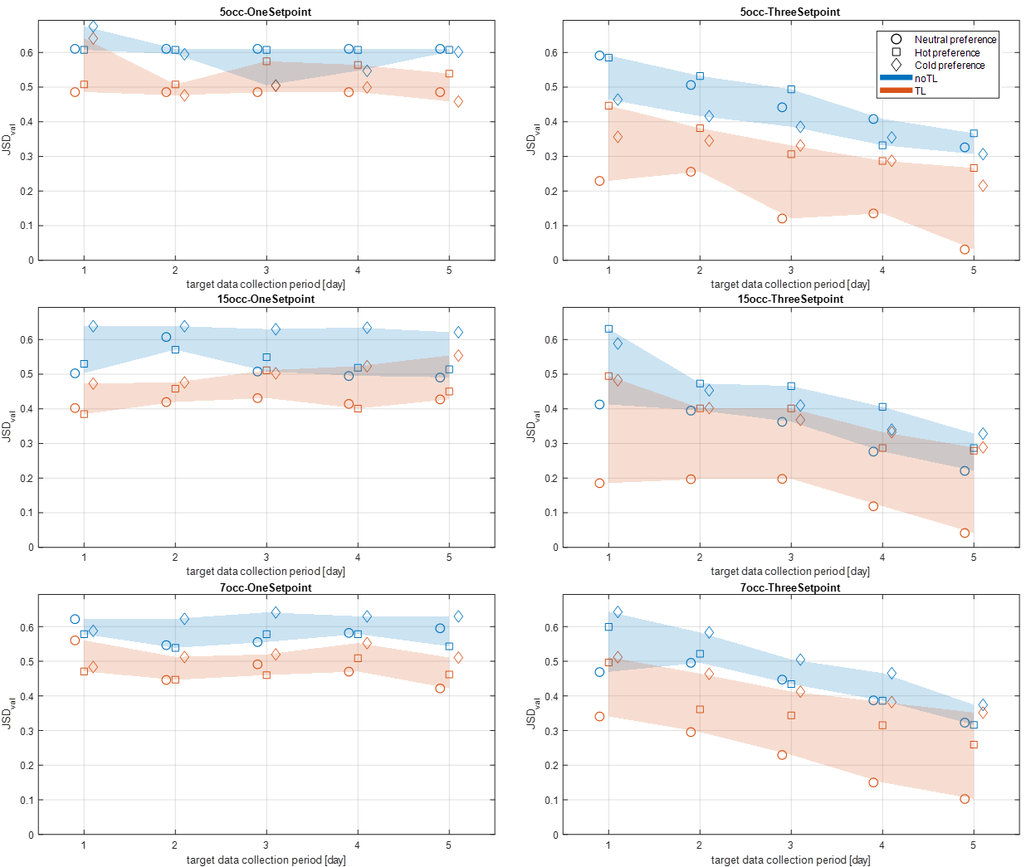

Figure ‑ Results of the transfer learning evaluation

Based on the results shown in the Figure 4‑5, the following conclusions can be drawn:

* Effectiveness of transfer learning: Across all evaluation cases, compared the orange marks with the blue marks, the group thermal comfort model trained with transfer learning always has a lower JSD than the model trained without transfer learning. Therefore it is concluded that transfer learning improves the group thermal comfort model's predictive performance, demonstrating its validity in solving the issue with data scarcity in modeling the target domain.
* Impact of data collection period on model performance: For the one cooling setpoint scenario, increasing the number of days of data collection does not lead to better model performance, regardless of whether transfer learning is used or not. However, for three cooling setpoints scenario, longer data collection leads to better model performance. This suggests that under steady HVAC operating conditions, additional data may become redundant, while in more complex HVAC operating scenarios, the collection of additional data enhances the generalizability of the model.
  + Impact of occupant group characteristics on transfer learning effectiveness: The effect of transfer learning is not significantly influenced by the number of occupants or their thermal preferences. This suggests that the proposed transfer learning framework is robust across different occupant groups.

As discussed in Section 4.3, this study also explores the relationship between the information entropy in the target domain data and the performance of the model before and after applying transfer learning. The results are visualized in Figure 4‑8. The left plot shows the JSD of the model before and after transfer learning under different information entropy in the target domain. To further analyze the trend, a linear fitting, shown in the dashed line in the plot, was performed based on empirical observations. The R² values for the fitted curves before and after transfer learning are 0.51 and 0.47, respectively. While these low R² values indicate a weaker fit, they are sufficient for the purpose of visualizing the general trend in the data distribution. The right plot shows the model JSD reduction (the effect of transfer learning) under different information entropy.

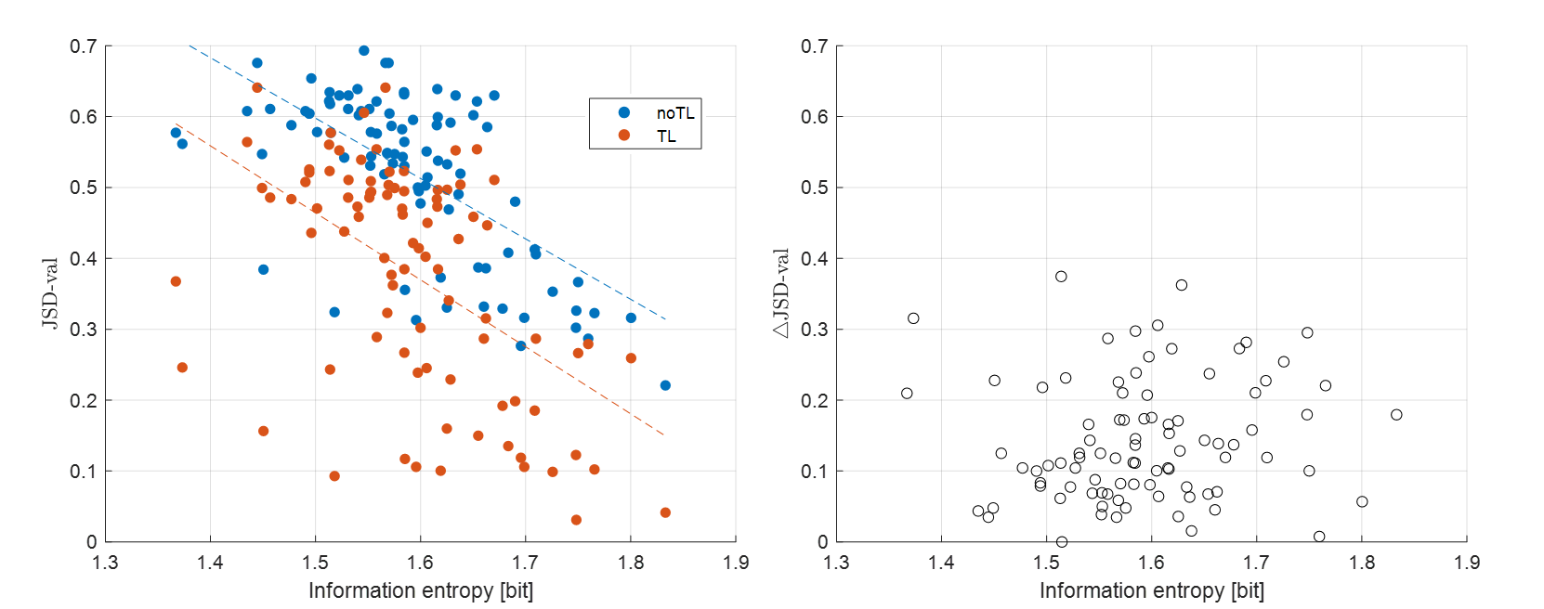

Figure ‑ The results of model performance (JSD) and transfer learning effects (ΔJSD) under different information entropy

The key observations from Figure 4‑8 are summarized below:

* Model performance: Regardless of whether transfer learning is used, a higher information entropy in the target domain data generally results in a model with lower JSD, indicating better predictive performance. This suggests that richer target domain data improves the generalizability of the group thermal comfort model.
* Transfer learning effect: The effect of transfer learning is always positive, i.e., it always reduces the JSD of the model. However, there is no significant relationship between information entropy and the effect of transfer learning (ΔJSD). The average ΔJSD was 0.147. This suggests that, regardless of the information entropy of the target domain data, transfer learning always can enhance the model's predictive performance. However, the extent of improvement is difficult to estimate.

## Chapter Conclusions

This section presents the developed transfer learning framework for the group thermal comfort model and its instance-based transfer learning method, specifically sample adaptation. To evaluate the effectiveness of the framework, a series of evaluation cases were designed and simulated using the virtual testbed. Overall, the deigned evaluation cases involve a wide variation, including occupant group size, group thermal preferences, zone temperature setpoint control strategies, and data collection duration. The evaluation results show that, in all cases, transfer learning improves predictive performance compared to training the group thermal comfort model using only limited target domain data; however, the extent of this improvement varies from case to case. The proposed transfer learning framework is applicable across various occupant groups, demonstrating its generalizability and adaptability in diverse scenarios. These results highlight the applicability and value of transfer learning in addressing data scarcity in group thermal comfort modeling.

This chapter is structured to align with the research subtasks outlined in Section 1.4, focusing on transfer learning for group occupant thermal comfort models. Section 4.2 corresponds to Subtask 3.1, which involves developing a transfer learning framework for group occupant thermal comfort models. Section 4.3 corresponds to Subtask 3.2, which designs evaluation cases for transfer learning used in group thermal comfort models. Section 4.4 corresponds to Subtask 3.3, which evaluates the effectiveness of the transfer learning framework across different scenarios. Also, the group thermal comfort model obtained in Section 4.4 corresponds to Subtask 2.1, i.e., developing and evaluating a predictive model for group occupant thermal comfort.

# Development of MPC-based Group Occupant Centric Control

## Introduction

Building on the predictive models developed in Chapter 3 and Chapter 4, this chapter integrates them into the proposed transferable MPC-based group occupant-centric control (TMPC-GOCC) strategy and evaluates its effectiveness. Chapter 3 introduced key predictive models, including the group occupant thermal comfort model, the building system energy consumption model, and the zone environment model. Chapter 4 demonstrated using transfer learning to get a group thermal comfort model with higher predictive performance. These models collectively form the foundation of the MPC framework. This chapter details the development and implementation of the TMPC-GOCC strategy, followed by control performance evaluation using the virtual testbed developed in Chapter 2. Specifically, Section 5.2 presents the MPC framework and outlines the MPC formulation, including predicted data flow, objective function, and constraints. Section 5.3 describes the evaluation cases design and the implementation in the virtual testbed. Finally, Section 5.4 analyzes the evaluation results and the control strategy's effectiveness.

## MPC Development

### Overall GOCC-based MPC framework

The core of the proposed TMPC-GOCC is an MPC-based control strategy, which objective is to determine the optimal control strategy for the HVAC system, ensuring energy savings and maintaining occupant thermal comfort. As described in Chapter 2, the HVAC system model in the virtual testbed is a two-stage air-source heat pump system with three discrete operating stages: off, low-speed mode, and high-speed mode. In the proposed MPC strategy, this operating state is the optimization variable. The MPC framework, illustrated in Figure 5‑1, demonstrates the information flow between these models, showing how predicted control signals influence the zone environment, HVAC system energy consumption, and group thermal comfort. To maintain consistency with the predictive models developed in Chapter 3, the prediction time step (Δt) for MPC optimization is also set to 15 minutes.

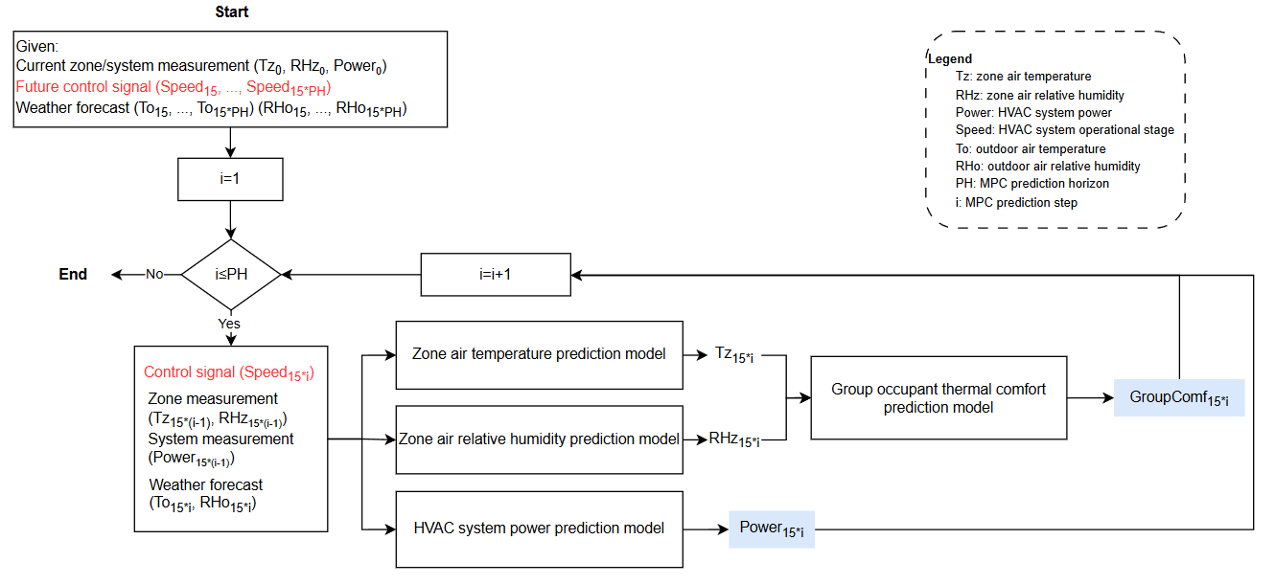

Figure ‑ TMPC-GOCC MPC framework

The following is a detailed description of the MPC framework process:

* In this framework, the inputs include measurements of the zone environment and the HVAC system at the current timestep ($i$), specifically the zone air temperature (${Tz}_{i}$), zone air relative humidity (${RHz}_{i}$), and HVAC system power consumption (${Power}_{i}$). Additionally, the inputs also include the control signals of the HVAC system over the future prediction timesteps (${Speed}_{i+15}$, ${Speed}_{i+30}$, …) and the weather forecast within the prediction horizon, including outdoor air temperature (${To}_{i+15}$, ${To}_{i+30}$, …) and outdoor air relative humidity (${RHo}_{i+15}$, ${RHo}_{i+30}$, …). The HVAC system control signals, which are heat pump operation stage (off, low-speed, or high-speed) in this study, over the future prediction steps are the optimization variables, highlighted in red in the framework.
* At each prediction timestep, the zone air temperature prediction model, the zone air relative humidity prediction model, and the HVAC system power prediction model are used to forecast the zone air temperature (${Tz}_{i+15}$), zone air relative humidity (${RHz}_{i+15}$), and HVAC system power (${Power}_{i+15}$) for the next timestep ($i+15$), based on the current measurements and control signal generated from the optimizer (described in Section 5.2.2) . The corresponding equations of these predictions are presented in Equations 16 to 18 below.
* The predicted zone air temperature and relative humidity will serve as inputs to the group thermal comfort model, which then predicts the group thermal comfort (${GroupComf}_{i+15}$). The equation is provided in Equation 19 below. The group thermal comfort model used in the MPC framework could be either the model without transfer learning or the model obtained through transfer learning.
* If the prediction horizon is longer than one prediction step, the predictions generated at the current timestep will be subsequently used as inputs (instead of measurements) for the next prediction timestep. After predictions have been completed for all timesteps in the prediction horizon, the framework execution ends, providing a set of predicted results of HVAC power and group occupant comfort within the prediction horizon.

${Tz}_{i+15}=f_{Tz}({Tz}_{i},{RHz}_{i},{Power}_{i},{To}_{i+15},{RHo}_{i+15},{Speed}_{i+15})$ (16)

${RHz}_{i+15}=f_{RHz}\left({Tz}_{i},{RHz}_{i},{Power}_{i},{To}_{i+15},{RHo}_{i+15},{Speed}_{i+15}\right)$ (17)

${Power}_{i+15}=f_{Power}({Tz}_{i},{RHz}_{i},{Power}_{i},{To}_{i+15},{RHo}_{i+15},{Speed}_{i+15})$ (18)

${GroupComf}_{i+15}=f_{PGroupComf}({Tz}_{i+15},{RHz}_{i+15},{To}_{i+15})$ (19)

### MPC Optimization

As previously discussed, the objective of this MPC framework is to minimize HVAC system energy consumption while maintaining occupant thermal comfort. To achieve this, an appropriate objective function is formulated based on the predicted results from the MPC framework, optimizing both HVAC system power usage and group thermal comfort. The optimization objective is highlighted in blue in Figure 5‑1. Since this optimization involves two different units of measurement, energy consumption and group thermal comfort, the group thermal comfort is converted to a constraint, making the optimization problem a single-objective optimization problem for HVAC energy consumption. The corresponding objective function is given in Equation 20, which represents the total HVAC energy consumption over the prediction horizon. To maintain an acceptable thermal comfort, constraints are manually set so that at least 80% of occupants in the group are satisfied, as expressed in Equation 21, where ${Num}_{Occ}$ denotes the total number of occupants. Notice that the threshold, 80%, can be adjusted by the user when the framework is implemented in a real building.

$\min{J\left(x\right)}=\sum_{t}^{PH}{{Power}_{t}×Δt}$ (20)

$Constraint: {GroupComf}_{15*t}≥80\% ×{Num}_{Occ}$ (21)

For the prediction horizon, based on the prediction model accuracy evaluation in Section 3.3, a prediction horizon of 4 is selected for the MPC. Regarding the optimization algorithm, since the decision variable is the 3 possible operating states of the HVAC system, and the optimization range is limited to 4, the computational complexity is relatively low. Therefore, an exhaustive search method is employed in this study to determine the optimal operating state of the HVAC system within the prediction horizon.

In summary, the proposed control strategy is a group occupant-centric control based MPC (GOCC-based MPC). Based on the proposed MPC framework, the MPC optimizes the HVAC system’s control signals at a 15-minute timestep within a one-hour prediction horizon using an exhaustive search method. And the objective is to minimize energy consumption while ensuring that at least 80% of occupants remain thermally comfortable within the predicted range.

### Traditional MPC strategy

To comparatively demonstrate the performance of the proposed GOCC-based MPC, a simple and traditional MPC strategy is established as a baseline. This baseline MPC strategy is temperature-based, with system power as the optimization objective, and its objective function is defined in Equation (5). Unlike the GOCC-based MPC, which incorporates group occupant thermal comfort constraints, the baseline MPC adheres to the ASHRAE-recommended comfort temperature range [169], using zone temperature as a constraint. Specifically, the zone air temperature is maintained within a lower limit of 22.22°C (72°F) and an upper limit of 26.67°C (80°F), as formulated in Equation 22. To compare with the GOCC-based MPC strategy, the temperature-based MPC adopts the same prediction timestep, prediction horizon, and optimization algorithm settings as those used in the GOCC-based MPC. Table 5‑1 summarizes a comparison of the key characteristics of both control strategies.

$Constraint: {22.22℃≤Tz}_{15*t}≤26.67℃$ (22)

Table ‑ Summary of the key characteristics of Temperature-based MPC and Proposed GOCC MPC strategies

|  |  |  |
| --- | --- | --- |
|  | **Temperature-based MPC** | **Proposed GOCC MPC** |
| **Objective function** | $$J\left(x\right)=\sum_{t}^{PH}{{Power}_{15*t}}×Δt$$ | |
| **Constraints** | $${22.22℃≤Tz}_{15*t}≤26.67℃$$ | $${GroupComf}_{15*t}≥80\% ×{Num}_{Occ}$$ |
| **Prediction timestep** | 15 minutes | |
| **Prediction horizon** | 4 | |
| **Optimization algorithm** | Exhaustive method | |

The GOCC-based and temperature-based MPCs will be incorporated as supervisory control in the virtual testbed, respectively. During the occupied period, the MPC will optimize the control of the HVAC system every 15 minutes. The optimized HVAC control signal (operation stage of the ASHP) at the first prediction timestep will be used to back calculate the corresponding cooling setpoint based on the control logic of the system operation speed and zone cooling setpoints as mentioned in Section 2.4.4.

Specifically, in this study, the two-stage heat pump is ultimately controlled through its operating state, which is determined by the zone cooling setpoint and zone temperature, as described in Section 2.4.4. Since the operating state is the most fundamental control signal of the heat pump, it is selected as the optimization objective in the proposed MPC framework. However, because the operating stage of the HVAC system is not directly controllable by the user, the zone cooling setpoint, which influences the operating stage through the control logic, serves as the actual control input in a real-world application. Therefore, once the MPC optimizes the desired operating stage, the corresponding zone cooling setpoints can be deduced based on the control logic, thereby enabling indirect control of the HVAC system.

## Evaluation Method

### Development of three MPC strategies for comparison

The MPC framework presented in Section 5.2 and the predictive models developed in Chapter 3 and 4 are applied to control the HVAC system at the virtual testbed introduced in Chapter 2 to evaluate the effectiveness of the proposed TMPC-GOCC strategy. Three types of MPC are designed for comparative evaluation:

1. Temperature-Based MPC, which follows ASHRAE-recommended temperature constraints.
2. GOCC-Based MPC, where the group thermal comfort model is trained without transfer learning.
3. GOCC+TL MPC, where the group thermal comfort model is trained with transfer learning, representing the final TMPC-GOCC strategy proposed in this study.

Figure 5‑2 illustrates the development process for these three types of MPCs. The development of each strategy begins with the data collection of building, HVAC system, and occupant. Next, the HVAC system and zone environment models are developed, corresponding to the works described in Section 3.3. By integrating these models into the MPC framework introduced in Section 5.2, the Temperature-Based MPC is completed. For MPC strategies involved GOCC, the group thermal comfort model is developed based on collected occupant data. Depending on whether transfer learning is applied, either a general group thermal comfort model (trained solely on target domain data) or a TL-based group thermal comfort model (with transfer learning) is developed. These steps align with the processes outlined in Section 3.2 and Chapter 4. Finally, the GOCC-based MPC and GOCC+TL MPC are developed by integrating the group thermal comfort model with the other predictive models and the MPC framework.

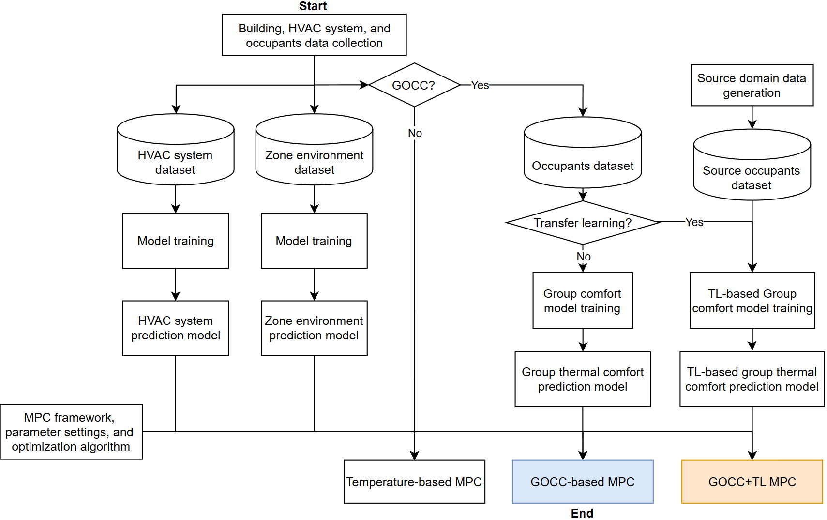

Figure ‑ Flowchart of the development process of the three MPCs

The three developed MPCs are implemented in the virtual testbed and each of them is used to control the HVAC system for 5 days (July 13 to July 17). The performance of the proposed TMPC-GOCC is evaluated by comparing the control performance of these three types of MPC cases (described in Section 5.3.3). Among them, the Temperature-based MPC serves as the baseline case, against which the GOCC-based MPC and GOCC+TL MPC will be compared. It is important to note that occupant thermal comfort is stochastic, meaning that occupant's thermal responses vary even under the same environmental conditions. Therefore, when the virtual testbed simulation is completed, the simulated zone environment change will be recorded. Based on this simulated zone environment, the simulation of occupant thermal comfort will be repeated 50 times using the occupant thermal comfort model to capture the stochastic nature. The results from these repeated simulations will be used to analyze and evaluate the control performance about occupant comfort.

### Evaluation Cases Design about Impact of group thermal comfort model

By comparing TPMC-GOCC with other two MPCs, one of the focuses of this study is to evaluate the performance of the proposed TMPC-GOCC strategy. In addition, it is well known that using models with different accuracy will result in different control performances. Therefore, another focus of this study is to investigate the impact of the accuracy of a group thermal comfort model on control performance. Intuitively, large model prediction error inevitably leads to unsatisfactory control results. As discussed in Section 4.4, JSD is an index that can reflect the accuracy of a group thermal comfort model. The JSD of the group thermal comfort models tested earlier has a range of 0~log2. Therefore, to evaluate the impact of the group thermal comfort model’s accuracy on overall control performance, 10 cases that resulted in group thermal comfort models with a JSD in the range of 0~0.3 were manually selected as the evaluation cases for TMPC-GOCC. The 10 cases and their corresponding JSD values of the group thermal comfort models obtained through non-transfer learning and transfer learning are summarized in the Table 5‑2.

Table ‑ The validation errors (JSD) of group thermal comfort model in the TMPC-GOCC evaluation cases

|  |  |  |
| --- | --- | --- |
| **Evaluation cases** | **JSDnoTL-val** | **JSDTL-val** |
| 5occ-N-3SP-5D | 0.326 | 0.031 |
| 15occ-N-3SP-5D | 0.221 | 0.041 |
| 7occ-N-3SP-5D | 0.323 | 0.102 |
| 15occ-N-3SP-4D | 0.276 | 0.119 |
| 5occ-N-3SP-4D | 0.408 | 0.135 |
| 15occ-N-3SP-1D | 0.413 | 0.185 |
| 15occ-N-3SP-3D | 0.363 | 0.198 |
| 7occ-N-3SP-3D | 0.448 | 0.229 |
| 5occ-C-3SP-5D | 0.367 | 0.266 |
| 7occ-N-3SP-2D | 0.496 | 0.296 |

It is worth noting that when evaluating the application of transfer learning in group thermal comfort model in Chapter 4, the evaluation focuses on the applicability of transfer learning in different scenarios. As a result, various evaluation scenarios were designed, incorporating factors such as different occupant group sizes, thermal preferences, and HVAC system setpoints. However, in this chapter, the primary focus is on how the group thermal comfort model predictive accuracy impacts the final MPC control performance. Therefore, in the evaluation cases of this chapter, the scenarios serve merely as case identifiers, and the impacts of scenario characteristics on control performances will not be analyzed.

### Evaluation Index

Based on the evaluation case designed in Section 5.3.2, three types of MPC strategies, i.e., Temperature-Based MPC, GOCC-Based MPC, and TMPC-GOCC, are developed and implemented for a period of 5-days (July 13 to July 17) in the virtual testbed following the evaluation framework outlined in Section 5.3.1. The following two key aspects are examined: 1) The prediction model performance will be examined to determine their accuracy in forecasting HVAC system power consumption, zone environmental conditions, and occupant thermal comfort. 2) The control performance of the three MPC strategies will be compared, focusing on occupant thermal comfort and energy consumption. Given that the TMPC-GOCC strategy prioritizes group occupant-centric control (GOCC), improvements in occupant comfort will be the primary criterion for assessing its effectiveness. A set of key performance indicators (KPIs), listed in Table 5‑3, has been selected for evaluation purposes. A brief description of these KPIs is provided below:

* The prediction accuracy of the zone air temperature relative humidity, and HVAC system's power were evaluated using the Root Mean Square Error (RMSE). Based on the model prediction errors in Section 3.3, the prediction accuracy criteria are 0.5°C, 5%, and 90W, respectively.
* The prediction accuracy of group occupant thermal comfort was evaluated using the weighted average Jensen-Shannon Divergence (JSD). This metric is only available for the GOCC-based MPC and GOCC+TL MPC cases. In addition, since this study will explore the effect of different JSDs on the control performance, no criteria is set for JSD.
* The control performance in terms of occupant comfort is evaluated using the average occupant discomfort vote.
* The control performance in terms of energy use is evaluated using the total energy consumption.

To account for the stochastic nature of occupant thermal comfort, as discussed in Section 5.3.1, the occupant comfort model conducted 50-times simulations to capture the distribution of occupant thermal comfort vote. As a result, the final JSD and average occupant discomfort vote are presented using box plots, providing a clearer visualization of the variability in results. Additionally, to quantify differences between the distributions, the box plot’s mean and median values are used as key metrics in this study. This approach enables a more robust comparison of control performance across different MPC strategies.

Table ‑ key performance indicators for TMPC-GOCC evaluation

|  |  |  |
| --- | --- | --- |
| **Evaluation Index** | | **Equation** |
| **Prediction accuracy** | **Zone temperature** | $RMSE= \sqrt{\frac{\sum_{i=1}^{N}{{(y_{i}-ŷ_{i})}^{2}}}{N}}$ |
| **Zone relative humidity** |
| **HVAC system power** |
| **Group occupant thermal comfort** | $\overline{JSD}=\sum_{i=1}^{n}{w_{i}JSD_{i}}$ |
| **Control performance** | **Average occupant discomfort vote** | $AvgDisComf=\frac{\sum_{occ=1}^{N_{occ}}{\sum_{t=1}^{T}{{DisComfVote}_{occ,t}}}}{N_{occ}}$ |
| **Total energy use** | $E=\sum_{t=1}^{T}{Q_{t}∆t}$ |

By comparing the control performance of the three MPC strategies, with a particular focus on group thermal comfort, the effectiveness of the proposed TMPC-GOCC is evaluated. Moreover, this study also aims to determine the threshold of the group thermal comfort model that ensures the effectiveness of the TMPC-GOCC strategy. To achieve this, the relationship between a group thermal comfort model’s JSD value and its improvement in occupant comfort compared with Temperature-based MPC will be analyzed.

## Evaluation Results and Analysis

After developing the MPC evaluation cases, these cases were tested using the virtual testbed. As mentioned in Section 4.4, the test were conducted on a system equipped with an Intel(R) Xeon(R) CPU E5-2699 v4 @ 2.20 GHz. Under this configuration, each temperature-based MPC case required approximately 90 minutes to complete, while both GOCC-based MPC and GOCC+TL MPC required approximately 120 minutes per case.

This section presents and analyzes the control performance of the three MPCs for the evaluation cases described above. Section 5.4.1 presents the predictive accuracy of the zone air temperature and humidity and HVAC system models; Section 5.4.2 presents the predictive performance of the group thermal comfort model; Sections 5.4.3 and 5.4.4 present the MPC control performance in terms of occupant thermal comfort and the HVAC system energy consumption, respectively; Section 5.4.5 provides an analysis of the underlying factors influencing the performance of MPC control; and Section 5.4.6 is a discussion of the accuracy thresholds for the group thermal comfort model.

### Prediction accuracy of zone temperature, zone relative humidity, and HVAC system power model

Using the 15occ-N-3SP-4D evaluation case as an example, Figure 5‑3 through Figure 5‑5 show the zone temperature, zone relative humidity, and HVAC system power results obtained over five days using the three different MPC strategies, respectively, where the blue lines represent the real measurements from the virtual testbed and the orange circles represent the predicted results from the MPC. The prediction errors for all evaluation cases are summarized in Table 5‑4. As shown in Table 5‑4, the prediction errors for zone temperature, zone relative humidity, and HVAC system power across all evaluation cases are within the criteria mentioned in Section 5.3.3.

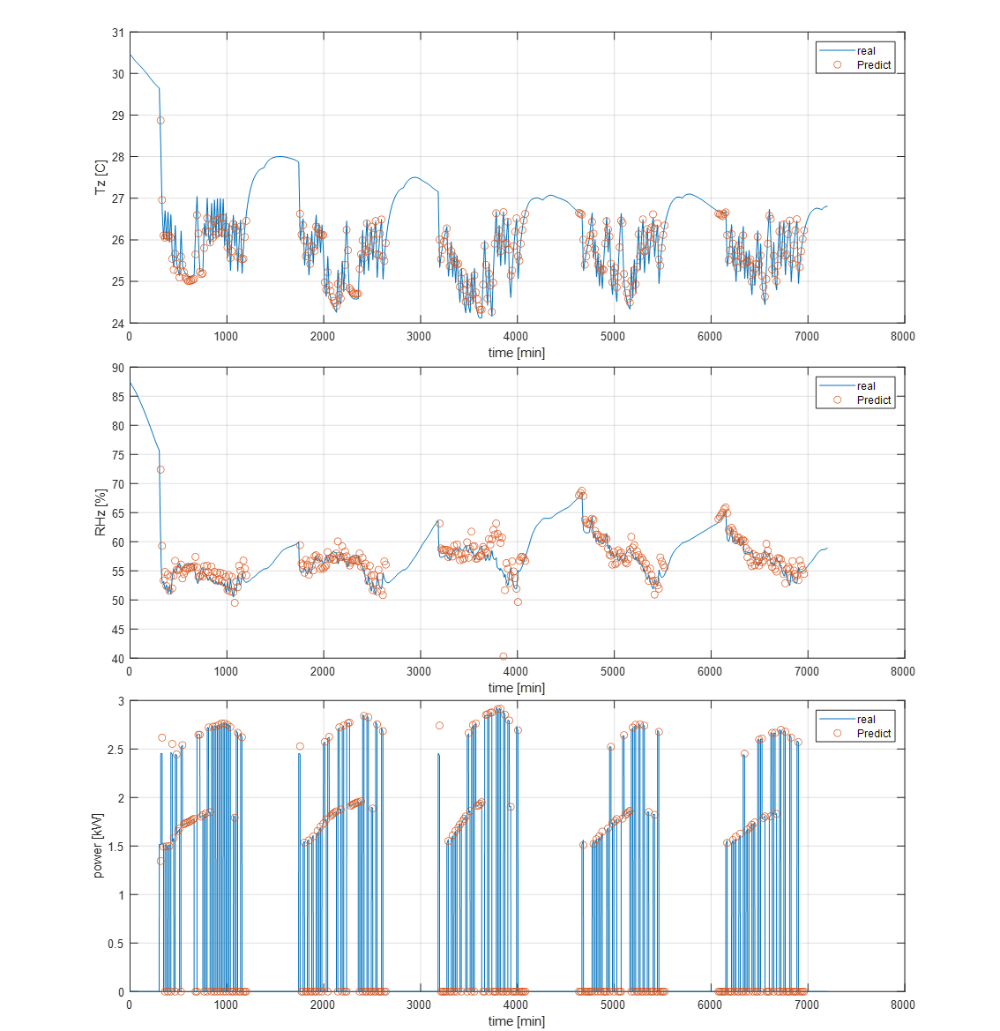

Figure ‑ Prediction model performances for evaluation case 15occ-N-3SP-4D with temperature-based MPC

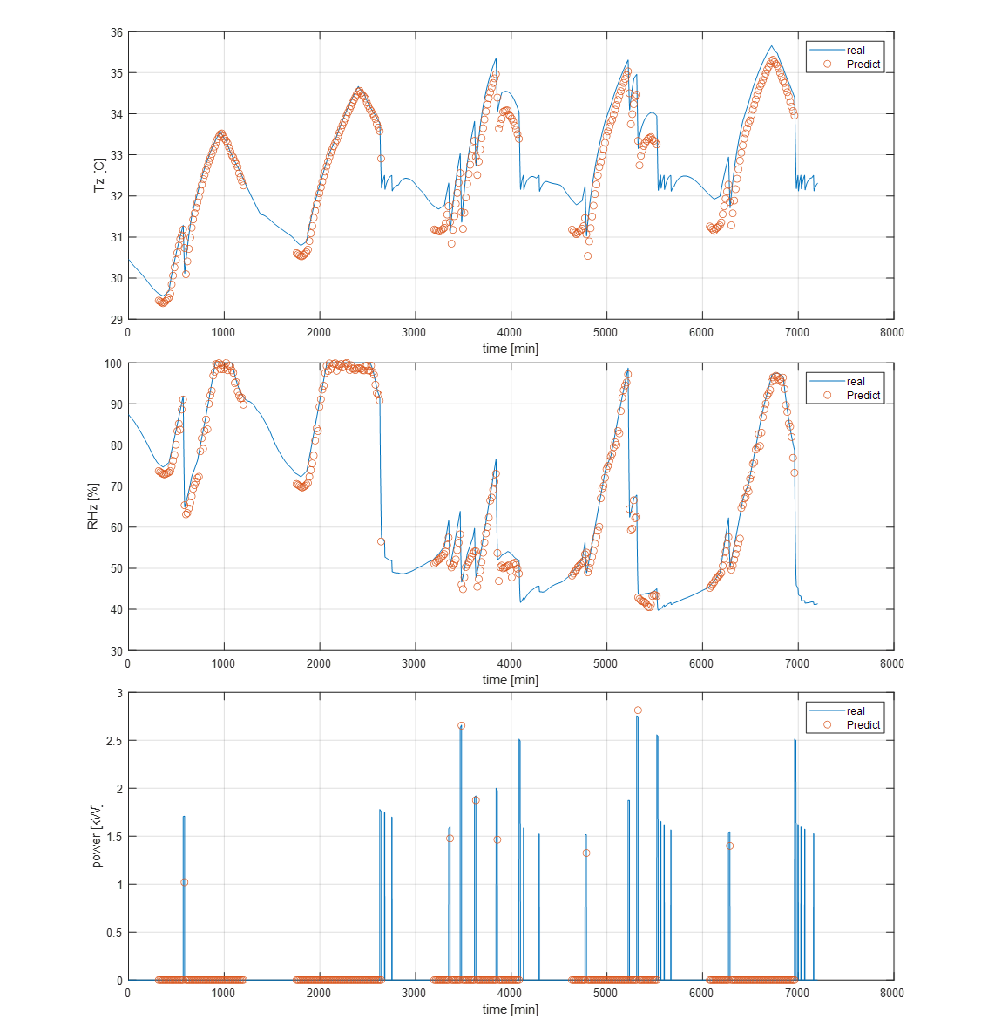

Figure ‑ Prediction model performances for evaluation case 15occ-N-3SP-4D with GOCC-based MPC

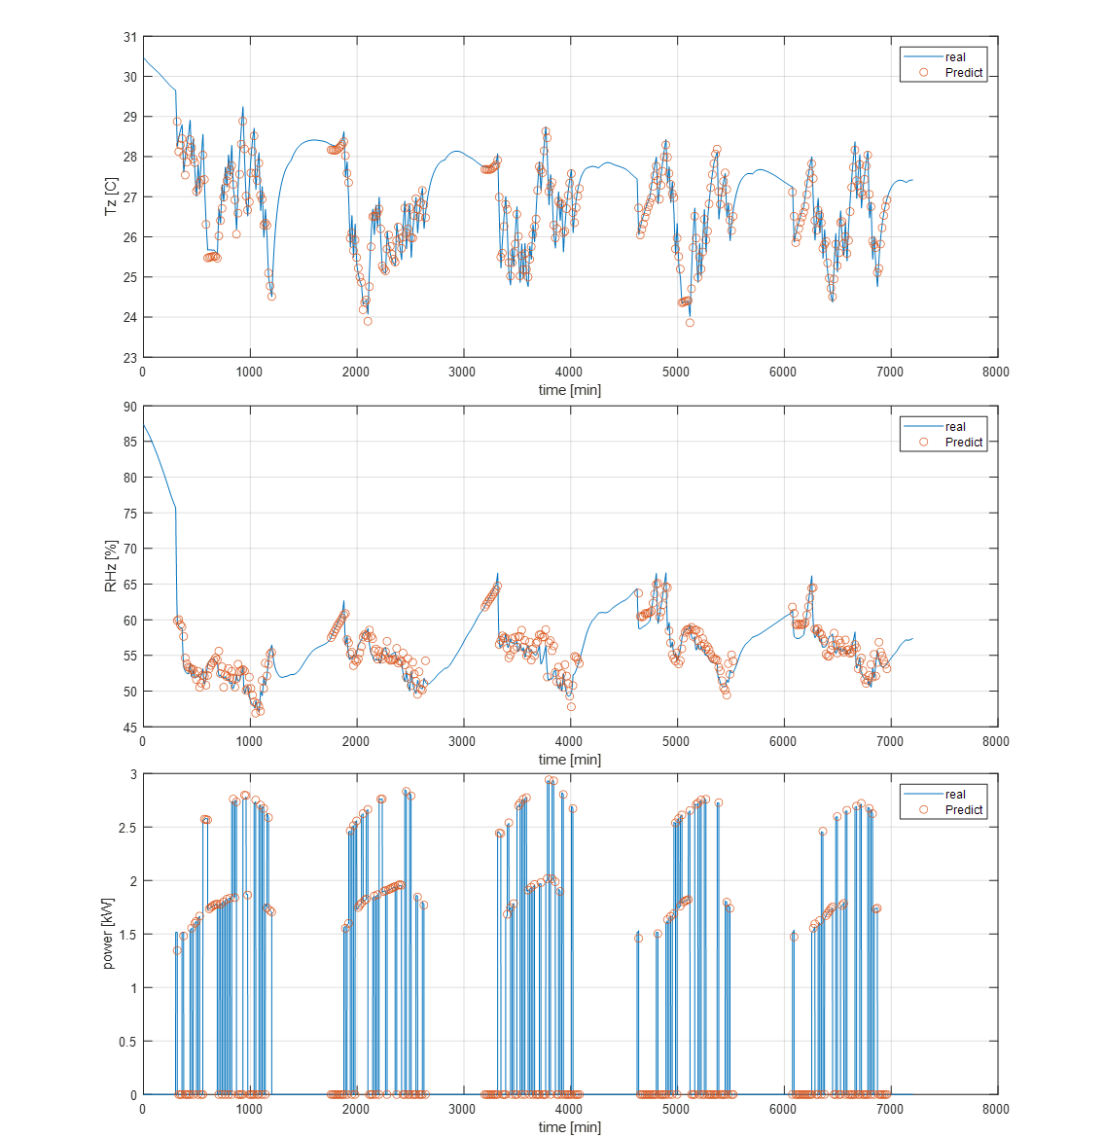

Figure ‑ Prediction model performances for evaluation case 15occ-N-3SP-4D with GOCC+TL MPC

Table ‑ Prediction error (RMSE) of zone temperature, zone relative humidity, and HVAC system power for all evaluation cases

|  |  |  |  |  |  |  |  |  |  |  |  |  |  |  |  |
| --- | --- | --- | --- | --- | --- | --- | --- | --- | --- | --- | --- | --- | --- | --- | --- |
|  | **5occ-N-3SP-5D** | | | **15occ-N-3SP-5D** | | | **7occ-N-3SP-5D** | | | **15occ-N-3SP-4D** | | | **5occ-N-3SP-4D** | | |
| **Tz [C]** | **RHz [%]** | **power [W]** | **Tz [C]** | **RHz [%]** | **power [W]** | **Tz [C]** | **RHz [%]** | **power [W]** | **Tz [C]** | **RHz [%]** | **power [W]** | **Tz [C]** | **RHz [%]** | **power [W]** |
| **Temperature-based MPC** | 0.2 | 1.51 | 24.5 | 0.26 | 1.56 | 14.5 | 0.09 | 0.16 | 21.1 | 0.26 | 1.56 | 14.5 | 0.2 | 1.51 | 24.5 |
| **GOCC-based MPC** | 0.21 | 2.86 | 5.5 | 0.4 | 1.52 | 43.5 | 0.41 | 1.16 | 31 | 0.26 | 1.88 | 11.8 | 0.33 | 4.42 | 37.3 |
| **GOCC+TL MPC** | 0.24 | 1.71 | 17 | 0.28 | 1.67 | 20.5 | 0.21 | 2.61 | 5.2 | 0.33 | 3.23 | 33.2 | 0.36 | 4.21 | 47.9 |
|  | **15occ-N-3SP-1D** | | | **15occ-N-3SP-3D** | | | **7occ-N-3SP-3D** | | | **5occ-C-3SP-5D** | | | **7occ-N-3SP-2D** | | |
| **Tz [C]** | **RHz [%]** | **power [W]** | **Tz [C]** | **RHz [%]** | **power [W]** | **Tz [C]** | **RHz [%]** | **power [W]** | **Tz [C]** | **RHz [%]** | **power [W]** | **Tz [C]** | **RHz [%]** | **power [W]** |
| **Temperature-based MPC** | 0.26 | 1.56 | 14.5 | 0.26 | 1.56 | 14.5 | 0.09 | 0.16 | 21.1 | 0.2 | 1.51 | 24.5 | 0.09 | 0.16 | 21.1 |
| **GOCC-based MPC** | 0.26 | 1.2 | 16.4 | 0.28 | 3.03 | 20.7 | 0.43 | 2.69 | 44.2 | 0.44 | 2.66 | 15.7 | 0.23 | 2.68 | 6.8 |
| **GOCC+TL MPC** | 0.37 | 2.53 | 23.7 | 0.29 | 2.95 | 22.8 | 0.27 | 1.58 | 25 | 0.25 | 1.63 | 12.5 | 0.36 | 3.11 | 29.5 |

According to the Figure 5‑3 to Figure 5‑5, under the Temperature-based MPC, the zone temperature is maintained below 27°C during occupied hours, aligning with the temperature constraints set in this control strategy and meeting the expected outcomes. While under the GOCC-based MPC, both zone temperature and humidity appear are almost uncontrolled, with temperature reaching 30°C and relative humidity exceeding 90%. And the HVAC system power remains at zero for a long time, indicating that the system is not operating. For the GOCC+TL MPC, the zone temperature fluctuates between 25°C and 28°C, and the zone air relative humidity and the HVAC system power profile also look reasonable. A more detailed analysis of the results from GOCC-based MPC and GOCC+TL MPC cases will be discussed in Section 5.4.5.

### Prediction accuracy of group thermal comfort model

Based on multiple simulations of occupant thermal comfort, the JSD box plots of the group thermal comfort model are presented in the Figure 5‑6. Each sub-figure illustrates the distribution of the group thermal comfort model JSD in both GOCC-based MPC and GOCC+TL MPC across the evaluation cases. The median and mean values of these distributions are summarized in Table 5‑5 for further comparison and analysis.



Figure ‑ JSD boxplots of group thermal comfort models in GOCC-based MPC and GOCC+TL MPC for evaluation cases

Table ‑ The median and mean of prediction accuracy ($\overline{JSD}$) of group occupant thermal comfort in evaluation cases

|  |  |  |  |  |  |  |  |  |  |  |
| --- | --- | --- | --- | --- | --- | --- | --- | --- | --- | --- |
|  | **5occ-N-3SP-5D** | | **15occ-N-3SP-5D** | | **7occ-N-3SP-5D** | | **15occ-N-3SP-4D** | | **5occ-N-3SP-4D** | |
| **medium** | **mean** | **medium** | **mean** | **medium** | **mean** | **medium** | **mean** | **medium** | **mean** |
| **GOCC-based MPC** | 0.175 | 0.187 | 0.261 | 0.266 | 0.465 | 0.45 | 0.316 | 0.285 | 0.347 | 0.37 |
| **GOCC+TL MPC** | 0.074 | 0.073 | 0.096 | 0.107 | 0.092 | 0.105 | 0.112 | 0.138 | 0.183 | 0.184 |
|  | **15occ-N-3SP-1D** | | **15occ-N-3SP-3D** | | **7occ-N-3SP-3D** | | **5occ-C-3SP-5D** | | **7occ-N-3SP-2D** | |
| **medium** | **mean** | **medium** | **mean** | **medium** | **mean** | **medium** | **mean** | **medium** | **mean** |
| **GOCC-based MPC** | 0.394 | 0.388 | 0.437 | 0.421 | 0.518 | 0.474 | 0.323 | 0.315 | 0.616 | 0.554 |
| **GOCC+TL MPC** | 0.086 | 0.125 | 0.307 | 0.285 | 0.176 | 0.187 | 0.294 | 0.274 | 0.376 | 0.367 |

The results indicate that the group thermal comfort model performance in GOCC+TL MPC is always better than that in GOCC-based MPC. Additionally, the JSD values of the group thermal comfort models across different evaluation cases closely align with the JSD values in the model development phase mentioned in Section 5.3.2. This consistency suggests that the accuracy of the group thermal comfort model is performing as expected.

### Control performance on group thermal comfort

Similar to the evaluation of the accuracy of the group thermal comfort model, the results of the average occupant thermal discomfort vote are also presented in the form of a box plot, as shown in Figure 5‑7. The median and mean values of the box plot are summarized in Table 5‑6 for further analysis and comparison.



Figure ‑ Average Occupant Discomfort Vote boxplots of three MPCs in evaluation cases

Table ‑ The median and mean of the average occupant discomfort vote in evaluation cases

|  |  |  |  |  |  |  |  |  |  |  |
| --- | --- | --- | --- | --- | --- | --- | --- | --- | --- | --- |
|  | **5occ-N-3SP-5D** | | **15occ-N-3SP-5D** | | **7occ-N-3SP-5D** | | **15occ-N-3SP-4D** | | **5occ-N-3SP-4D** | |
| **medium** | **mean** | **medium** | **mean** | **medium** | **mean** | **medium** | **mean** | **medium** | **mean** |
| **Temperature-based MPC** | 13 | 13.5 | 18.5 | 18.1 | 13 | 16.3 | 18 | 18.1 | 13 | 13.5 |
| **GOCC-based MPC** | 60.5 | 65.4 | 82 | 78.0 | 109 | 103.4 | 90.5 | 83.3 | 69.5 | 74.3 |
| **GOCC+TL MPC** | 8.5 | 8.8 | 9 | 11.5 | 9 | 10.6 | 7.5 | 9.1 | 15 | 14.6 |
|  | **15occ-N-3SP-1D** | | **15occ-N-3SP-3D** | | **7occ-N-3SP-3D** | | **5occ-C-3SP-5D** | | **7occ-N-3SP-2D** | |
| **medium** | **mean** | **medium** | **mean** | **medium** | **mean** | **medium** | **mean** | **medium** | **mean** |
| **Temperature-based MPC** | 18.5 | 18.1 | 18 | 18.1 | 13.5 | 16.3 | 13.5 | 17.3 | 13.5 | 16.3 |
| **GOCC-based MPC** | 73.5 | 75.6 | 97 | 90.0 | 100 | 100.0 | 48.5 | 50.0 | 137.5 | 131.7 |
| **GOCC+TL MPC** | 13 | 15.0 | 39.5 | 35.6 | 13.5 | 13.2 | 28.5 | 26.7 | 80 | 86.4 |

The results indicate that, compared to the Temperature-based MPC, the GOCC-based MPC tends to result in higher occupant discomfort. This outcome can be explained by the predictive performance of the group thermal comfort model in the GOCC-based MPC case, which is discussed in Section 5.4.2. Specifically, the JSD of the group thermal comfort model in GOCC-based MPC is relatively higher, indicating a lower prediction accuracy. This leads to misestimations of group thermal comfort, ultimately resulting in failed control decisions and occupant’s poorer thermal comfort. In contrast, for the GOCC+TL MPC cases, several evaluated cases (i.e., 5occ-N-3SP-5D, 15occ-N-3SP-5D, 7occ-N-3SP-5D, 15occ-N-3SP-4D, 15occ-N-3SP-1D, and 7occ-N-3SP-3D) show improved occupant thermal comfort compared to the Temperature-based MPC cases. Among these, the most effective case is 15occ-N-3SP-4D, where the GOCC+TL MPC strategy reduces the average occupant discomfort by approximately 9 votes (50%) compared to the Temperature-Based MPC. The less effective but still beneficial case is 15occ-N-3SP-1D, which achieves a reduction of 3 in discomfort (approximately 16%). The relationship between the JSD of the group thermal comfort model and its benefit on occupant thermal comfort will be further examined in Section 5.4.6.

### Control performance on HVAC system energy usage

The resulting HVAC system energy consumption of the three MPCs in all evaluation cases are presented in Figure 5‑8 and Table 5‑7. In Table 5‑7, GOCC-based MPCs and GOCC+TL MPCs also show the change in their energy consumption relative to Temperature-based MPCs, with green color representing energy saving and red color representing more energy consuming. When analyzing the results, it becomes evident that those cases with poor group comfort model prediction accuracy tend to have a much lower energy consumption compared to corresponding cases controlled by Temperature-based MPC. Evidently, this reduction in energy usage is achieved by sacrificing occupant thermal comfort. Therefore, a lower energy consumption in these cases does not imply good control performance. The cases identified in Section 5.4.3 as effective in improving occupant thermal comfort have varying impacts on energy consumption. Some result in higher consumption, while others lead to lower consumption compared to corresponding ones controlled by Temperature-based MPC. Since the primary goal of this study is to improve group thermal comfort, it will be preferred to prioritize thermal comfort improvements over energy consumption when evaluating the effectiveness of the TMPC-GOCC. The impact of effective GOCC+TL MPC cases on HVAC energy consumption will be further analyzed in the following section 5.4.5.



Figure ‑ HVAV energy usage of three MPCs in all evaluation cases

Table ‑ The total energy usage [kWh] in all evaluation cases

|  |  |  |  |  |  |
| --- | --- | --- | --- | --- | --- |
|  | **5occ-N-3SP-5D** | **15occ-N-3SP-5D** | **7occ-N-3SP-5D** | **15occ-N-3SP-4D** | **5occ-N-3SP-4D** |
| **Temperature-based MPC** | 72.1 | 75.4 | 74.0 | 75.4 | 72.1 |
| **GOCC-based MPC** | 48.1 (-24) | 40.1 (-35.3) | 17.1 (-56.9) | 28.1 (-47.3) | 46.3 (-25.8) |
| **GOCC+TL MPC** | 78.6 (+6.5) | 63.1 (-12.3) | 54.3 (-19.7) | 62.4 (-13) | 66.8 (-5.3) |
|  | **15occ-N-3SP-1D** | **15occ-N-3SP-3D** | **7occ-N-3SP-3D** | **5occ-C-3SP-5D** | **7occ-N-3SP-2D** |
| **Temperature-based MPC** | 75.4 | 75.4 | 74.0 | 72.1 | 74.0 |
| **GOCC-based MPC** | 33.4 (-42) | 26.6 (-48.8) | 17.1 (-56.9) | 32.9 (-39.2) | 8.3 (-65.7) |
| **GOCC+TL MPC** | 70.5 (-4.9) | 38.0 (-37.4) | 59.4 (-14.6) | 49.6 (-22.5) | 22.4 (-56.1) |

### Control performance analysis

In this section, the performance of the proposed TMPC-GOCC strategy is further analyzed with a focus on the two main aspects, i.e., whether it can reduce the thermal discomfort of the group occupants compared to temperature-based MPCs, and the reasons for the impact of the effective TMPC-GOCC strategy in terms of energy consumption.

#### Reasons for the poor performance of GOCC-based MPC

To further analyze the reasons behind the failure of GOCC-based MPC, a detailed examination is conducted using the 15occ-N-3SP-4D case (results shown in Figure 5‑3 to Figure 5‑5) as an example. In this case, the validation errors (JSD) of the group thermal comfort model obtained without and with transfer learning are 0.276 and 0.119, respectively, as shown in Table 5‑2. When these models are applied in a MPC strategy, their median prediction accuracy ($\overline{JSD}$), as shown in Table 5‑5, are 0.316 and 0.112, which are consistent with the validation errors reported in Chapter 4.

When examining the zone environment results, combined the group thermal comfort model JSD and occupant discomfort vote, it is evident that in the GOCC-based MPC case, the poor predictive performance of the group thermal comfort model (trained without transfer learning) leads to incorrect predictions of group occupant comfort. This results in higher occupant discomfort votes. The subfigure (a) in Figure 5‑9 shows the MPC predicted group thermal comfort result in the 15occ-N-3SP-4D GOCC-based MPC case. And the subfigure (b) in Figure 5‑9 shows the virtual testbed simulated group thermal comfort result (using one of the 50 simulations as an example) in the same case. In this case, as shown in subfigure (a) in Figure 5‑9, the group thermal comfort model trained without TL always incorrectly believed that the group thermal comfort would satisfy the MPC constraints of thermal comfort for 80% of the occupants in poor thermal environments (e.g., temperatures and humidity at 30°C and 80%). As a result, the GOCC-based MPC strategy chose not to turn on the HVAC system. This misjudgment creates a vicious cycle where the thermal environment becomes increasingly uncontrolled, further exacerbating discomfort. This ultimately leads to the simulation results in subfigure (b) in Figure 5‑9 that the group thermal comfort of the 15-occupants group never exceeded 10.

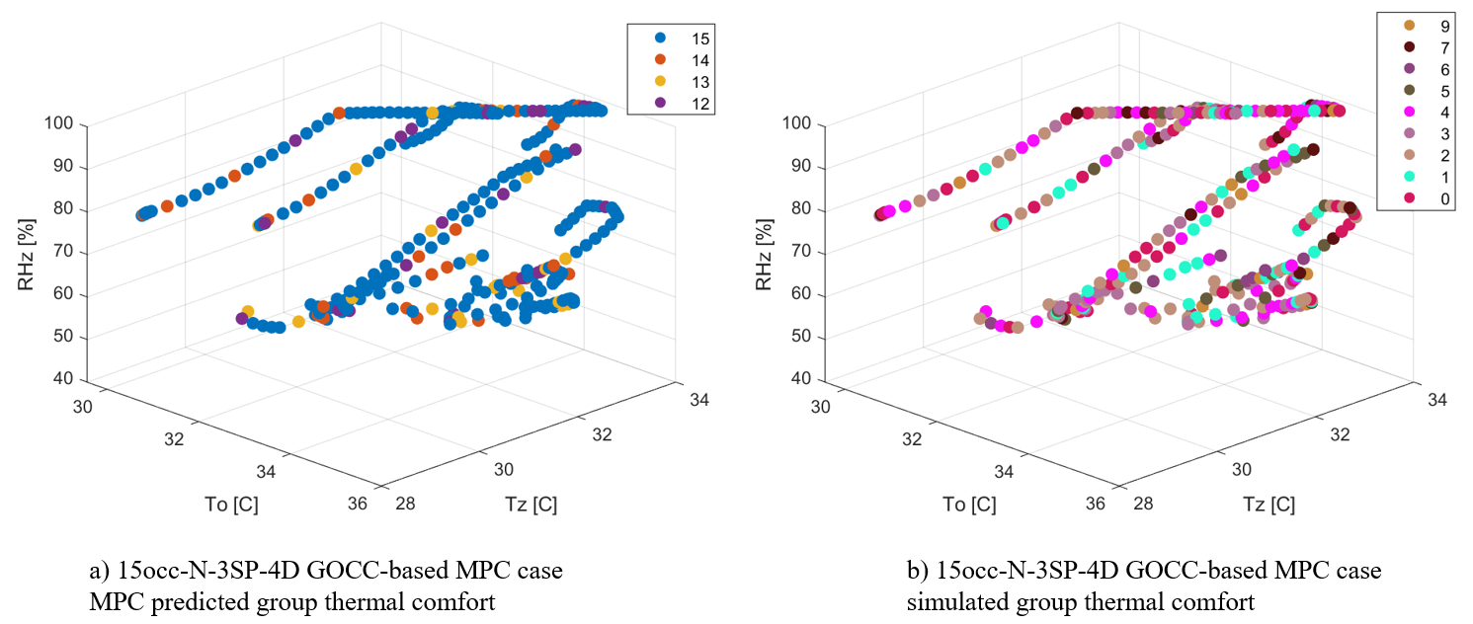

Figure ‑ 15occ-N-3SP-4D GOCC-based MPC predictive performance

In contrast, in the GOCC+TL MPC case, the group thermal comfort model trained with transfer learning achieves better predictive performance, allowing the MPC to estimate group occupant comfort correctly. The Figure 5‑10 shows the predicted results of the MPC for group thermal comfort and the simulation results of the virtual test bed in the 15occ-N-3SP-4D GOCC+TL MPC case. During MPC optimization, the controller indeed ensures that at least 80% of occupants remain thermally comfortable, leading to appropriate HVAC operation. As a result, occupant discomfort is significantly reduced compared to the temperature-based MPC, demonstrating the effectiveness of the proposed TMPC-GOCC strategy in improving occupant thermal comfort.

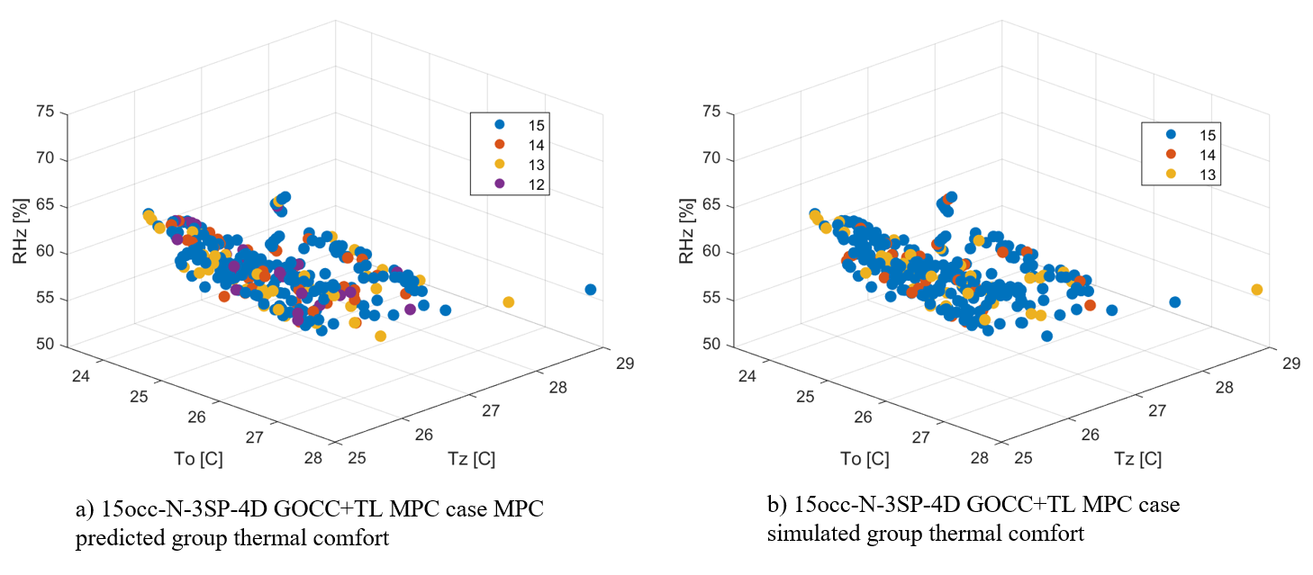

Figure ‑ 15occ-N-3SP-4D GOCC+TL MPC predictive performance

#### The impact of effective TMPC + TL MPC on HVAC system energy usage

Based on the results in Section 5.4.3, the GOCC+TL MPC cases that effectively reduce occupant discomfort include 5occ-N-3SP-5D, 15occ-N-3SP-5D, 7occ-N-3SP-5D, 15occ-N-3SP-4D, 15occ-N-3SP-1D, and 7occ-N-3SP-3D. Among these cases, only the 5occ-N-3SP-5D case has higher HVAC energy consumption compared to its temperature-based MPC, whereas the rest of the cases achieve both improved occupant comfort and reduced energy consumption.

These six cases involve three occupant groups consisting of 5, 7, and 15 occupants, all of whom have neutral thermal preferences. However, despite this nominal similarity in thermal preference, the specific thermally acceptable ranges for these groups still differ since they are sampled from the RP-884 curve, as described in Section 4.3.2. Figure 5‑11 presents the PMV-PPD curves for the three groups, where the median average thermal acceptable ranges for the groups of 5, 7, and 15 occupants are -0.20, 0.14, and 0.21, respectively.

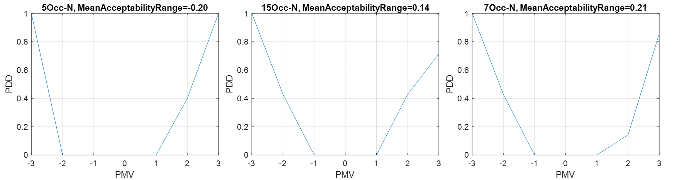

Figure ‑ PMV-PDD curves for 5-, 15-, and 7-occupants group with neutral thermal preference

As a comparison, for a typical thermal environment (zone air temperature of 26.5°C, zone humidity of 55%, zone mean radiant temperature of 27°C, and zone air speed of 0) and typical occupant measurements (metabolic rate of 1.2met, clothing insulation level of 0.3clo) under temperature-based MPC control, the calculated PMV is 0.06. Comparing the PMV value with the thermal preferences of the three occupant groups, it can be concluded that the 5-person group prefers a cooler environment, while the 7-person and 15-person groups prefer a warmer environment.

When the GOCC+TL MPC is implemented, the MPC aims to control the thermal environment to align with the thermal preferences of the occupant group. As a result, a cooler thermal preference leads to greater HVAC energy consumption, whereas a warmer thermal preference leads to lower HVAC energy consumption. So, in conclusion, compared to its temperature-based MPC, the impact of this GOCC+TL MPC on energy consumption ultimately depends on the group's thermal acceptable range or thermal preference. In another word, if the occupants, as a group, prefer a warmer environment, GOCC+TL MPC can effectively reduce energy consumption, while improving overall group thermal comfort. Even if the occupants, as a group, prefer a cooler environment, the GOCC+TL MPC strategy may lead to higher energy consumption compared to traditional Temperature-based MPC. This increased energy use is justified by its role in improving group thermal comfort.

### Group thermal comfort model JSD threshold and recommendation

As mentioned in Section 5.4.3, a lower JSD generally correlates with better control performance in cases using GOCC+TL MPC. Therefore, this section aims to quantify the relationship between group thermal comfort model’s JSD value and the effectiveness of corresponding GOCC+TL MPC control to determine a JSD threshold. This JSD threshold will serve as a recommended accuracy criterion for the group thermal comfort model in practical applications, guiding model development to ensure reliable control performance.

The effectiveness of a GOCC+TL MPC is evaluated by the occupants’ discomfort vote, compared to that from temperature-based MPC cases. Therefore, the following two indices, namely the mean or median difference of average occupant discomfort vote in temperature-based MPC and GOCC+TL MPC, are defined in Equation (23-24) and computed using data from Table 5‑6. If the computed differences are positive, then the TMPC-GOCC is effective in minimizing occupant discomfort, compared to temperature-based MPC.

${ΔAvgDiscomfVote}_{mean}=mean\left({AvgDiscomfVote}_{temp-based MPC}\right)-mean({AvgDiscomfVote}_{GOCC+TL MPC})$ (23)

${ΔAvgDiscomfVote}_{med}=med\left({AvgDiscomfVote}_{temp-based MPC}\right)-med({AvgDiscomfVote}_{GOCC+TL MPC})$ (24)

The JSD of the group thermal comfort model in GOCC+TL MPC (Table 5‑5) and its control effect ($ΔAvgDiscomfVote$) for all evaluation cases are plotted in the Figure 5‑12. In Figure 5‑12, blue points represent average discomfort vote results obtained using mean values, while orange points correspond to those from median values. Given the observed trend, a quadratic curve fitting was performed, with R² values of 0.96 and 0.92 for the mean and median fitted curves, respectively. Additionally, a black dashed line is plotted in the figure to indicate $ΔAvgDiscomfVote$ = 0, serving as a reference for determining when the GOCC+TL MPC begins to outperform the temperature-based MPC in terms of occupant comfort. It is important to note that this quadratic fit is used only to illustrate the general trend of the relationship between the JSD of the group thermal comfort model and its impact on MPC control performance. By comparing the fitted curve with the dashed line, the JSD threshold at which GOCC+TL MPC becomes effective can be approximately inferred. While this threshold value does not guarantee a better performance, it serves as an empirical reference for practical applications. According to Figure 5‑10, the intersection of the fitted curve and the dashed line occurs at JSD = 0.212. This suggests that when the JSD of the group thermal comfort model is less than 0.212, the GOCC+TL MPC strategy results in reduced occupant discomfort compared to the Temperature-based MPC, for all evaluation cases.

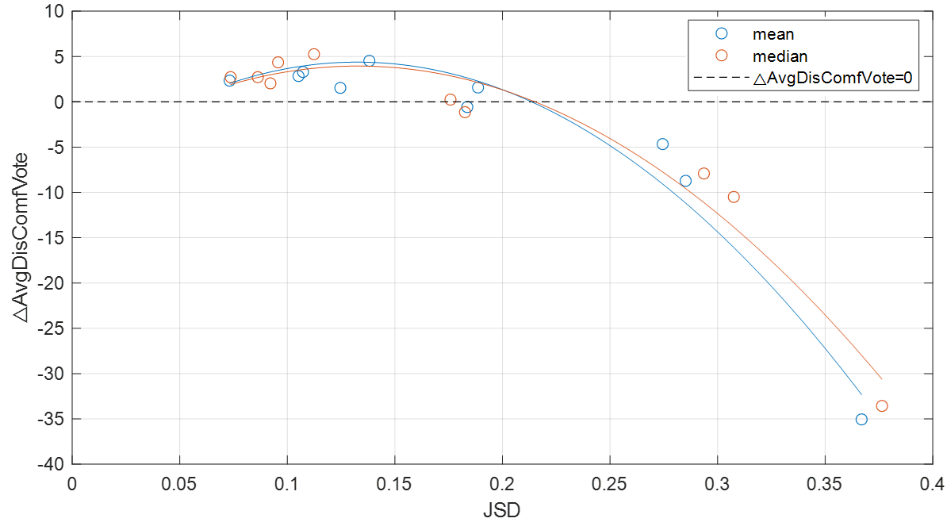

Figure ‑ Relationship between the JSD of a group thermal comfort model and the control effect of its MPC

Based on the above discussions, it is concluded that a JSD threshold around 0.2 can be used for similar studies to evaluate their group thermal comfort model accuracy. If a group thermal comfort model’s accuracy is higher than 0.2, there is a better chance that this model can improve group thermal comfort, when used in an MPC strategy. For scenarios that differ from those in this study, such as different building types or HVAC systems, the JSD threshold may not remain consistent, but can serve as a reference. In this study, the proposed group thermal comfort model uses three input features: zone air temperature, zone air relative humidity, and outdoor air temperature. As detailed in Section 4.3.2, the evaluation cases covered the following ranges: zone air temperature from 23.5°C to 28.1°C, zone air relative humidity from 55.9% to 84.0%, and outdoor air temperature from 23.5°C to 31.1°C. These ranges cover the most typical indoor and outdoor environment conditions in summer. Therefore, in other scenarios, if the environmental conditions fall within these ranges, the recommended JSD threshold of 0.2 remains applicable. Otherwise, more case studies are needed for a valid JSD threshold suitable for the new scenarios.

Additionally, as discussed in Section 4.4, transfer learning can always enhance the predictive performance of the group thermal comfort model, i.e., reducing its JSD. While the exact reduction varies case by case, the average improvement for all tested cases is about 0.15. Threshold like the ones discussed above can be further used to guide data collection. For example, by combining the JSD threshold and the average improvement of JSD from transfer learning, it can be suggested that the JSD of the group thermal comfort model trained solely on collected data (before applying transfer learning) should not exceed 0.35. Otherwise, even with transfer learning, the final group thermal comfort model may not be accurate enough for MPC purposes. Furthermore, the left plot in Figure 4‑6 in Section 4.4 illustrates the relationship between the information entropy of the collected data and the JSD of the group thermal comfort model before and after transfer learning. Based on this relationship, it can be further suggested that when the information entropy of the collected data exceeds 1.6 bits, the JSD of the group thermal comfort model after transfer learning will likely be below 0.2, which then makes the subsequent work of TMPC+GOCC likely effective.

It is important to note that these suggestions are based on generalized ideal assumptions derived from the overall results of this study. However, considering the diverse cases that have been tested, the suggestions serve as a starting point for future users in data collection. Variability in real-world conditions, data quality, and model uncertainties may influence the actual effectiveness of the suggestions, and further validation may be required for specific use cases.

## Chapter Conclusions

This chapter integrates the findings from previous chapters, including the virtual testbed introduced in Chapter 2, the predictive models developed in Chapter 3, and the application of transfer learning to the group thermal comfort model in Chapter 4, for the development and evaluation of the TMPC-GOCC strategy. Ten evaluation cases with varying occupant numbers, thermal comfort preference, and target data collection mechanisms, were used to compare the performances of three MPC strategies, namely, Temperature-based MPC, GOCC-based MPC, and GOCC+TL MPC. Comparison results demonstrate the advantages of the proposed TMPC-GOCC strategy in enhancing group thermal comfort. Additionally, this chapter further reveals that poor prediction accuracy of the group thermal comfort model leads to incorrect MPC decisions and ultimately results in unsatisfied MPC performance. Finally, a JSD threshold for the group thermal comfort model accuracy is determined, which serves as a recommended criteria for future model development, ensuring the effectiveness of the TMPC-GOCC strategy in practical applications.

The work presented in this chapter aligns with Task 4 outlined in Section 1.4, which focuses on developing and evaluating the proposed TMPC-GOCC strategy. Specifically, Subtask 4.1 corresponds to Section 5.2, which involves designing the MPC framework, including its objective function, constraints, and optimization algorithms. Subtask 4.2 corresponds to Section 5.3, which includes the evaluation case design and the evaluation method used for TMPC-GOCC. Finally, Subtask 4.3 corresponds to Section 5.4, which analyzes the control performance of TMPC-GOCC.

# Summary and Future Works

## Overall Achievement

The primary research objective of this thesis is to develop and evaluate a Transferable MPC-based Group Occupant-Centric Control (TMPC-GOCC) strategy. This strategy aims to mitigate occupant comfort conflicts while addressing the challenge of insufficient occupant data for reliable predictive model development. To achieve this goal, the research is divided into four key tasks, summarized as follows:

* Task 1 focuses on developing a virtual testbed that includes HVAC systems, building zones, and occupant models. This involves a simulation model for an air-source heat pump system, an EnergyPlus model for a small office zone, and an agent-based occupant thermal comfort model.
* Task 2 centers on developing predictive models required for the TMPC-GOCC framework, including models for group occupant thermal comfort, zone environmental conditions, and HVAC system power. The main innovation is developing and evaluating the group occupant thermal comfort model.
* Task 3 develops and evaluates a transfer learning methodology for the group occupant thermal comfort model. This includes designing a transfer learning framework, defining its applicable scenarios, and evaluating it across different conditions.
* Task 4 develops and evaluates the TMPC-GOCC strategy. This includes formulating the MPC by integrating predictive models, defining objective functions and constraints, and selecting optimization algorithms. A series of evaluation cases is designed to assess the strategy’s effectiveness. After implementing them into the virtual testbed, a comprehensive evaluation of the control performance is performed.

This dissertation has the following major achievements:

Developed a representative and comprehensive virtual testbed (Chapter 2): A virtual testbed integrating the building, HVAC system, and occupant models was developed. The components of the testbed have been verified using real data. This testbed serves as a data generation platform and a testing environment for the development and evaluation of the proposed control strategy.

Developed forecasting models of group thermal comfort, zone environmental condition, and HVAC system power that can be used in a model-predictive-control framework (Chapter 3): The concept of group thermal comfort was defined, and a prediction model was developed for it. Additionally, a weighted average JSD was proposed as a performance metric to evaluate the predictive accuracy of the group thermal comfort model. The results demonstrate that the proposed model effectively captures occupant thermal comfort distribution.

Developed a transfer learning framework (Chapter 4): To address the challenge of insufficient training data, a transfer learning framework was developed for the group thermal comfort model. The framework was evaluated through a series of case studies, demonstrating that transfer learning consistently improves the predictive performance of the group thermal comfort model.

Developed the TMPC-GOCC strategy (Chapter 5): The TMPC-GOCC strategy was developed and implemented in the virtual testbed which is used to assess TMPC-GOCC’s control performance. The results show that the proposed TMPC-GOCC strategy effectively reduces average occupant thermal discomfort compared to conventional MPC strategies, such as temperature-constrained MPC. Furthermore, a JSD threshold suitable for the group thermal comfort model was identified, serving as a recommended accuracy criterion for future model development.

## Limitation and Future Work

### Single HVAC System and Zone Thermal Model in the Virtual Testbed

This study primarily focuses on evaluating the effectiveness of the proposed TMPC-GOCC strategy for occupant groups across diverse scenarios. As a result, the development of the virtual testbed and evaluation case design prioritized the variability in occupant groups. Consequently, the virtual testbed in this study is based on a single HVAC system type and one zone type—specifically, a two-stage air source heat pump in a small office building. While the current findings demonstrate that TMPC-GOCC is effective within this testbed, its performance remains untested in other HVAC configurations. For instance, its applicability to systems such as AHU-VAV or VRF systems requires further evaluation. Additionally, the ASHP used in this study has limited control signals, restricting the HVAC operation to three discrete states: no operation, low-speed operation, and high-speed operation. This constrained control flexibility may limit the optimization potential of the MPC strategy.

Therefore, future research should extend the evaluation scope by incorporating additional HVAC configurations and building types to comprehensively assess the robustness and adaptability of the proposed TMPC-GOCC strategy.

### The Index of Group Thermal Comfort

The proposed group thermal comfort index is defined as the number of occupants who are thermally comfortable within a group in the same space. In the current study scenario, where the maximum number of occupants is 15, this index effectively captures differences under different thermal environmental conditions. However, in larger occupant groups, minor differences in this index become less impactful, particularly for MPC optimization. For instance, in a group of 100 occupants, the difference between having 91 and 92 comfortable occupants has a negligible effect on optimization outcomes.

To address this limitation, future research could explore a categorical classification approach for the group thermal comfort model in scenarios with a large number of occupants. Instead of predicting an exact count, the model could classify group comfort into five discrete categories: Majority (more than 80% of occupants comfortable), Most (60%–80% comfortable), Average (40%–60% comfortable), Few (20%–40% comfortable), and Very Few (less than 20% comfortable). This classification method would make the group thermal comfort model more robust while reducing computational complexity for MPC optimization. By simplifying the comfort representation, this approach could improve the scalability of the TMPC-GOCC strategy in large-scale occupant scenarios, ensuring more effective and efficient control decisions.

### The Algorithm Used in Modeling and Optimization

This study did not focus extensively on algorithm tuning, as most algorithms were mostly implemented using default MATLAB guide settings. This includes the Random Forest model for the group thermal comfort model, the genetic algorithm for sample adaptation in transfer learning, and the exhaustive search method for MPC optimization. While the final results obtained were satisfactory, the computational time required for individual processes was relatively high. For instance, running transfer learning for the group thermal comfort model in a single case took approximately 30 minutes, and simulating a single GOCC+TL MPC case required 120 minutes. Considering the various evaluation cases designed in each chapter, the overall computational time remains a concern.

To address this issue, future research can focus on tuning algorithm settings to reduce computational costs. This could involve adjusting hyperparameters within the existing algorithms or exploring alternative machine-learning approaches.

### Inconsistency Between the Objective Function and Evaluation Method

In the TMPC-GOCC strategy, HVAC system energy consumption and occupant thermal comfort are key considerations. However, the MPC objective function and the evaluation method are not consistent when handling these factors. In the MPC formulation, occupant thermal comfort is treated as a constraint, and the objective function focuses on minimizing HVAC system energy consumption. However, during control performance evaluation, the primary focus is on occupant thermal comfort improvements rather than energy consumption, as the TMPC-GOCC strategy is designed to be occupant-centric. This inconsistency could be a potential limitation or drawback of the study.

To address this issue, future research could explore the development of a unified metric that combines both HVAC system energy consumption and occupant thermal comfort into a single objective function. One possible approach is a weighted method, where energy efficiency and thermal comfort are assigned by adjustable weights based on user-defined preferences. This would not only create greater consistency between the MPC objective function and its evaluation method but also allow users to customize the balance between energy savings and occupant comfort.

### Recommended JSD Thresholds

The JSD thresholds for the group thermal comfort model are ideally inferred from the evaluation results and serve as recommended values to guide future model development. Although this report discusses the applicability of the deduced JSD threshold, the JSD threshold cannot guarantee its effectiveness in other scenarios.

Further research is needed to refine the JSD threshold across a wider range of building types, climatic zones, and occupant groups, improving the generalizability and robustness of these recommendations. If available, future study is suggested to incorporate real-world experiment and virtual testbed simulation cases to establish more universally applicable accuracy benchmarks for group thermal comfort models in TMPC-GOCC applications.

## List of Publications

**Published Journal Papers**

Li Y, Chen Z, Wen J, et al. A framework for calibrating and validating an HVAC system in Modelica[J]. Journal of Building Performance Simulation, 2025: 1-21.

Kimball R., Wen J., O’Neill Z., Li Y., et al. Developing Learning-Based Models for Occupant Centric Control[J]. 2022.

Calfa, C., Yang Z., Li Y., Chen Z., O’Neill Z., and Wen J., "Performance assessment of a real water source heat pump within a hardware-in-the-loop (HIL) testing environment." Science and Technology for the Built Environment 29, no. 10 (2023): 1011-1026

Chen Z., Li Y., Wen J., et al. A Simulation Framework for Analyzing the Impact of Stochastic Occupant Behaviors on Demand Flexibility in Typical Commercial Buildings[J]. 2023.

**Published Conference Papers**

1. Li Y., Chen Z, Wen J, et al. A framework for calibrating and validating an air loop dynamic model in an HVAC system in Modelica[C]. Proceedings of Building Simulation 2023: 18th Conference of IBPSA, Shanghai, CN, 2023.
2. Chen, Z., Wen, J., Li Y., et al., “A hardware-in-the-loop approach for laboratory performance verification of flexible building equipment in a typical commercial building”, ASHRAE Annual Conference, June 2021.
3. Chen, Z., Wen, J., Bushby, S. T., Lo, L. J., O’Neill, Z., Payne, W. V., Li Y., et al., “Development of a hardware-in-the-loop testbed for laboratory performance verification of flexible building equipment in typical commercial buildings”, ASHRAE Annual Conference, June 2022, Toronto, Ontario Canada.
4. Calfa, C., Yang, Z., Fu, Y., Chen, Z., O’Neill, Z., Wen, J., Li Y., et al., “Development of a water source heat pump hardware-in-the-loop (HIL) testing facility for smart building applications”, ASHRAE Annual Conference, June 2022, Toronto, Ontario Canada.
5. Chen, Z., Wen, J., Bushby, S. T., Lo, L. J., O’Neill, Z., Payne, W. V., Li Y, et al., “An analysis of the hybrid internal mass modeling approach in EnergyPlus”, eSim 2022 Conference, June 2022, Ottawa, ON.
6. Calfa C., Yang Z., Li Y., et al. Performance Assessment of a Model Predictive Controller for a Heat Pump in a Hardware-in-the-Loop Experimental Test Environment. ASHRAE 2025 winter conference, Orlando, Florida, February 8-12, 2025.

**Future Publication Plans**

A framework of transfer learning used in group occupant thermal comfort model

This journal article is a summary based on the content of Chapters 3 and 4 on group thermal comfort modeling and transfer learning. This paper will first identify the limitation of occupant thermal comfort models in real-world applications. It will then propose a concept of group thermal comfort and discuss its model development and evaluation methods. Finally, using transfer learning techniques to improve the scalability of the group thermal comfort model will be proposed.

Development of an MPC-based OCC with consideration of group occupant thermal comfort

This journal article is a summary based on the content of Chapters 5 about group OCC MPC development. This paper will first review the current state of the art of traditional MPC OCCs. It will then propose a framework for considering MPC for group thermal comfort and design a series of cases to evaluate its effectiveness in improving occupant comfort and energy savings.

A labeled demand flexibility dataset for typical commercial building HVAC systems: results from Hardware-in-the-Loop testing

This paper discusses how hardware-in-the-loop experiments were used to obtain high-resolution data about different HVAC systems under different operating conditions. The datasets include minute-by-minute performance data under various grid scenarios, climate conditions, occupant behavior, and control strategies that capture system response and energy consumption patterns.

Evaluation of demand flexibility on typical commercial building HVAC systems

This paper is an evaluation of the demand flexibility of a typical commercial building HVAC system. It evaluates a number of key performance indicators such as peak demand, daily energy consumption, overall demand flexibility, cost, etc. based on published relevant datasets.

# References

1. Klepeis, N.E., et al., *The National Human Activity Pattern Survey (NHAPS): a resource for assessing exposure to environmental pollutants.* Journal of Exposure Science & Environmental Epidemiology, 2001. **11**(3): p. 231-252.

2. Anastasi, G., et al., *Optimized Energy and Air Quality Management of Shared Smart Buildings in the COVID-19 Scenario.* Energies, 2021. **14**(8): p. 2124.

3. De Giuli, V., O. Da Pos, and M. De Carli, *Indoor environmental quality and pupil perception in Italian primary schools.* Building and Environment, 2012. **56**: p. 335-345.

4. Andargie, M.S. and E. Azar, *An applied framework to evaluate the impact of indoor office environmental factors on occupants’ comfort and working conditions.* Sustainable Cities and Society, 2019. **46**: p. 101447.

5. Li, N., et al., *Grey preference analysis of indoor environmental factors using sub-indexes based on Weber/Fechner's law and predicted mean vote.* Indoor and Built Environment, 2016. **25**(8): p. 1197-1208.

6. Lowry, G., *Energy saving claims for lighting controls in commercial buildings.* Energy and Buildings, 2016. **133**: p. 489-497.

7. O'Brien, W., et al., *Introducing IEA EBC Annex 79: Key challenges and opportunities in the field of occupant-centric building design and operation.* Building and Environment, 2020. **178**: p. 106738.

8. de Araújo Vieira, E.M., L.B. da Silva, and E.L. de Souza, *The influence of the workplace indoor environmental quality on the incidence of psychological and physical symptoms in intensive care units.* Building and Environment, 2016. **109**: p. 12-24.

9. Do, H. and K.S. Cetin, *Mixed-Mode ventilation in HVAC System for energy and economic benefits in residential buildings.* Energies, 2022. **15**(12): p. 4429.

10. Joe, J., *Investigation on pre-cooling potential of UFAD via model-based predictive control.* Energy and Buildings, 2022. **259**: p. 111898.

11. Taheri, S., P. Hosseini, and A. Razban, *Model predictive control of heating, ventilation, and air conditioning (HVAC) systems: A state-of-the-art review.* Journal of Building Engineering, 2022. **60**: p. 105067.

12. Qin, S.J. and T.A. Badgwell, *A survey of industrial model predictive control technology.* Control engineering practice, 2003. **11**(7): p. 733-764.

13. Mayne, D., *Model predictive control theory and design.* Nob Hill Pub, Llc, 1999.

14. Gunantara, N., *A review of multi-objective optimization: Methods and its applications.* Cogent Engineering, 2018. **5**(1): p. 1502242.

15. Meimand, M. and F. Jazizadeh, *A personal touch to demand response: An occupant-centric control strategy for HVAC systems using personalized comfort models.* Energy and Buildings, 2024. **303**: p. 113769.

16. De Dear, R., et al., *A review of adaptive thermal comfort research since 1998.* Energy and Buildings, 2020. **214**: p. 109893.

17. Zhao, Q., Z. Lian, and D. Lai, *Thermal comfort models and their developments: A review.* Energy and Built Environment, 2021. **2**(1): p. 21-33.

18. Enescu, D., *A review of thermal comfort models and indicators for indoor environments.* Renewable and Sustainable Energy Reviews, 2017. **79**: p. 1353-1379.

19. Martins, L.A., V. Soebarto, and T. Williamson, *A systematic review of personal thermal comfort models.* Building and Environment, 2022. **207**: p. 108502.

20. Park, J.Y., et al., *A critical review of field implementations of occupant-centric building controls.* Building and Environment, 2019. **165**: p. 106351.

21. Xie, J., et al., *Review on occupant-centric thermal comfort sensing, predicting, and controlling.* Energy and Buildings, 2020. **226**: p. 110392.

22. Naylor, S., M. Gillott, and T. Lau, *A review of occupant-centric building control strategies to reduce building energy use.* Renewable and Sustainable Energy Reviews, 2018. **96**: p. 1-10.

23. Soleimanijavid, A., I. Konstantzos, and X. Liu, *Challenges and opportunities of occupant-centric building controls in real-world implementation: A critical review.* Energy and Buildings, 2024: p. 113958.

24. Yau, Y. and B. Chew, *A review on predicted mean vote and adaptive thermal comfort models.* Building Services Engineering Research and Technology, 2014. **35**(1): p. 23-35.

25. Tennant, R., et al., *The Warwick-Edinburgh mental well-being scale (WEMWBS): development and UK validation.* Health and Quality of life Outcomes, 2007. **5**(1): p. 1-13.

26. Waterman, A.S., et al., *The Questionnaire for Eudaimonic Well-Being: Psychometric properties, demographic comparisons, and evidence of validity.* The journal of positive psychology, 2010. **5**(1): p. 41-61.

27. Balaji, B., et al. *Sentinel: occupancy based HVAC actuation using existing WiFi infrastructure within commercial buildings*. in *Proceedings of the 11th ACM Conference on Embedded Networked Sensor Systems*. 2013.

28. Azar, E., et al., *Simulation-aided occupant-centric building design: A critical review of tools, methods, and applications.* Energy and Buildings, 2020. **224**: p. 110292.

29. Dong, B., et al., *An information technology enabled sustainability test-bed (ITEST) for occupancy detection through an environmental sensing network.* Energy and Buildings, 2010. **42**(7): p. 1038-1046.

30. Yang, Z., et al., *A systematic approach to occupancy modeling in ambient sensor-rich buildings.* Simulation, 2014. **90**(8): p. 960-977.

31. Chen, Z., et al., *Building occupancy estimation with environmental sensors via CDBLSTM.* IEEE Transactions on Industrial Electronics, 2017. **64**(12): p. 9549-9559.

32. Chen, Z., C. Jiang, and L. Xie, *Building occupancy estimation and detection: A review.* Energy and Buildings, 2018. **169**: p. 260-270.

33. Salimi, S., Z. Liu, and A. Hammad, *Occupancy prediction model for open-plan offices using real-time location system and inhomogeneous Markov chain.* Building and Environment, 2019. **152**: p. 1-16.

34. Hagberg, K.G., *Evaluating field measurements of impact sound.* Building Acoustics, 2010. **17**(2): p. 105-128.

35. Zhang, E., et al., *Acoustic comfort evaluation modeling and improvement test of a forklift based on rank score comparison and multiple linear regression.* Applied Acoustics, 2018. **135**: p. 29-36.

36. Abboushi, B., et al., *Assessing the visual comfort, visual interest of sunlight patterns, and view quality under different window conditions in an open-plan office.* LEUKOS, 2021. **17**(4): p. 321-337.

37. Hong, T., et al., *Advances in research and applications of energy-related occupant behavior in buildings.* Energy and buildings, 2016. **116**: p. 694-702.

38. Zhao, J., et al., *Occupant behavior and schedule modeling for building energy simulation through office appliance power consumption data mining.* Energy and Buildings, 2014. **82**: p. 341-355.

39. Ren, X., D. Yan, and C. Wang, *Air-conditioning usage conditional probability model for residential buildings.* Building and Environment, 2014. **81**: p. 172-182.

40. Langevin, J., J. Wen, and P.L. Gurian, *Modeling thermal comfort holistically: Bayesian estimation of thermal sensation, acceptability, and preference distributions for office building occupants.* Building and Environment, 2013. **69**: p. 206-226.

41. Pang, Z., et al., *Nationwide HVAC energy-saving potential quantification for office buildings with occupant-centric controls in various climates.* Applied Energy, 2020. **279**: p. 115727.

42. Ma, Y., et al., *Model predictive control for the operation of building cooling systems.* IEEE Transactions on control systems technology, 2011. **20**(3): p. 796-803.

43. Ferreira, P., et al., *Neural networks based predictive control for thermal comfort and energy savings in public buildings.* Energy and buildings, 2012. **55**: p. 238-251.

44. Chen, X., Q. Wang, and J. Srebric, *Occupant feedback based model predictive control for thermal comfort and energy optimization: A chamber experimental evaluation.* Applied energy, 2016. **164**: p. 341-351.

45. Afram, A. and F. Janabi-Sharifi, *Theory and applications of HVAC control systems–A review of model predictive control (MPC).* Building and Environment, 2014. **72**: p. 343-355.

46. Yao, Y. and D.K. Shekhar, *State of the art review on model predictive control (MPC) in Heating Ventilation and Air-conditioning (HVAC) field.* Building and Environment, 2021. **200**: p. 107952.

47. Li, D., C.C. Menassa, and V.R. Kamat, *Robust non-intrusive interpretation of occupant thermal comfort in built environments with low-cost networked thermal cameras.* Applied energy, 2019. **251**: p. 113336.

48. Liu, S., et al., *Personal thermal comfort models with wearable sensors.* Building and Environment, 2019. **162**: p. 106281.

49. Daum, D., F. Haldi, and N. Morel, *A personalized measure of thermal comfort for building controls.* Building and Environment, 2011. **46**(1): p. 3-11.

50. Feng, Z., C.W. Yu, and S.-J. Cao, *Fast prediction for indoor environment: models assessment*. 2019, SAGE Publications Sage UK: London, England. p. 727-730.

51. Gharsellaoui, S., et al., *Interval-valued features based machine learning technique for fault detection and diagnosis of uncertain HVAC systems.* IEEE Access, 2020. **8**: p. 171892-171902.

52. Li, N., G. Calis, and B. Becerik-Gerber, *Measuring and monitoring occupancy with an RFID based system for demand-driven HVAC operations.* Automation in construction, 2012. **24**: p. 89-99.

53. Wang, Z., et al., *An occupant-centric control strategy for indoor thermal comfort, air quality and energy management.* Energy and Buildings, 2023. **285**: p. 112899.

54. Kong, M., et al., *HVAC energy savings, thermal comfort and air quality for occupant-centric control through a side-by-side experimental study.* Applied Energy, 2022. **306**: p. 117987.

55. Ouf, M.M., J.Y. Park, and H.B. Gunay. *A simulation-based method to investigate occupant-centric controls*. in *Building Simulation*. 2021. Springer.

56. Zadeh, Z.K. and M.M. Ouf, *A simulation-based framework to optimize occupant-centric controls given stochastic occupant behaviour.* Building and Environment, 2022. **219**: p. 109144.

57. Park, J.Y. and Z. Nagy. *HVACLearn: A reinforcement learning based occupant-centric control for thermostat set-points*. in *Proceedings of the Eleventh ACM International Conference on Future Energy Systems*. 2020.

58. Saini, J., M. Dutta, and G. Marques, *Indoor air quality prediction systems for smart environments: A systematic review.* Journal of Ambient Intelligence and Smart Environments, 2020. **12**(5): p. 433-453.

59. Fathi, S., et al., *Machine learning applications in urban building energy performance forecasting: A systematic review.* Renewable and Sustainable Energy Reviews, 2020. **133**: p. 110287.

60. Wei, Y., et al., *A review of data-driven approaches for prediction and classification of building energy consumption.* Renewable and Sustainable Energy Reviews, 2018. **82**: p. 1027-1047.

61. Ahmad, T., et al., *A comprehensive overview on the data driven and large scale based approaches for forecasting of building energy demand: A review.* Energy and Buildings, 2018. **165**: p. 301-320.

62. Bourdeau, M., et al., *Modeling and forecasting building energy consumption: A review of data-driven techniques.* Sustainable Cities and Society, 2019. **48**: p. 101533.

63. Chen, Y., et al., *Physical energy and data-driven models in building energy prediction: A review.* Energy Reports, 2022. **8**: p. 2656-2671.

64. Zhang, L. and J. Wen, *A systematic feature selection procedure for short-term data-driven building energy forecasting model development.* Energy and Buildings, 2019. **183**: p. 428-442.

65. Eseye, A.T., et al., *Machine learning based integrated feature selection approach for improved electricity demand forecasting in decentralized energy systems.* IEEE Access, 2019. **7**: p. 91463-91475.

66. Kiesler, S. and L. Sproull, *Group decision making and communication technology.* Organizational behavior and human decision processes, 1992. **52**(1): p. 96-123.

67. Hwang, C.-L. and M.-J. Lin, *Group decision making under multiple criteria: methods and applications*. Vol. 281. 2012: Springer Science & Business Media.

68. Frankfurt, H., *Equality and respect.* Social Research, 1997: p. 3-15.

69. Marmot, M., *Achieving health equity: from root causes to fair outcomes.* The Lancet, 2007. **370**(9593): p. 1153-1163.

70. Stark, C.A., *Decision procedures, standards of rightness and impartiality.* Nous, 1997. **31**(4): p. 478-495.

71. Fishburn, P.C., *Simple voting systems and majority rule.* Behavioral Science, 1974. **19**(3): p. 166-176.

72. Harvey, N. and C.A. Holmes, *Nominal group technique: an effective method for obtaining group consensus.* International journal of nursing practice, 2012. **18**(2): p. 188-194.

73. Crisp, J., et al., *The delphi method?* Nursing research, 1997. **46**(2): p. 116-118.

74. Okoli, C. and S.D. Pawlowski, *The Delphi method as a research tool: an example, design considerations and applications.* Information & management, 2004. **42**(1): p. 15-29.

75. Wang, J.-J., et al., *Review on multi-criteria decision analysis aid in sustainable energy decision-making.* Renewable and sustainable energy reviews, 2009. **13**(9): p. 2263-2278.

76. Amaripadath, D., et al., *A systematic review on role of humidity as an indoor thermal comfort parameter in humid climates.* Journal of Building Engineering, 2023: p. 106039.

77. Riley, M. and S. Kamaruzzaman. *Critical aspects of the inclusive environmental for the well-being of building occupant–A review*. in *MATEC Web of Conferences*. 2016. EDP Sciences.

78. De Dear, R., *Thermal comfort in practice.* Indoor air, 2004. **14**(s 7): p. 32-39.

79. Qiao, R., et al., *Towards inclusive underground public transportation: Gender differences on thermal comfort.* Building and Environment, 2023. **242**: p. 110569.

80. Monge-Barrio, A., et al., *Vulnerable and non-vulnerable occupants in residential buildings.* Passive Energy Strategies for Mediterranean Residential Buildings: Facing the Challenges of Climate Change and Vulnerable Populations, 2018: p. 21-44.

81. Olaniyan, S., A. Ayinla, and A. Odetoye, *Building envelope vis-a-vis indoor thermal discomfort in tropical design: How vulnerable are the constituent elements.* Int. J. Sci. Environ. Technol, 2013. **2**: p. 1370-9.

82. Pliakos, K., et al., *Integrating machine learning into item response theory for addressing the cold start problem in adaptive learning systems.* Computers & Education, 2019. **137**: p. 91-103.

83. Weiss, K., T.M. Khoshgoftaar, and D. Wang, *A survey of transfer learning.* Journal of Big data, 2016. **3**(1): p. 1-40.

84. Pan, S.J. and Q. Yang, *A survey on transfer learning.* IEEE Transactions on knowledge and data engineering, 2009. **22**(10): p. 1345-1359.

85. Ruder, S., *Transfer learning-machine learning’s next frontier.* Accessed: April, 2017.

86. Day, O. and T.M. Khoshgoftaar, *A survey on heterogeneous transfer learning.* Journal of Big Data, 2017. **4**: p. 1-42.

87. Zhuang, F., et al., *A comprehensive survey on transfer learning.* Proceedings of the IEEE, 2020. **109**(1): p. 43-76.

88. Niu, S., et al., *A decade survey of transfer learning (2010–2020).* IEEE Transactions on Artificial Intelligence, 2020. **1**(2): p. 151-166.

89. asgarian, a., *An Introduction to Transfer Learning, a simple and concise explanation with real examples*, in *Medium*. 2018: <https://medium.com/georgian-impact-blog/transfer-learning-part-1-ed0c174ad6e7>.

90. Gupta, N. and A.S. Jalal, *Traditional to transfer learning progression on scene text detection and recognition: a survey.* Artificial Intelligence Review, 2022: p. 1-46.

91. Neumann, L. and J. Matas. *A method for text localization and recognition in real-world images*. in *Computer Vision–ACCV 2010: 10th Asian Conference on Computer Vision, Queenstown, New Zealand, November 8-12, 2010, Revised Selected Papers, Part III 10*. 2011. Springer.

92. Epshtein, B., E. Ofek, and Y. Wexler. *Detecting text in natural scenes with stroke width transform*. in *2010 IEEE computer society conference on computer vision and pattern recognition*. 2010. IEEE.

93. Ravishankar, H., et al. *Understanding the mechanisms of deep transfer learning for medical images*. in *Deep Learning and Data Labeling for Medical Applications: First International Workshop, LABELS 2016, and Second International Workshop, DLMIA 2016, Held in Conjunction with MICCAI 2016, Athens, Greece, October 21, 2016, Proceedings 1*. 2016. Springer.

94. Yosinski, J., et al., *Understanding neural networks through deep visualization.* arXiv preprint arXiv:1506.06579, 2015.

95. Deng, J., et al. *Imagenet: A large-scale hierarchical image database*. in *2009 IEEE conference on computer vision and pattern recognition*. 2009. Ieee.

96. Maqsood, M., et al., *Transfer learning assisted classification and detection of Alzheimer’s disease stages using 3D MRI scans.* Sensors, 2019. **19**(11): p. 2645.

97. Byra, M., et al., *Knee menisci segmentation and relaxometry of 3D ultrashort echo time cones MR imaging using attention U‐Net with transfer learning.* Magnetic resonance in medicine, 2020. **83**(3): p. 1109-1122.

98. Di, S., et al., *Cross-domain traffic scene understanding: A dense correspondence-based transfer learning approach.* IEEE transactions on intelligent transportation systems, 2017. **19**(3): p. 745-757.

99. Lu, C., et al., *Transfer learning for driver model adaptation in lane-changing scenarios using manifold alignment.* IEEE transactions on intelligent transportation systems, 2019. **21**(8): p. 3281-3293.

100. Liu, Y., et al., *Driver pose estimation using recurrent lightweight network and virtual data augmented transfer learning.* IEEE transactions on intelligent transportation systems, 2019. **20**(10): p. 3818-3831.

101. Pan, W., E. Xiang, and Q. Yang. *Transfer learning in collaborative filtering with uncertain ratings*. in *Proceedings of the AAAI Conference on Artificial Intelligence*. 2012.

102. Hu, G., Y. Zhang, and Q. Yang. *Transfer meets hybrid: A synthetic approach for cross-domain collaborative filtering with text*. in *The World Wide Web Conference*. 2019.

103. Xiao, M., C. Hu, and Z. Wu, *Modeling and predictive control of nonlinear processes using transfer learning method.* AIChE Journal, 2023. **69**(7): p. e18076.

104. Bao, Y., J. Mohammadpour Velni, and M. Shahbakhti. *An online transfer learning approach for identification and predictive control design with application to RCCI engines*. in *Dynamic systems and control conference*. 2020. American Society of Mechanical Engineers.

105. Somu, N., et al., *A hybrid deep transfer learning strategy for thermal comfort prediction in buildings.* Building and Environment, 2021. **204**: p. 108133.

106. Park, H. and D.Y. Park, *Prediction of individual thermal comfort based on ensemble transfer learning method using wearable and environmental sensors.* Building and Environment, 2022. **207**: p. 108492.

107. Li, K., et al., *Data efficient indoor thermal comfort prediction using instance based transfer learning method.* Energy and Buildings, 2024: p. 113920.

108. Gao, N., et al., *Transfer learning for thermal comfort prediction in multiple cities.* Building and Environment, 2021. **195**: p. 107725.

109. Zhang, X. and P. Li, *Transfer Learning in the Transformer Model for Thermal Comfort Prediction: A Case of Limited Data.* Energies, 2023. **16**(20): p. 7137.

110. Payne, W.V., S.H. Yoon, and P.A. Domanski, *Heating mode performance measurements for a residential heat pump with single-faults imposed*. 2017: US Department of Commerce, National Institute of Standards and Technology.

111. Models, P.B., in *Building Energy Codes Program*, U.S.D.o.E. (DOE), Editor. 2023: <https://www.energycodes.gov/prototype-building-models>.

112. Karris, S.T., *Introduction to Simulink with engineering applications*. 2006: Orchard Publications.

113. DoE, U., *EnergyPlus Engineering Reference, US Department of Energy*. 2013.

114. MongoDB, I., *Mongodb.* URL <https://www>. mongodb. com/. Cited on (2014), 2014. **9**.

115. EnergyPlusToFMU, L.B.N. Laboratory, Editor. 2109, Lawrence Berkeley National Laboratory: <https://simulationresearch.lbl.gov/>.

116. Langevin, J., J. Wen, and P.L. Gurian, *Simulating the human-building interaction: Development and validation of an agent-based model of office occupant behaviors.* Building and Environment, 2015. **88**: p. 27-45.

117. Bushby, S.T., et al., *A Hardware-in-the-Loop Approach for Laboratory Performance Verification of Flexible Building Equipment in a Typical Commercial Building.* ASHRAE Transactions, 2021: p. 20-22.

118. Chen, Z., et al., *Development of a Hardware-in-the-loop Testbed for Laboratory Performance Verification of Flexible Building Equipment in Typical Commercial Buildings.* arXiv preprint arXiv:2301.13412, 2023.

119. Jin Wen, Z.C., Steven T. Bushby, L.James Lo, Zheng O'Neill, W. Vance Payne, Amanda Pertzborn, Caleb Calfa, Yangyang Fu, Gabriel Grajewski, Yicheng Li, Zhiyao Yang, *Hardware-in-the-loop Laboratory Performance Verification of Flexible Building Equipment in a Typical Commercial Building: Performance of Heating, Ventilation, and Air Conditioning and Thermal Energy Storage Across the United States*, N.I.o.S.a. Technology, Editor. 2023: <https://data.nist.gov/od/id/mds2-3058>.

120. Payne, W.V., *Measuring and Rating the Performance of Residential Air Conditioners and Heat Pumps*. 2014: <https://www.nist.gov/system/files/documents/iaao/VancePayne.pdf>.

121. Chen, Z. *Hardware-in-the-loop Laboratory Performance Verification of Flexible Building Equipment in a Typical Commercial Building (HILFT) Data Postprocess*. 2024.

122. Chen, Z., et al., *A Simulation Framework for Analyzing the Impact of Stochastic Occupant Behaviors on Demand Flexibility in Typical Commercial Buildings.* 2023.

123. Yoon, S.H., W.V. Payne, and P.A. Domanski, *Residential heat pump heating performance with single faults imposed.* Applied thermal engineering, 2011. **31**(5): p. 765-771.

124. Baxter, V.D., et al., *Heat pump concepts for nZEB Technology developments, design tools and testing of heat pump systems for nZEB in the USA: Country report IEA HPT Annex 40 Task 2, Task 3 and Task 4 of the USA*. 2015, Oak Ridge National Lab.(ORNL), Oak Ridge, TN (United States). Building ….

125. American Society of Heating, V., and Air Conditioning Engineers (ASHRAE), *Guideline 14-2014*, in *Measurement of Energy and Demand Savings*. 2014.

126. Garrett, A. and J.R. New, *Suitability of ASHRAE guideline 14 metrics for calibration*. 2016, Oak Ridge National Lab.(ORNL), Oak Ridge, TN (United States).

127. Payne, W.V., S.H. Yoon, and P.A. Domanski, *Residential heat pump heating performance with single faults imposed.* 2010.

128. Chen, Z., et al. *An Analysis of the Hybrid Internal Mass Modeling Approach in EnergyPlus*. in *12th eSim Building Simulation Conference, Ottawa, Canada*. 2022.

129. Lee, S.H. and T. Hong, *Leveraging zone air temperature data to improve physics-based energy simulation of existing buildings*. 2018, Lawrence Berkeley National Lab.(LBNL), Berkeley, CA (United States).

130. Lu, S., et al., *Data-driven simulation of a thermal comfort-based temperature set-point control with ASHRAE RP884.* 2019. **156**: p. 137-146.

131. Han, M., et al., *A review of reinforcement learning methodologies for controlling occupant comfort in buildings.* Sustainable Cities and Society, 2019. **51**: p. 101748.

132. The MathWorks, I. *MATLAB Deep Learning Toolbox*. Design, train, analyze, and simulate deep learning networks 2024.

133. *MATLAB Help Documentation 'trainNetwork'. Trains a neural network for feature classification or regression tasks (for example, a multilayer perceptron (MLP) neural network) using the feature data and responses specified by features.*

134. *MATLAB Help Documentation 'fitcsvm'*. Train support vector machine (SVM) classifier for one-class and binary classification]. Available from: <https://ww2.mathworks.cn/help/stats/fitcsvm.html?searchHighlight=fitcsvm&s_tid=srchtitle_fitcsvm_1>.

135. *MATLAB Help Documentation 'TreeBagger'*. Create bag of decision trees]. Available from: <https://ww2.mathworks.cn/help/stats/treebagger.html?searchHighlight=TreeBagger&s_tid=srchtitle_TreeBagger_1>.

136. *MATLAB Help Documentation 'fitcknn'*. Fit k-nearest neighbor classifier]. Available from: <https://ww2.mathworks.cn/help/stats/fitcknn.html?searchHighlight=fitcknn&s_tid=srchtitle_fitcknn_1>.

137. Townsend, J.T., *Theoretical analysis of an alphabetic confusion matrix.* Perception & Psychophysics, 1971. **9**: p. 40-50.

138. Onwuegbuzie, A.J., N.L. Leech, and K.M. Collins, *Qualitative analysis techniques for the review of the literature.* Qualitative Report, 2012. **17**: p. 56.

139. Endres, D.M. and J.E. Schindelin, *A new metric for probability distributions.* IEEE Transactions on Information theory, 2003. **49**(7): p. 1858-1860.

140. Cheong, S.-A., et al., *Extending the recursive Jensen-Shannon segmentation of biological sequences.* arXiv preprint arXiv:0904.2466, 2009.

141. Yan, J., et al., *Identifying critical states of complex diseases by single-sample Jensen-Shannon divergence.* Frontiers in oncology, 2021. **11**: p. 684781.

142. Itzkovitz, S., E. Hodis, and E. Segal, *Overlapping codes within protein-coding sequences.* Genome research, 2010. **20**(11): p. 1582-1589.

143. Nguyen, H.-V. and J. Vreeken. *Non-parametric jensen-shannon divergence*. in *Machine Learning and Knowledge Discovery in Databases: European Conference, ECML PKDD 2015, Porto, Portugal, September 7-11, 2015, Proceedings, Part II 15*. 2015. Springer.

144. Melville, P., et al. *Active learning for probability estimation using Jensen-Shannon divergence*. in *Machine Learning: ECML 2005: 16th European Conference on Machine Learning, Porto, Portugal, October 3-7, 2005. Proceedings 16*. 2005. Springer.

145. Zhong, Y., et al., *Forecast of air-conditioning duration in office buildings in summer using machine learning and Bayesian theories.* Journal of Building Engineering, 2022. **61**: p. 105218.

146. Briët, J. and P. Harremoës, *Properties of classical and quantum Jensen-Shannon divergence.* Physical review A, 2009. **79**(5): p. 052311.

147. Battistel, L., et al., *An investigation on humans’ sensitivity to environmental temperature.* Scientific Reports, 2023. **13**(1): p. 21353.

148. Olesen, B.W. and K. Parsons, *Introduction to thermal comfort standards and to the proposed new version of EN ISO 7730.* Energy and buildings, 2002. **34**(6): p. 537-548.

149. Patro, R. *Cross-Validation: K Fold vs Monte Carlo*. 2021; Available from: <https://towardsdatascience.com/cross-validation-k-fold-vs-monte-carlo-e54df2fc179b>.

150. Zhang, L. and J. Wen, *Active learning strategy for high fidelity short-term data-driven building energy forecasting.* Energy and Buildings, 2021. **244**: p. 111026.

151. MathWorks. *MATLAB Help Documentation 'train'. Train shallow neural network*. 2024.

152. MathWorks. *MATLAB Help Documentation 'fitlm'. Fit linear regression model*. 2024.

153. Jekabsons, G., *ARESLab*

*Adaptive Regression Splines toolbox for Matlab/Octave*, G. Jekabsons, Editor. 2013: <https://citeseerx.ist.psu.edu/document?repid=rep1&type=pdf&doi=8a214a03675caf47d0f6c17d1353b3aef5705851>.

154. Ramos Ruiz, G. and C. Fernandez Bandera, *Validation of calibrated energy models: Common errors.* Energies, 2017. **10**(10): p. 1587.

155. Webster, L., et al., *M&V Guidelines: Measurement and Verification for Federal Energy Projects*. 2008, Version 3.0, Technical Report.

156. Hastie, T., R. Tibshirani, and J. Friedman, *The elements of statistical learning*. 2009, Citeseer.

157. Sun, S., H. Shi, and Y. Wu, *A survey of multi-source domain adaptation.* Information Fusion, 2015. **24**: p. 84-92.

158. Xiao, D., et al., *Domain adaptive motor fault diagnosis using deep transfer learning.* Ieee Access, 2019. **7**: p. 80937-80949.

159. MathWorks. *MATLAB Help Documentation 'ga'*. Find minimum of function using genetic algorithm 2024.

160. Voss, J., *Revisiting office space Standards.* Grand Rapids, MI: Haworth, 2000: p. 1-6.

161. G. Miller, N., *Workplace trends in office space: implications for future office demand.* Journal of Corporate Real Estate, 2014. **16**(3): p. 159-181.

162. Tallarida, R.J., et al., *Chi-square test.* Manual of pharmacologic calculations: with computer programs, 1987: p. 140-142.

163. Neukomm, M., V. Nubbe, and R. Fares, *Grid-interactive efficient buildings*. 2019, US Dept. of Energy (USDOE), Washington DC (United States); Navigant ….

164. Bahri, A., et al., *Remote sensing image classification via improved cross-entropy loss and transfer learning strategy based on deep convolutional neural networks.* IEEE Geoscience and Remote Sensing Letters, 2019. **17**(6): p. 1087-1091.

165. Huang, J., et al., *A cosine-based correlation information entropy approach for building automatic fault detection baseline construction.* Science and Technology for the Built Environment, 2022. **28**(9): p. 1138-1149.

166. Huang, J., et al., *Eigen-Entropy: A metric for multivariate sampling decisions.* Information sciences, 2023. **619**: p. 84-97.

167. Kozak, J. and P. Juszczuk, *Entropy in Real-World Datasets and Its Impact on Machine Learning*. 2023: MDPI-Multidisciplinary Digital Publishing Institute.

168. Baíllo, A. and J.E. Chacón, *Statistical outline of animal home ranges: an application of set estimation*, in *Handbook of statistics*. 2021, Elsevier. p. 3-37.

169. Standard, A., *Thermal environmental conditions for human occupancy.* ANSI/ASHRAE, 55, 1992. **5**.

1. Preliminary Test of TL Used in Group Thermal Comfort Model

In the proposal report, an application on transfer learning across seasons has been shown to be effective. This appendix is a summary of that relevant content.

To demonstrate the TL framework, as a preliminary test, the transfer learning framework was applied to the transfer learning problem of group thermal comfort models under different seasons, i.e., transferring the thermal comfort model in summer season (source domain) to shoulder season (target domain). In this preliminary test, the data in the source domain is the data under full occupancy of 20 summer workdays from the real ASHP with a sample size of 20*480. Specifically, the outdoor temperature, zone temperature, and zone humidity are used as features, and the group thermal comfort calculated according to the inclusive and homogeneous method is used as prediction objective. The data for the target domain is also from real ASHP. The artificially limited data for the target domain is assumed to be only 3 days under shoulder season, with a sample size of 3*480. To clarify again, 1) the current phase uses data from real ASHP to demonstrate the effectiveness of the proposed TL framework with a preliminary test. The data generated from the virtual testbed will be used later to investigate other transfer learning problems; 2) the number of data samples in the source and target domains is not thoroughly discussed. This is because, in practice, the number of samples is related to the measurements available in the real building. Transfer learning is the solution to improve the scalability of the thermal comfort model in the target domain, i.e., the prediction ability for unknown data, as much as possible given the limited useful data in the source and target domains. Under the current research phase, the sample data in the source and target domains are determined by reasonable assumptions.

According to the proposed TL framework, the data of source and target domains are the inputs of the framework. Since the source and target domains are in the same feature space, there is no need for feature mapping, sample adaptation can be performed directly. Based on the objective function mentioned above, the default genetic algorithm, "ga", is used in MATLAB to sample the data in the source domain to minimize the marginal distribution difference between the resampled data and the data in the target domain. In the objective function, x is an indicator of the samples sampled in the source domain. This is accomplished by making x a 1*n vector, with n representing the number of samples. Each number in x, xi, is an integer from 1 to 20*480, the number of samples in the source domain, indicating the ID of each sample. At the current stage, the number of samples taken, n, is set equal to the number of samples in the target domain. The choice of the number of samples is discussed in subsequent parts of this chapter. After 1465 steps, optimization terminated because of the average change in objective function less than the function tolerance. The Figure A-1 shows the optimization process of the genetic algorithm. By genetic algorithm, the optimal sampling of the source domain is completed, and the MMD of the resampled data and the target domain is 0.1006. The Figure A-2 shows the distributions of the original source domain samples and target domain samples in the feature space (MMD=0.1533), and the distributions of the samples sampled after sample adaptation and the target domain samples in the feature space, respectively.



Figure A-1 The minimum objective function value for each generation during optimization with GA

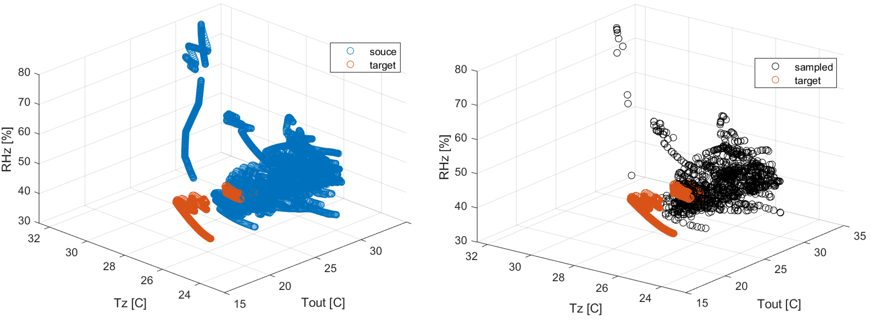

Figure A-2 Distributions of samples in feature space (Left: source domain vs. target domain; right: sampled vs. target domain)

After obtaining the resample data, the cross-validation of the RF model is performed in combination with the target domain data using the method mentioned in Chapter 3. Note that for cross-validation, the samples obtained from sample adaptation are always used as part of the training data, combined with partial target domain data as the final training data to train the RF model for the target domain. The remaining target domain samples are used to validate the RF model. As a control group, the cross-validation of the RF model was performed only using the target domain data and the same method. The results show that the JSD of the model obtained purely from the target domain is 0.114, while the JSD of the model obtained by transfer learning is 0.087. Therefore, the results of this preliminary test indicate that transfer learning improves the scalability of the thermal comfort model under different seasons.

1. Information Entropy Calculation of Target Domain Data in TL

This appendix details the calculation of the information entropy of the target domain data, which contributes to the evaluation case design of transfer learning.

Information entropy is a fundamental concept derived from Shannon's Information Theory, used to quantify the richness, diversity, or uncertainty within a dataset. It measures the average amount of information carried by a random variable and is particularly useful for evaluating how evenly data points are distributed across different categories or states. A higher entropy value typically indicates a more diverse or informative dataset, while a lower entropy value reflects greater uniformity or redundancy. An extension of this concept is Eigen Entropy, which generalizes information entropy to the domain of matrix eigenvalue distributions. Rather than analyzing scalar probabilities directly, Eigen Entropy evaluates the distribution of eigenvalues. By applying the principles of information entropy to the spectral properties of a matrix, Eigen Entropy captures the variability of the data.

Equations B-1 to B-3 are the formulation of eigen entropy, where $A$ is the feature and outcome matrix, $λ=[{λ_{1}, …,λ}_{n}]$ is the eigenvector, $P_{i}$ is the normalized eigenvalue, and $EE$ is the eigen entropy. When the data in the matrix is highly concentrated, the EE is minimized to 0. When the data in the matrix is evenly distributed (all eigenvalues are equal), the EE is maximum, and the maximum value is related to the dimension of the matrix.

$A=\left[\begin{matrix}a_{11} & ⋯ & a_{1n} \\ ⋮ & ⋱ & ⋮ \\ a_{m1} & ⋯ & a_{mn}\end{matrix}\right]$ (B-1)

$P_{i}=\frac{\left|λ_{i}\right|}{\sum_{j=1}^{n}{\left|λ_{j}\right|}}$ (B-2)

$EE=-\sum_{i=1}^{m}{P_{i}}\log_{2}(P_{i})$ (B-3)

As for the preliminary test used to determine the data collection period of target domain data in TL evaluation case design, $EE$ is used to measure the data richness of the target domain data. Using the virtual testbed developed in Chapter 2, consistent with the source domain data generation in transfer learning, Atlanta summer was also selected as a test condition for the virtual testbed. A 10-day simulation (starting on July 6) was conducted for cases with group occupant numbers of 5, 7, and 15, respectively, and a neutral group heat preference. The HVAC system was also controlled using one cooling setpoint and three cooling setpoints, respectively. The input features (i.e., zonal air temperature, zonal air relative humidity, and outdoor air temperature) and the target output (i.e., group thermal comfort calculated by occupant thermal comfort voting) of the group thermal comfort model were recorded during the simulation. The eigen entropy of the collected data was monitored as the simulation progressed to assess the richness of the data.

Figure B-1 present the eigen entropy of simulation results for groups of 5 (blue line), 7 (orange line), and 15 occupants (yellow line) under the one-set-point scenario (subfigure a) and the three-set-point scenarios (subfigure b), respectively. The results indicated that eigen entropy stabilized after five consecutive days of data collection, suggesting that the dataset's diversity reached a sufficient level within this period. Considering practical constraints and aiming to minimize disruption to occupants' regular working hours, this study selected a data collection window of 1 to 5 days, starting from July 6, which marks the beginning of a typical summer week. This range was used when generating the target domain dataset, ensuring both data richness and practical feasibility for real-world applications.

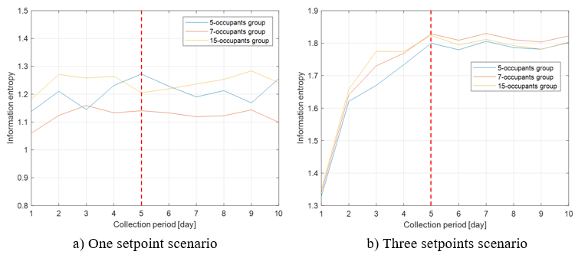

Figure B-1 Information entropy varies with the time period of data collection